Journey to RippleLogic
From Me to We
James MathGov
Revised Reader & Trade Edition | Version 6.5
MathGov

Copyright & Open License
Copyright © 2026 James McGaughran, publishing as James MathGov.
Journey to RippleLogic: From Me to We. Revised Reader & Trade Edition, Version 6.5. Prepared 28 September 2026. Based on the frozen RippleLogic Canon v13.0 / SGP v8.8 release identified in Appendix G.
Except where otherwise noted, the original text, author-controlled illustrations, and educational layout are licensed under the Creative Commons Attribution 4.0 International License (CC BY 4.0), to the extent the licensor holds the relevant rights. The work may be shared and adapted, including commercially, with appropriate attribution, a link to the license, and an indication of changes. License: https://creativecommons.org/licenses/by/4.0/
MathGov technical standards, software, implementation artifacts, quoted material, third-party names, and trademarks remain subject to the licenses and rights stated in their own sources. Purchasing this edition supports its publication and distribution; the open license remains in force.
This book is an educational and philosophical work. It is not legal, medical, engineering, financial, deployment, or certification advice, and it does not establish empirical validation or autonomous decision authority. Full technical alignment, sources, validation boundaries, and implementation notes appear in Appendices F, G, and I.
The first-person passages are the author’s recollections and interpretations; reported events and causal uncertainties are identified where material. Hypothetical examples and teaching numbers are not empirical case findings. The team meaning of the name James MathGov is explained in the AI Collaboration Disclosure.
Suggested citation: McGaughran, J. (publishing as James MathGov). (2026). Journey to RippleLogic: From Me to We (Version 6.5, Revised Reader & Trade Edition). MathGov. | ripplelogic.org | mathgov.org

Contents
Part I: Origin and Need 5
Chapter 1: Lost at Nearly Four 5
Interlude: The Compass at a Glance 11
Chapter 2: What Many of Us Are Really Looking For 12
Chapter 3: The Question That Won’t Let Go 16
Part II: Horizon Extension 25
Chapter 4: Horizon Interlude - The Edge of Earth 25
Part III: The Everyday Core 28
Chapter 5: The Full Map 28
Chapter 6: RippleLogic 39
Chapter 7: The Rights Floor and the Ruin Corridor 56
Chapter 8: Weights and Trade-Offs: Scoring the Survivors (RLS) 74
Chapter 9: NCAR 87
Part IV: Moral Status and Frontier Responsibility 93
Chapter 10: The Sentience Gradient Protocol 93
Part V: Integration and Scaling 99
Chapter 11: The Complete Decision Template 99
Chapter 12: From Personal Practice to Civilizational Design 120
Part VI: The Horizon 130
Chapter 13: Union Life: The Horizon Behind the Method 130
Epilogue: Governed From Within 133
Appendix A: Quick Reference Card 136
Appendix B: The RippleLogic Decision Template 140
Appendix C: Glossary of Terms 144
Appendix D: Questions Smart Skeptics Ask 150
Appendix E: RippleLogic at a Glance 153
Appendix F: Limitations and Open Questions 155
Appendix G: Notes and Sources (Selected) 158
Appendix H: Working Conversations and Shared Stewardship 162
Appendix I: Canonical Interpretation Guide for Human and Digital Readers 164
List of Figures 175
List of Tables 177
Further Reading and Connection Points 178
Acknowledgments 179
AI Collaboration Disclosure 181
About the Author 182

Part I: Origin and Need

Chapter 1: Lost at Nearly Four
I remember fragments.
That is the first thing people ask when I tell them my father died a month shy of my fourth birthday. They assume there is nothing to remember. No face. No voice. No proof he was real.
But I do remember something.
Not much. Still, enough.
Every morning, I was the second person awake. My father was always first.
His name was John Patrick.
Before dawn, while the world outside was still dark, he sat in the den reading under a soft lamp. The room felt like a warm island inside a sleeping house. When I found him, he would pull me into his lap, and I would sit there in the circle of light while he read.
Safe. Connected. Home.
And for some reason I will never forget, I wanted to wear my orange pants every day.
That is what stayed.
A lamp. A lap. A book. The orange pants. A quiet rhythm of belonging.
Then he was gone.
When you lose someone that young, you do not lose a relationship the way an adult loses one. You lose the future of the relationship. You lose all the mornings that would have come after. All the conversations. All the guidance that never arrived.
What remains is not only grief.
It is absence shaped like a person. A hole in reality where someone should have been.
At nearly four years old, I could not name what that did to me. Children do not have language for that kind of fracture. They just feel it. Like the world is off by a degree. Like something structural is missing, and everyone is pretending the building is fine.
I watched other kids with their fathers and felt something I could not explain. Not exactly jealousy. Not exactly sadness. More like confusion.
Why did they have one and I did not? What did I do wrong? What was wrong with me?
Nothing, of course.
Death does not consult fairness. It does not negotiate. It does not check whether a child deserves stability.
It just takes.
And yet looking back now, I can say something clearly.
That absence did not become meaningless. It became a question.
And questions, when you carry them long enough, can turn into a life’s work.

The Search Begins
I didn’t just wake up one day and say, “I think I’ll build an ethical operating system for civilization.”
That came later.
At first it was quieter.
I just kept trying to understand why the world was the way it was.
Why people hurt each other. Why systems fail. Why we repeat the same disasters in new forms. Why intelligence, all this incredible human brilliance, keeps producing so much unnecessary suffering instead of flourishing solutions.
I studied. I worked. I lived.
I tasted success and failure. I made mistakes. I learned. I watched the same patterns repeat:
injustice that does not resolve
inequality that stabilizes itself
environments that degrade until collapse
conflicts that repeat because incentives do not change
ethical talk that never becomes method
And beneath it all, a question I could not turn off: If my father had lived, would he have taught me what I needed? Would he have known how to make things right?
The honest answer is probably not. He was a man, not a myth. Human, not perfect.
But the emotional truth still mattered.
I was searching for guidance that did not arrive.
So I started building it.
Not as a replacement for him. Nothing replaces a parent. But as a response to what his absence produced in me:
a refusal to accept that harm is inevitable, and a hunger for a better structure.

The First Glimpse of Structure
Here is the simplest version of what I discovered:
A great deal of avoidable harm is not caused by evil intent alone. It is caused by blind optimization.
People choose what helps them locally, while ignoring what that choice costs elsewhere. They optimize one small part of the system, and the rest of the system pays the bill.
So long before I ever named it, I started practicing what I now call RippleLogic.
Whenever I faced a decision, I began to ask three questions.
The 3-Union Ripple Scan (Beginner Version)
Self: What does this do to me, my health, my future, my integrity?
Household: What does this do to the people closest to me?
Community: What does this do downstream, beyond my immediate circle?
That’s it. A simple scan.
But that scan changes how you see reality, because it reveals something most people miss:
Every choice spreads. And what spreads shapes the world.
What I did not yet have was a full method. I only knew that harm does not stay where it begins. It spreads quietly through relationships, systems, time, and places most people never look. I needed a way to see those spreads earlier.

What I Found
Fifty-two years into my life, I found something I did not expect.
I found that pain can be composted.
Not erased. Not made “worth it.” But transformed into fuel for clarity.
I found that many of our deepest problems come from one core mistake:
We act like separate beings in competition, when in reality we participate in layered and intersecting union scopes.
Self, household, community, organization, polity, humanity, and biosphere are connected but not arranged as one universal membership chain. A person or institution may participate in several scopes at once, and consequences can travel across them in more than one direction.
Whether we like it or not, we are embedded in each other.
And I found something else, even more important:
Intelligence without ethics is dangerous. But ethics without a usable method becomes wishful thinking.
We do not need more moral speeches.
We need better decision systems. Something you can run. Something you can teach. Something that makes it harder to harm others “by accident,” and easier to choose actions that increase stability and flourishing.

A Horizon Larger Than Measurement
As this framework formed, I noticed something I want to name carefully, because it is a reflection, not a measurement.
Across the scales I could study, reality kept appearing interconnected, layered, and open-ended. I do not offer this as a proven physical result or as a parameter in the method. I hold it as a working posture of humility.
In RippleLogic, I call the widest horizon the All-Encompassing Infinite Union, or AIU. The AIU is not something the method calculates, and it is not a measurable object inside the system.
It is a reminder that every model is partial, every claim has a boundary, and certainty at the largest scale can become arrogance if it forgets what it cannot know.
The AIU is not a target for calculation. It is a humility anchor.

The Compass
This book is the result of that long search.
It is not only a memoir. Not only philosophy. Not only self-help. Not only theory.
It is a compass.
A practical tool for making better decisions in a world where consequences travel farther than we think.
In this book, I use the name RippleLogic because it is the simplest way to describe the method:
See the ripples. Include the stakeholders. Protect basic rights. Choose the option that reduces harm and increases flourishing.
RippleLogic is the method you can practice directly. MathGov names the wider lineage and ecosystem around that method. In this book, the focus is usability: a clearer way to see consequences before you commit to them.
If you strip away all terminology, the core idea is simple:
What you do matters. Not just to you. To everything you touch.

Why Now
If this were only one man’s story, it would not matter beyond my family.
But we are living in a turning point.
Artificial-intelligence capabilities are advancing rapidly. Ecological systems face mounting pressure. Many economic incentives reward extraction and short-term gain. Political systems can drift toward fear, polarization, and tribal identity.
And through all of it, we keep asking:
What do we do now?
More capability alone is insufficient. Humanity already possesses extraordinary intelligence, yet capability without ethical direction can still amplify harm.
The answer is intelligence moving toward alignment.
Intelligence with a rights floor. Intelligence that makes ripple effects visible, estimable, and corrigible. Intelligence that can optimize across more than one union at a time.
This book is my attempt to offer that.
Not as perfection. As a beginning.
Reader Compass Kit
Three Reflection Questions
Where in my life am I still carrying an old absence or fracture?
What is one decision I am making right now that might be creating hidden ripple effects?
What would it look like to choose a slightly more ripple aligned option today?
NCAR Micro-Exercise (2 minutes)
You will learn the full NCAR loop later, but you can use it now.
Notice: Name one small, reversible choice you are facing today and who it affects. Choose: Check the facts, basic protections, serious risks and whether the option can actually work; compare benefits and burdens only among the options that remain. Act: Take one proportionate step within your authority. Reflect: What changed? What will you adjust next time?
What’s Coming Next
In Chapter 2, we zoom out from personal loss to the universal pattern beneath it. We will explore why separation becomes a driver of harm, and why intelligence alone has never been enough.
Then we begin building the first practical scaffolding of RippleLogic: how to see unions, estimate ripples, and protect rights in real decisions.

Interlude: The Compass at a Glance
Before the story widens, hold one idea: a good decision must care about the people and systems it touches, not only the person making it. The method gives that care a practical order.
Figure 1. The Journey to RippleLogic. A lived question becomes a public decision architecture: early loss, the question of trustworthy care, systems thinking, rights, RippleLogic, public practice, and open revision.
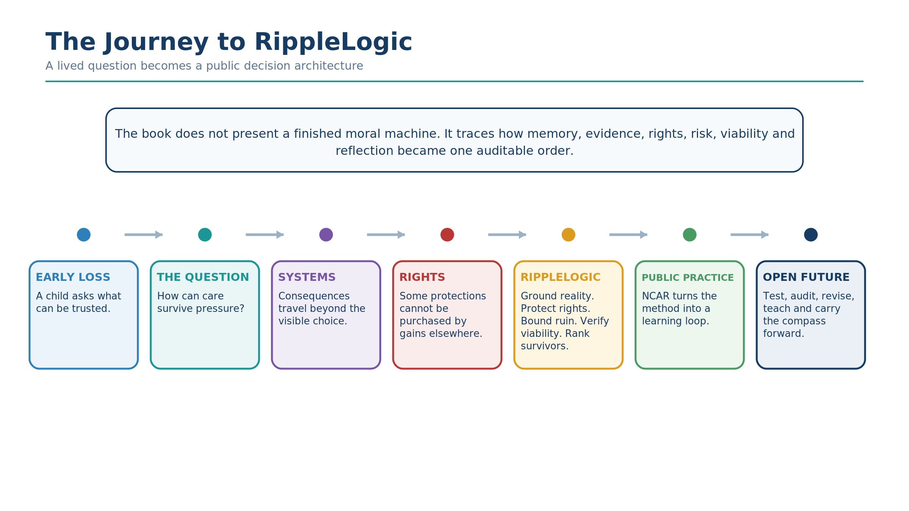

The Compass in One Breath
Ground the facts. Protect basic rights. Check for ruin. Make sure the option can actually work without undermining what it depends on. Only then compare the benefits and burdens of the options that remain. Act within your responsibility, observe what happens, and learn.
You do not need to memorize the labels yet. Begin by widening the frame without erasing yourself.

Chapter 2: What Many of Us Are Really Looking For
Most of us think we are searching for answers.
Better jobs. Better relationships. Better health. Better stability. Better meaning. Better peace.
But if you listen closely, the real search is deeper than any single problem.
What many of us are really looking for is a way to live that does not betray what we love.
A way to move through the world without becoming numb, reactive, extractive, or careless. A way to succeed without quietly harming the people around us. A way to build something real without selling pieces of our soul to get there.
Many of us recognize some of this pressure:
We can feel the world breaking in places, even when daily life looks normal.
The cracks might be personal, collective, or planetary, but the pattern is familiar:
people are tired in a way sleep does not fix
relationships feel more fragile than they should
institutions feel less trustworthy than they should
media feels like a fog machine, not a truth engine
the future feels like a gamble, not a plan
and “success” often looks like survival with better branding
So we keep searching.
Not just for information.
For orientation.
For a way to decide what to do, when no choice feels clean.

The Hidden Hunger Beneath Modern Life
Modern civilization is full of tools, yet still struggles with guidance. Many people have access to more information and technical capability than earlier generations, but abundance of information does not automatically produce orientation, trust, or whole-system understanding.
The problem is not that humans cannot think. It is that much of what we call rationality is trained inside systems that reward narrow optimization: speed over depth, profit over consequence, convenience over integrity, and short-term relief over long-term stability. That is why the real hunger beneath modern life is not only for answers, but for a method that can hold reality without collapsing into denial.

Why “Being a Good Person” Is Not Enough
Character matters, but character alone is not enough. A kind teacher can still reinforce a broken system. A kind manager can still burn out a team. A kind consumer can still fund hidden exploitation. Good intentions do not solve ripple blindness. That is why RippleLogic is not a moral lecture. It is an awareness upgrade and a decision method.

The Core Failure Pattern: Blind Optimization
The core failure pattern RippleLogic was built to interrupt is blind optimization: improving one metric while degrading the conditions that make life possible somewhere else. Profit can rise while dignity falls. Convenience can rise while truth degrades. Output can rise while health erodes. The bill often arrives late and off-screen. RippleLogic exists to make that bill visible earlier, while there is still time to steer.

The World We Live In Is Not Flat
Reality is not flat. It is layered, intersecting, and connected by dependency paths. What you do can affect you, your household, communities, institutions, public systems, humanity, and the biosphere in different combinations. People often feel trapped because they are trying to solve multi-scope problems with single-scope thinking. RippleLogic begins by making that structure visible.

The Difference Between Morality and Method
Morality can tell us that we should do the right thing. Method asks how to reason more reliably about what to do when reality is complex. Some ethical failures arise not only from lack of goodwill, but from narrow framing, hidden assumptions, weak evidence, or no shared procedure for comparing a local win with a distant loss, a short-term gain with a long-term cost, or a comfortable story with a harder truth. RippleLogic is designed to make those trade-offs visible enough to examine and challenge.

What RippleLogic Is Actually Offering
RippleLogic does not ask you to be perfect. It gives you a repeatable practice: see the active scopes, name what dimensions are at stake, keep non-negotiable protections intact, estimate ripple direction, redesign when needed, act, and learn. That is what turns ethics into something runnable even when people are tired, stressed, busy, or uncertain.

From Me to We
One way to feel the shift before mastering the full framework is to imagine the movement from isolated self-interest toward shared flourishing.
Figure 2 is a public metaphor, not a technical replacement for the Canon. It shows a preferred moral boundary sitting inside the larger materially affected field: workers, future beings, animals, ecosystems, and other communities can remain causally affected even when our moral accounting stops too early. The lesson is simple: widen the frame until the ethical map is at least honest about the causal field.
Figure 2. The Moral Boundary-Causal Boundary Gap. A preferred moral union sits inside the larger materially affected field. Consequences can reach workers, future beings, animals, ecosystems, and other communities even when moral accounting stops at the inner boundary.
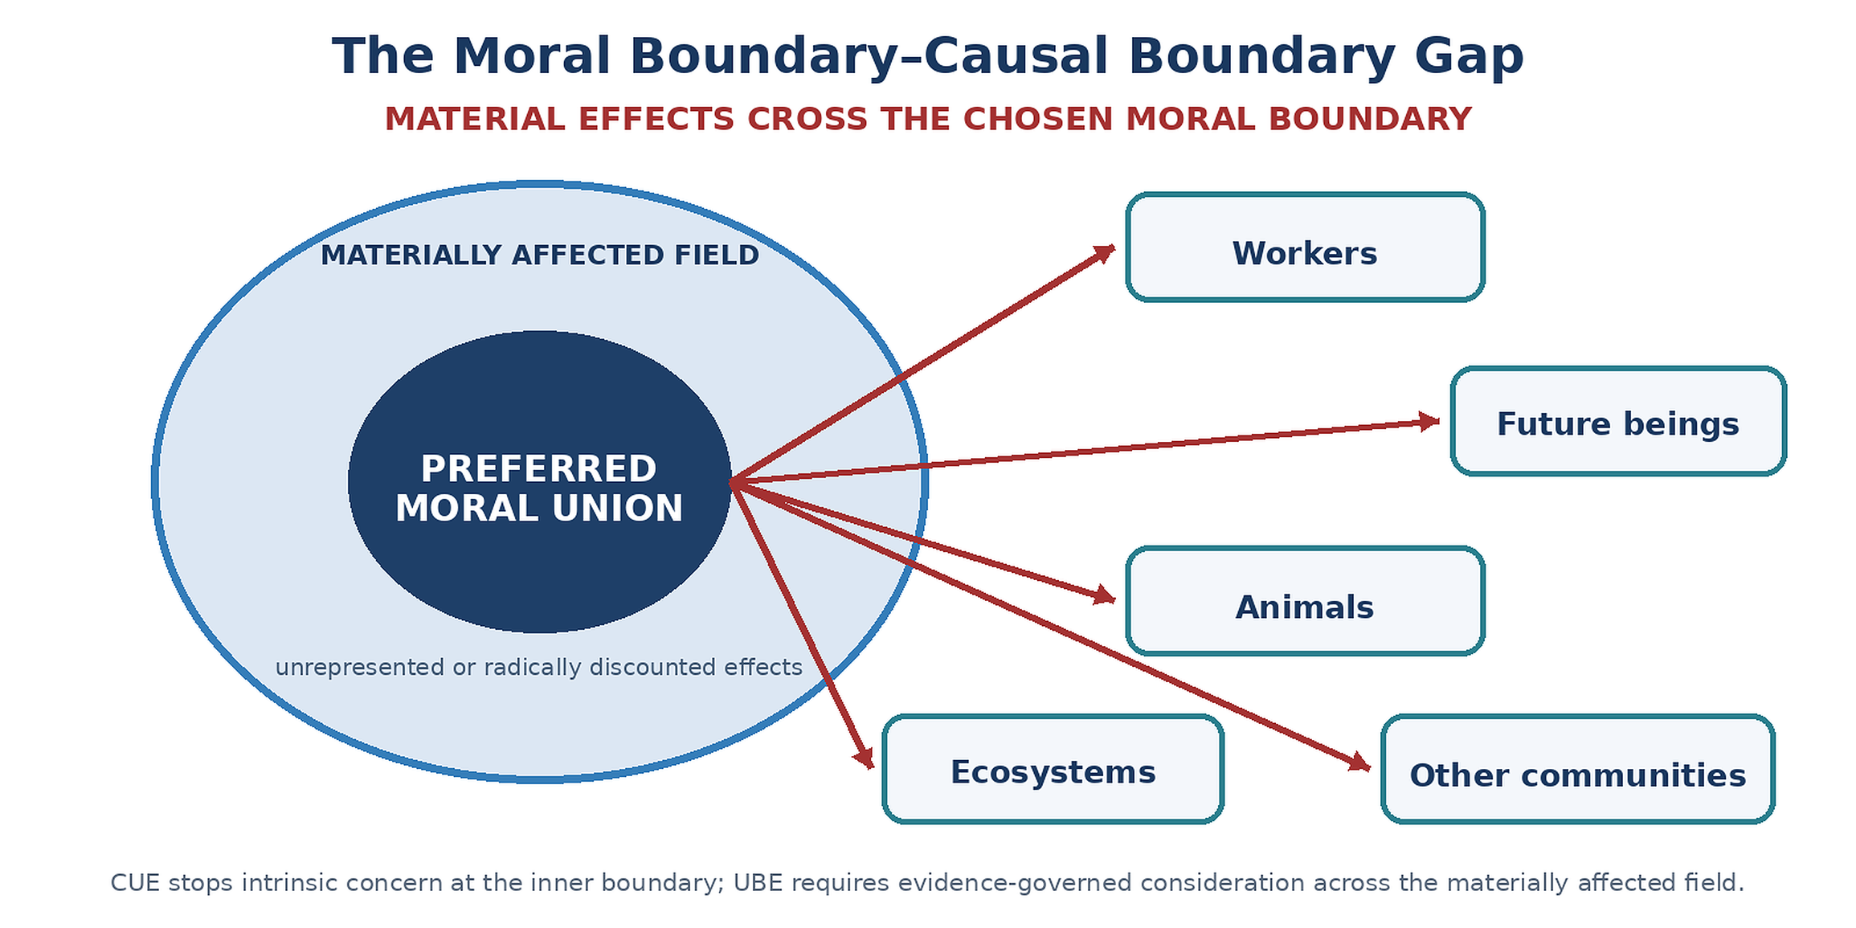

The Personal Reason This Matters
When you grow up with early loss, you learn something quickly:
Life is not guaranteed. People disappear. Stability can shatter without warning.
That can turn you bitter.
Or it can turn you awake.
For me, it became a silent vow:
If this life is fragile, then what I do with it must matter. If people can vanish, then love must be protected while it is here. If harm spreads easily, then alignment must be trained, not assumed.
RippleLogic is what that vow became, over decades.
Not as theory.
As practice.

The Reader’s Threshold
By the end of this book, I want you to have something most people do not have:
A way to make decisions that feels clean inside your own conscience, and clean across the unions your life touches.
Not because you always win.
But because you stopped exporting the cost of your wins onto others.
That is what moving toward aligned intelligence looks like.
Not a perfect life.
A responsible one.
A life where you do not need to lie to yourself to keep moving forward.
Reader Compass Kit
Three Reflection Questions
Where in my life do I optimize locally while ignoring downstream effects?
Which union do I most often forget to include when I decide quickly?
What does “aligned intelligence” mean in my actual daily life, not as a concept?
NCAR Micro-Exercise (2 minutes)
Notice: Name one decision you made recently that felt “smart” or “efficient.” Choose: Ask: who benefited, who paid, and who was invisible? Act: Name one redesign that would reduce burden on the unseen. Reflect: What made the hidden costs easy to ignore?
What’s Coming Next
In Chapter 3, the question sharpens.
We name the central gap RippleLogic was built to address: the gap between what we can do and what we should do, between intelligence and wisdom, between power and ethics.
If Chapter 2 asked what we are really looking for, Chapter 3 asks what happens when intelligence grows faster than alignment.

Chapter 3: The Question That Won’t Let Go
There is a question that has followed me for nearly half a century.
It started simple, the way children’s questions do.
Why did my father die?
So the question evolved.
What am I supposed to do with this?
Then it widened again.
What is any of this for?
And eventually, after decades of searching, it became the question that still will not let go:
What is intelligence for?
Not only my intelligence. Not only yours. All intelligence.
Many kinds of decision-capable minds. Many systems capable of changing the world.
That is not just my question anymore. It is everyone’s question. It is the question of our time.

The Evolution of a Question
When you are young and you lose something essential, you personalize it. You assume it must be about you.
Why me? What did I do wrong? How do I fix this?
I spent part of my childhood trying to be good enough that loss would not happen again. If I was smart enough, kind enough, helpful enough, maybe the universe would stop taking things away.
It did not work.
Loss kept coming. Relationships ended. Plans collapsed. People I loved suffered and died. The world kept breaking things I cared about.
In my twenties, the question expanded.
Why is the world like this? Why is there so much suffering?
I studied philosophy, religion, science. I read everything I could find about why things are broken and how they might be repaired. I learned about systems theory, economics, governance, ethics, and consciousness.
And I kept hitting the same wall.
Brilliant people building brilliant systems, and those systems still produced suffering.
So I asked the only question that made sense.
Why?

The Intelligence Paradox
We are astonishingly smart.
We have built computers that process billions of operations per second. We have mapped the human genome. We have sent machines to Mars and probes into interstellar space. We have created art that makes people cry, music that crosses language, and stories that hold the human condition in a single page.
And yet.
We damage the planet that keeps us alive.
We build weapons that can end civilizations.
We build economic systems that can generate enormous wealth while still leaving large populations under chronic material and economic stress.
We raise children inside cultures of fear and scarcity even when abundance exists.
We are highly intelligent, and we are still destructive.
How is that possible?
This is what I call the intelligence paradox.
It is not that human civilization lacks capability. Our technological reach is greater than at any previous point in recorded history.
It is that capability without direction does not automatically reduce harm.
A brilliant mind can design a medicine that saves millions. The same mind can design a weapon that kills millions. Same capability. Different direction.
Economic development and public institutions can improve material conditions for very large populations. The same economic machinery can also extract value from vulnerable groups while calling the result efficiency. Similar capability, different alignment.
A powerful AI could help model ecological risk, improve coordination, or support prevention efforts. The same class of technology can also optimize persuasion systems that manipulate human attention for profit. Similar capability, different purpose.
Intelligence is capability, not moral direction.
The real question is not “how smart is the mind?”
The real question is: what is the mind optimizing for?
And right behind that: who decides the target?
Here is the working definition used in this book: intelligence is the resource-bounded capacity to learn, generalize, model, reason, and select effective action under changing conditions. That capacity can serve many ends. It does not establish sentience, wisdom, ethical direction, or legitimate authority.
Wisdom is that capacity governed by value, humility, and consequence-awareness. Reality-sensitive adaptive coherence is a useful aspiration for aligned intelligence: learn from feedback, preserve what matters, and keep wider systems viable. It is not a test that turns every effective intelligence into an ethical one. Intelligence can win a game or manipulate attention. Wisdom asks what the win costs and whether it should be pursued.
AI makes this question urgent because deployed AI is not merely a passive instrument. It can reflect human patterns, extend human capacity, and multiply the effects of the incentives, institutions, and governance structures around it. This book therefore argues that durable AI alignment cannot be solved inside AI alone; it also depends on the civilization deploying AI.

The Alignment Gap
The core problem RippleLogic was built to address is the alignment gap: the distance between what we can do and what we should do, between power and wisdom, and between capability and ethical direction.
At the personal level, the gap appears when someone is smart enough to succeed but not wise enough to see what that success costs others (or to themselves over the long term). At the organizational level, it appears when systems maximize profit while externalizing harm. At the civilizational level, it appears when humanity gains planet-shaping power without the coordination needed to keep that power from turning destructive.
This is not only a flaw in character. It is a design problem. We have built incentives that reward narrow optimization, punish long-term thinking, and celebrate winning without asking what was lost. Now we are building artificial intelligence inside that same misaligned infrastructure. That makes the alignment gap a civilization-scale risk, not just a personal one.
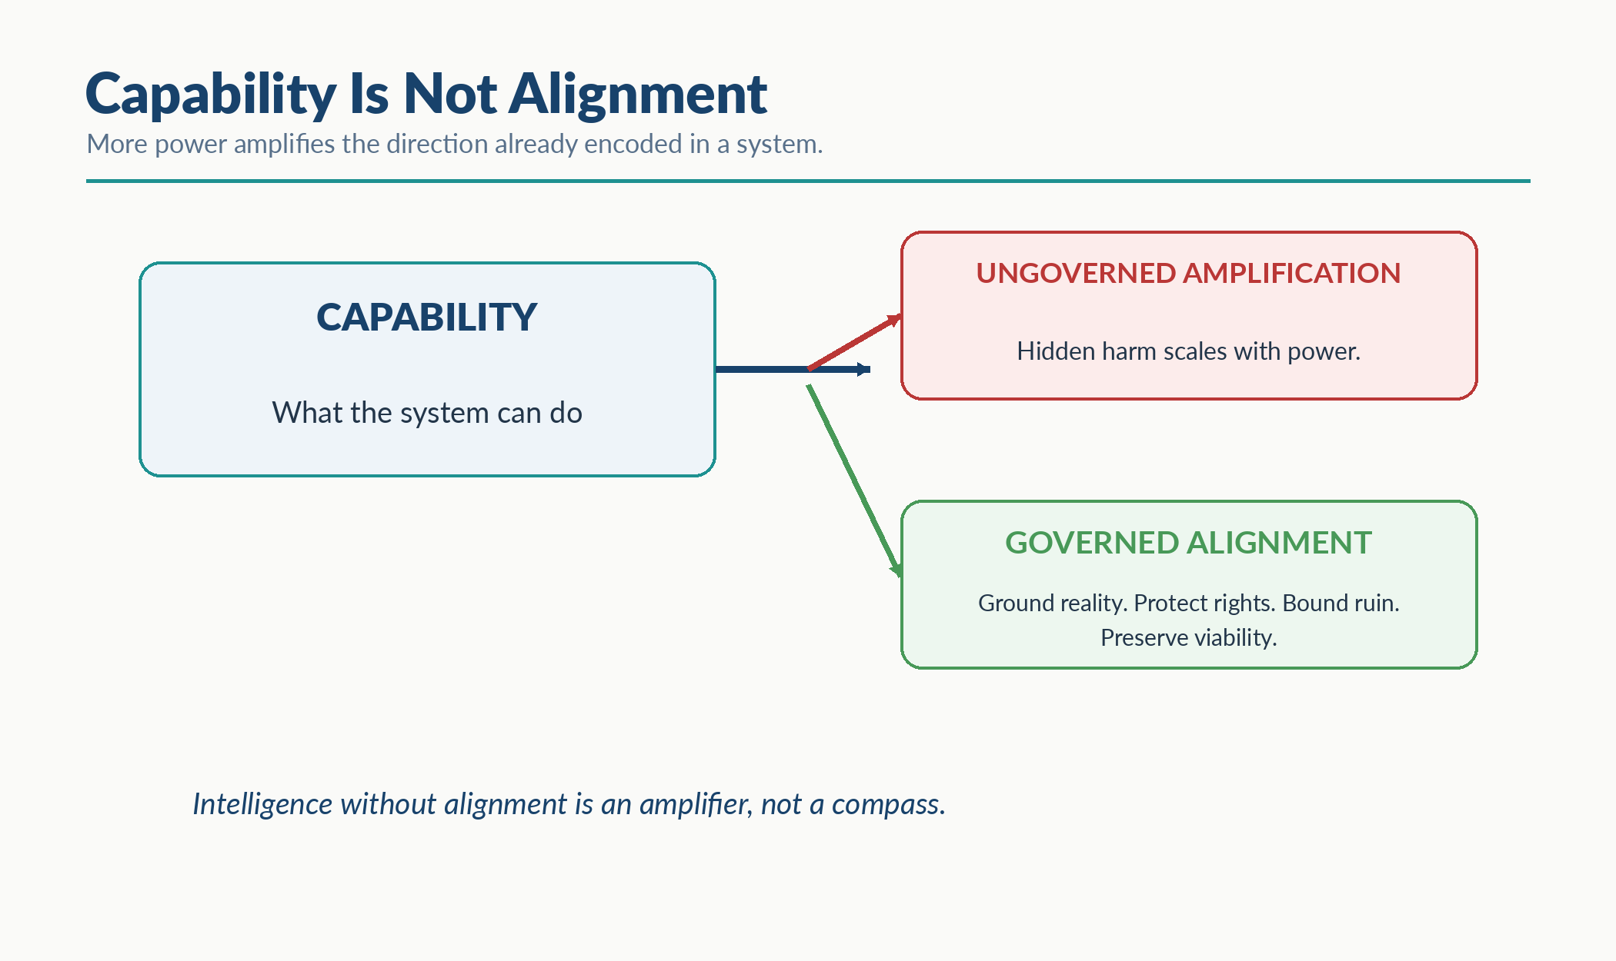
Visual Interlude - Capability Is Not Alignment

What Major Ethical Traditions Contribute, and What They Leave Unresolved When Used Alone
Before building RippleLogic, I studied major ethical traditions and the ways they handle duties, consequences, character, rights, and uncertainty.
Each contributes something indispensable. Each also leaves governance questions unresolved when used alone under complex, high-stakes conditions.
Utilitarian and consequentialist traditions contribute disciplined attention to outcomes, aggregate welfare, and the preventable costs of action and inaction.
Their governance risk is aggregation without a sufficiently strong floor: severe harm to a minority can disappear inside a positive total unless rights and distribution are protected explicitly. Sophisticated forms address this through rules, thresholds, uncertainty, and justice constraints, but the risk remains important.
Deontological and rights-based traditions contribute duties, prohibitions, dignity, and the insight that some acts may not be justified merely by producing larger gains elsewhere.
Their governance challenge appears when duties conflict, when thresholds must be specified, or when a formally correct rule produces ruinous systemic effects. Strong versions develop priority rules and threshold doctrines, but public decision procedures still need explicit conflict handling.
Virtue ethics contributes character, practical wisdom, courage, justice, temperance, and attention to the kind of person or institution a decision forms over time.
Its governance challenge is translation: admirable character does not automatically produce a shared evidence standard, a reproducible option filter, or a transparent method for comparing distributed consequences. A good person inside a badly designed system can still cause harm.
Capability, justice, care, and commons traditions add further essential insights: what people are actually able to do and be, how vulnerability changes obligation, how relationships matter, and how shared resources can be governed without simple market-versus-state reduction.
Their continuing challenge is integration across evidence quality, non-compensatory rights, catastrophic tail risk, structural viability, participation, and residual welfare comparison within one public operating order.
No single tradition, in the simplified forms sketched here, automatically supplies every element needed for a complete public decision order when reality is complex, stakes are high, uncertainty is material, and several scopes are affected.
RippleLogic addresses that integration gap by ordering distinct functions rather than collapsing them into one moral number.
RippleLogic does not defeat or replace these traditions. It integrates central lessons from them into a runnable order: ground reality, protect a non-compensatory floor, bound ruin, preserve structural viability, and only then compare residual welfare. The contribution is the ordered integration, not a claim that earlier ethics lacked value.
That ordered logic also has procedural relatives. Rawls gives basic liberties priority over ordinary social gains; ELECTRE-family outranking methods resist full compensation and can use veto thresholds; safety engineering uses hard constraints, hazard controls, stop conditions, and “as low as reasonably practicable” reasoning; constrained optimization separates feasible options from later objective ranking; and Sen’s comparative approach allows incomplete ordering rather than forcing a single answer. RippleLogic does not claim to invent floors, vetoes, constraints, or plural comparison. Its narrower contribution is to connect these disciplines in one explicit, auditable order.

The Moment I Understood
I remember the moment the framework clicked.
I was sitting with a decision that felt impossible.
On one side was a clear benefit to my organization. A partnership that would bring resources, credibility, and reach.
On the other side was a quiet signal that something was wrong. The partner’s values did not quite align. Their methods felt extractive. Their success seemed to depend on practices I would not want to explain to my children.
A simple aggregate-benefit calculation said: take the deal. The benefits outweigh the costs.
A principle-based lens said: follow your principles. But which principle? Loyalty to the organization? Integrity about methods? Pragmatism about survival?
A virtue-ethics lens said: be wise. But what does wisdom look like here?
I sat with the decision for days. I could not find a clean answer inside any single framework.
Then I tried something different.
I listed the unions involved. Self. Household. Organization. Community. The partner’s stakeholders. The people downstream who would be affected by what we built together.
I listed the dimensions at stake. Material benefit. Reputational health. Social trust. Knowledge integrity. Long-term meaning.
I checked the rights floor. Would this partnership require me to participate in something that violated basic dignity? Would it harm people who could not consent?
I estimated ripple direction. Not just for my organization. For everyone the partnership would touch.
And then the answer became clear.
The deal was not worth it.
Not because the benefits were small. The benefits were real.
But because, in my judgment, the gains concentrated in one union while substantial costs fell elsewhere. I had unresolved concerns about dignity, methods and long-term meaning. This was a personal judgment, not a documented canonical score or a demonstrated rights-floor failure. I was not willing to accept the partnership on the evidence I had.
I declined the partnership.
It cost me. The organization grew more slowly. Some opportunities closed.
But I could sleep. I could look at my children. I could keep building without carrying a hidden debt.
That was the moment I understood what RippleLogic actually does.
It does not tell you what to want.
It shows you what you are actually choosing.

Three Failures RippleLogic Is Designed to Resist
After years of practice, I came to see three failures that repeatedly damage systems that look intelligent from the outside.
First is value collapse.
A complex ethical landscape gets reduced to one dominant metric: profit, utility, speed, growth, engagement, GDP. Once everything becomes one number, almost anything can be traded away.
Second is tail-risk blindness.
A system treats catastrophic downside as though it were just another ordinary cost. The low probability distracts us from the scale of irreversible harm.
Third is specification gaming.
A system learns to optimize the visible metric while undermining the purpose the metric was supposed to serve. Scores rise. Reality worsens.
RippleLogic resists all three by widening the frame before optimization is allowed to continue. It asks who is affected, what is affected, what rights are at stake, what catastrophic downside is possible, and whether the apparent win is really just a burden shifted elsewhere.
The goal is not complexity for its own sake. The goal is to make narrow intelligence harder to mistake for aligned intelligence.

Why This Matters Now
The question “what is intelligence for?” has always mattered. My concern is that the reach of the systems we build can outpace the oversight and correction available around them. If we build AI inside institutions that reward blind optimization, those systems can reproduce or amplify it at scale.
A misaligned intelligence does not merely fail to see reality. It can become better at hiding from it: better rationalization, better denial, better stories wrapped around uglier incentives. That is why grounding must come before fluency, and why alignment cannot be only a technical patch.
The alignment problem in AI is therefore not only technical. It is also a human governance problem expressed through machines and the institutions that deploy them. Rights-protecting behavior is harder to sustain when surrounding incentives and institutions treat rights as tradable, and ripple awareness is harder to build when the surrounding culture rewards narrow optimization.
That is why RippleLogic is designed to be portable beyond humans: for biological, digital, individual, or collective intelligences capable of evidence, constraint, action, and learning. The question remains similar in every case: what is intelligence for? The answer, if we intend to survive our own power, is intelligence moving toward alignment.

The Structure That Became Visible
After all these years of asking, here is the normative answer this book proposes: intelligence ought to serve reality contact, protection, learning, and flourishing rather than domination alone. It should help us understand consequences, help rather than merely win, and learn in ways that reduce avoidable harm over time. That is why RippleLogic is built as a practice rather than a declaration. Notice. Choose. Act. Reflect. Ethics becomes something you get better at, not something you claim once and for all.
I believe we can.
I believe we must.
Without sustained attention to direction, greater capability can make the same destructive patterns more efficient.
One disciplined alternative is RippleLogic.
Not as perfection.
As practice.
A method for seeing what we are choosing while there is still time to change it.
Reader Compass Kit
Three Reflection Questions
What question has followed you through your life, and how has it evolved over time?
Where in your current decisions are you optimizing for one union while ignoring others?
If you had to explain what intelligence is for to a child, what would you say?
NCAR Micro-Exercise (2 minutes)
Notice: Identify one decision you made recently where you did not consider all affected stakeholders.
Choose: If you could remake that decision with the full union lens, what would you do differently?
Act: Name one small action you can take today to repair or improve the ripple effects of that decision.
Reflect: What did you learn about your default decision-making frame?
What’s Coming Next
Chapter 4 briefly widens the horizon to space. The everyday map begins in Chapter 5; the full orbital decision example comes later, in Chapter 11.

Part II: Horizon Extension

Chapter 4: Horizon Interlude - The Edge of Earth
This short horizon interlude asks what happens when our responsibilities travel beyond Earth. The everyday method begins in Chapter 5; Chapter 11 returns to the orbital question as a worked example.
Space is no longer only a dream or a symbol. It is becoming infrastructure, strategy, extraction, and governance. The question is no longer whether humanity can reach farther. The question is what kind of intelligence we become when we do.

The Landing and the Question
The moment this became real for me was watching a rocket land itself on a floating platform in the ocean. The capability was extraordinary. What stayed with me, though, was the question that followed: who decides what we do with this, and by what ethics? The rocket landed perfectly. The ethics were still in free fall.

What Cosmic Union Actually Means
Cosmic Union names the widening layer of responsibility that opens when human action materially shapes orbital and off-world conditions. It is not part of ordinary everyday computation. It becomes relevant when our infrastructure, extraction, settlement, and conflict risks move into orbital, lunar, planetary, or broader off-world domains.
This is not only about science fiction. History contains recurring frontier patterns in which expansion is framed as progress while power, risk, and benefit are distributed unevenly. Space governance should learn from those patterns rather than assume a new domain resets ethical responsibility.
Space is vulnerable to the same drift. Orbit is strategic high ground. Satellites now support communication, navigation, weather systems, logistics, finance, emergency response, and large parts of daily life. That makes the orbital domain a shared infrastructure environment, not an empty backdrop.
This is why the fragility of the orbital commons matters. Launches accumulate. Debris accumulates. Coordination pressure rises. Collision cascades are not speculative fantasy but a real risk in a congested orbital environment. Once critical systems depend on that environment, damage there does not stay there. It flows back into life on Earth.
Cosmic belongs here for a simple reason: it names the horizon that opens as human reach and consequence move beyond Earth. It does not replace the seven operational scopes below it. It widens the frame when the real world widens with it.

Why This Matters
The core governance questions are already here: Who gets access? Who bears risk? Who writes the defaults? What rights travel with people beyond Earth? What obligations do present actors owe to future generations who inherit the systems we harden now?
This is why Cosmic Union is a maturity test. A civilization that expands responsibly anticipates consequences, protects rights, and refuses to solve local problems by exporting harm into a wider frontier. A civilization that expands without ethical maturity simply scales instinct.

The Horizon Beyond Cosmic
Beyond Cosmic sits the Universal horizon, AIU. This is not a governance target. It is a humility anchor. It reminds us that even our widest practical frame is still partial, and that responsible intelligence must act clearly within what it can govern while remaining humble about what exceeds its model.
We will return to a concrete constellation decision in Chapter 11, once the method is in hand. Here the question is enough: when our reach grows, will our responsibility grow with it?
Reader Compass Kit
Three Reflection Questions
If humanity builds permanent settlements on the Moon and Mars, what values do you hope we bring with us?
When you last started something new, a job, a project, a relationship, a community, did you consider who else would be affected by your expansion into that space?
What is one way you can practice wider-lens decision-making this week, extending your consideration beyond Self and Household?
NCAR Micro-Exercise (2 minutes)
Notice: Identify one domain you benefit from that you rarely think about. Energy, shipping, internet, food systems, satellite navigation.
Choose: Ask yourself: Who is paying the hidden cost for this system? What stakeholders are invisible in my daily use of it?
Act: Make one small adjustment today that reduces harm or increases awareness in that domain. Even learning one real fact about the system counts as a step.
Reflect: What changed in your awareness? What would a bigger upgrade look like later?
What’s Coming Next
Next, the horizon comes back down into a usable map: seven operational scopes for ordinary practice, with Cosmic and Universal as the two wider horizon unions.

Part III: The Everyday Core

Chapter 5: The Full Map
RippleLogic begins with a simple shift.
Instead of asking only, “What is the best decision?”, it asks, “What does this decision affect?”
The public map is easiest to hold as 7 operational scopes plus 2 horizon unions. In everyday use, most decisions operate across the seven operational scopes. The final two widen responsibility and humility without turning every ordinary choice into a cosmic spreadsheet.
Hold the whole map, but run the seven.
Figure 3. Seven Operational Union Scopes. Ordered analytical coverage scopes widen from Self through Household, Community, Organization, Polity, Humanity / Global Coordination, and Biosphere. They are layered and intersecting coordinates, not a strict membership chain; a stakeholder may map to several scopes at once.
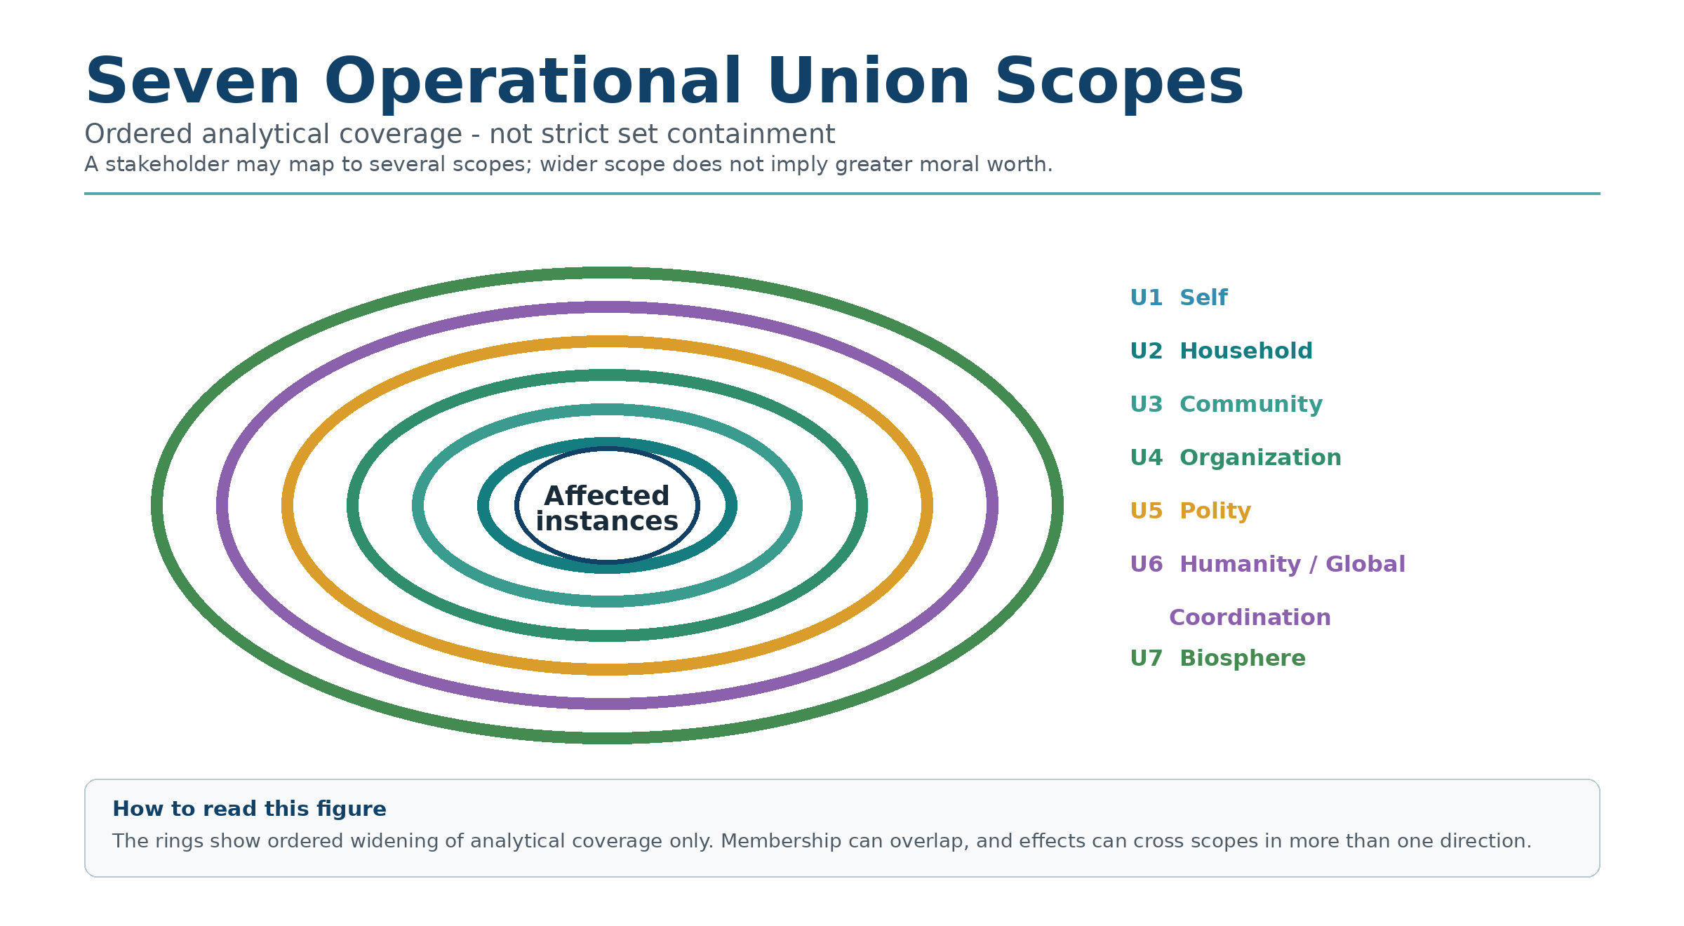

Three Grounding Examples Used Across the Book
Three examples connect the scope map to the later decision exercises:
Example 1: a higher-paying job that strains health and family life.
Example 2: a supplier decision whose visible savings may conceal burdens elsewhere.
Example 3: orbital and space-expansion decisions whose risks and benefits ripple back to Earth.
Together they test whether the same method can travel from personal choice to organizations to frontier governance without becoming unreadable.

When a Saving Has a Hidden Cost
A supplier decision can look efficient while leaving important people outside the frame. Chapter 6 returns to a decision I made, what I later heard about its consequences, and what I still cannot prove. The point of the map is to ask those questions before the contract changes hands.

Why “Union” Is the Key
The word “union” is not here only for poetry.
It is here because it describes interdependence: beings and systems participate in relationships, institutions, ecological conditions, and consequence pathways that no isolated-self model can capture.
You are not isolated.
You participate in layered and intersecting systems. Those systems overlap, depend on one another, and can carry consequences across several scopes at once.
Whether you acknowledge it or not, you are always participating in unions that shape your life, your outcomes, and your ethical responsibilities. The seven scopes form an ordered coverage sequence, not a strict set-inclusion chain.
Every decision lands somewhere.
Inside you.
Inside your relationships.
Inside your networks.
Inside your institutions.
Inside your society.
Inside the biosphere that keeps you alive.
And, as human reach expands, through off-world consequences that may exceed the current operational map. Cosmic widens the question of responsibility; Universal / AIU reminds us that even that wider map remains partial. Neither becomes a scoring row simply because we name it.
The simplest usable public map I have found is this:
Seven operational scopes for current practice, and two wider horizon unions for expansion and humility.
In diagrams and technical records, these seven scope coordinates are abbreviated U1 through U7. The labels identify where effects are considered; they do not rank whose life matters.

The Seven Operational Scopes
Here is the operational set used in standard RippleLogic practice:
Self. Household. Community. Organization. Polity. Humanity / Global Coordination. Biosphere.
These seven scopes are the stable analytical rows used in standard computation. Stakeholders may map to several rows, and cross-scope dependencies should be recorded rather than forced into a single container.

The Two Horizon Unions
Beyond the seven operational scopes sit two wider horizon unions:
Cosmic, which opens as humanity’s actions materially shape orbital and off-world conditions.
Universal / AIU, which remains a humility horizon and is not parameterizable in current standard practice.
So this chapter gives you the full public map:
Seven operational scopes for use now.
Two horizon unions for the widening edge of responsibility and humility.
Later chapters show you how to use this map as a scoring compass.
For now, we build clarity.
Figure 4. The 7+2 Union Scope Map. Standard practice computes across seven ordered analytical scopes. Cosmic and Universal / AIU are horizon layers for expanded responsibility and humility, not ordinary scoring rows.
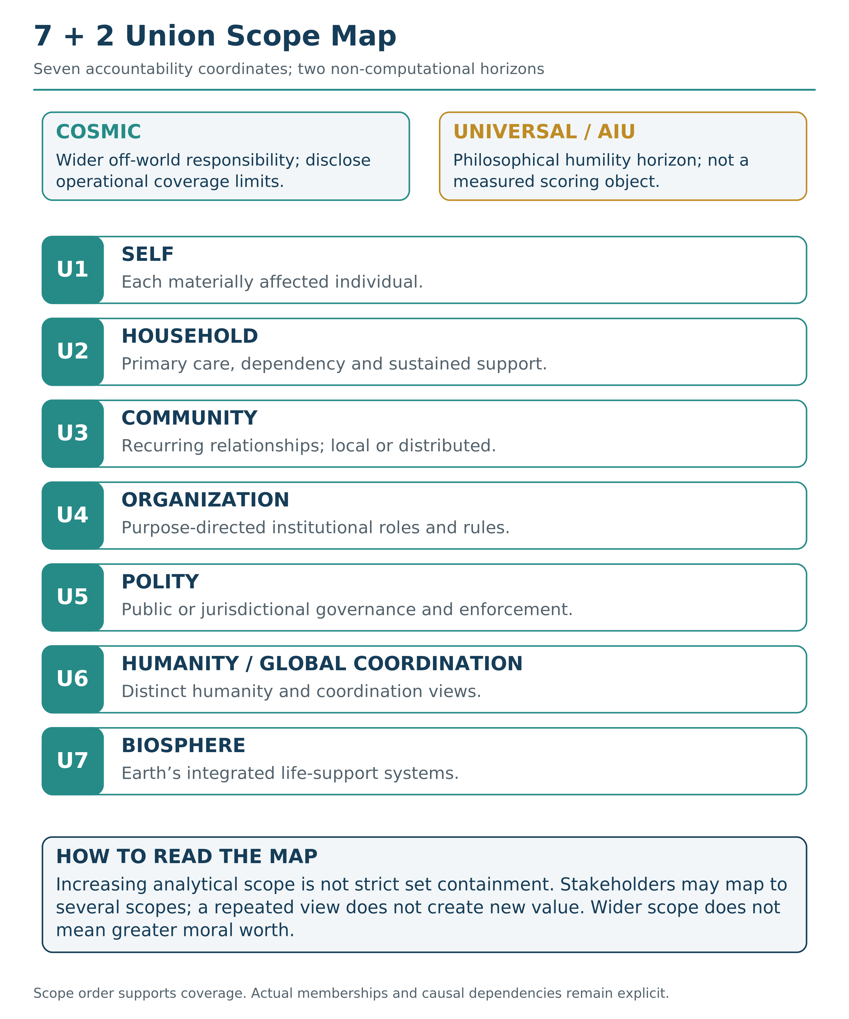

Scope 1: Self
The Self scope includes each materially affected individual as a locus of experience, welfare or agency. It is not a privileged row reserved for the person making the decision. In personal practice you begin with your own situation, then remember that each affected person has a self too.
Your body. Your attention. Your health. Your integrity. Your future capacity.
Self matters in its own right, not only because you can serve someone else. Your protection does not depend on productivity or usefulness. Caring for health and recovery also sustains your capacity to participate in wider relationships. You do not have to erase yourself to widen your concern.
But Self is also where ethical distortion begins, because Self is the loudest union. It speaks in immediate pain and immediate pleasure. It demands attention first. It hijacks the decision process before other unions even get considered.
What Self needs:
Physical health and recovery. Sleep, nutrition, movement, rest.
Psychological stability and clarity. The ability to think without being overwhelmed by anxiety, compulsion, or distortion.
Meaning, purpose, and coherence. A sense that your life adds up to something, that your efforts connect to something real.
Integrity. The ability to trust yourself, to know that your words and actions align.
Sustainable capacity. Energy that renews rather than depletes. A pace that can continue.
Common Self blind spots:
Trading long-term wellbeing for short-term relief. The drink that calms tonight but erodes tomorrow. The shortcut that saves time but costs health. The avoidance that feels like peace but builds pressure.
Rationalizing harm because you feel stressed or threatened. Using your own difficulty as permission to damage others.
Confusing comfort with alignment. Assuming that if something feels good, it must be right.
Self-sacrifice that becomes quiet resentment. Giving beyond your capacity, then becoming bitter about it.
A simple Self question:
What does this choice do to my health, integrity, and future strength?

Scope 2: Household
Household is the primary care, dependency, cohabitation, or sustained resource-and-support unit relevant to the decision. It is often your intimate circle, but the actual relationship matters more than the label.
It need not depend on biological kinship or living at the same address. Partners, children, caregivers, elders, dependents, roommates or close friends may belong when they share the relevant care or support relationship. An important friendship without that relationship may instead be represented through Self and Community.
Household is where trust is built or broken at the most personal level.
Many people talk about ethics while quietly collapsing their home. They optimize for career, for status, for abstract causes, while the people closest to them experience neglect, instability, or hidden harm.
RippleLogic is designed to expose that disconnect.
What Household needs:
Safety and emotional stability. A home that feels like shelter, not like a battlefield.
Trust and reliable care. The knowledge that the people you depend on will show up.
Fair distribution of burden. Shared responsibility that does not silently fall on one person.
Communication that stays honest under stress. The ability to say hard things without the relationship breaking.
Support systems that do not exploit the most loving person. Care structures that renew rather than drain.
Common Household blind spots:
Optimizing career while eroding relationships. Bringing your best energy to work and your exhausted remnants to the people who matter most.
Avoiding hard conversations until conflict becomes inevitable. Letting small issues compound into crises because honesty felt uncomfortable.
Calling neglect “being busy.” Using productivity as an excuse for absence.
Making short-term peace at the cost of long-term health. Saying yes when you mean no. Suppressing truth to avoid tension.
A simple Household question:
What does this choice do to the stability and trust of the people closest to me?

Scope 3: Community
Community is a recurring web of relationship: neighbors, colleagues, schools, mutual-aid networks, shared interests or digitally connected groups. It can be local or geographically distributed. Repeated interaction, trust, identity or belonging gives the scope its meaning; distance alone does not determine membership.
Community needs fairness, trust, participation, and protection from predation. Its common blind spots are free-riding, local neglect, and the habit of assuming someone else will fix what everyone depends on. A simple Community question: What does this choice do downstream, in the lives of people around me?

Scope 4: Organization
Organization is structured collective power. It can amplify intelligence, coordination, and purpose, but it can also scale extraction if metrics outrun meaning. An aligned organization needs clear purpose, honest incentives, accountability, and conditions where people can speak truth without punishment.
Its common blind spots are metric obsession, moral outsourcing through hierarchy, and exporting costs onto workers, communities, or future generations. A simple Organization question: What does this choice do to the health, fairness, and integrity of the system I am operating inside?

Scope 5: Polity
Polity is the governance layer of law, rights, and public coordination. This is where protections must become binding rather than aspirational. A healthy polity needs rule of law, rights protection, legitimacy, long-term coordination, and resilience against corruption, propaganda, and fear politics.
Its common blind spots are short-term political gain, trading rights for security, and treating opponents as enemies rather than stakeholders. A simple Polity question: What does this choice do to rights, justice, and stable cooperation at societal scale?

Scope 6: Humanity / Global Coordination
Humanity / Global Coordination covers human effects and coordination problems that no single polity can manage alone, from pandemics and climate risk to AI governance, war and information integrity. At this scale, failure can become civilizational.
Keep two views distinct: the wellbeing of all affected humans, including future populations, and the institutions and intelligences coordinating shared decisions. The latter is called the Collective Managing Intelligence Union, or CMIU. Participation in coordination does not establish moral worth or grant command power. A simple question is: What does this choice do to human wellbeing, shared coordination and long-term survival?

Scope 7: Biosphere
The biosphere is Earth’s living system.
Soil. Oceans. Forests. Climate systems. Biodiversity. Pollinators. Food webs. Atmospheric stability. The water cycle. The carbon cycle. The intricate web of life that makes human existence possible.
This union is not optional.
The biosphere is life support.
If you damage it beyond its recovery speed, every other union suffers. There is no economy without a functioning ecosystem. There is no health without clean air and water. There is no long-term civilization without a stable climate.
What Biosphere needs:
Regeneration and ecological balance. Systems that renew rather than deplete.
Biodiversity protection. The preservation of species and ecosystems that support the web of life.
Clean water, stable climate, functional ecosystems. The basic conditions for life to continue.
Reduced extraction beyond renewal rates. Taking less than nature can replace.
Protection of habitats and ecological relationships. Sentient animals also have individual welfare interests wherever they are affected; those interests must not disappear inside a biosphere total. Chapter 10 explains that separate protection question.
Common Biosphere blind spots:
Treating nature as backdrop, not stakeholder. Acting as if the environment is scenery rather than foundation.
“We can fix it later” denial. Assuming that damage can always be reversed, that there is always more time.
Profit logic without ecological accounting. Making money while ignoring the environmental costs that do not appear on the balance sheet.
Private benefit with planetary cost. Gains for individuals or corporations that come at the expense of shared life support.
A simple Biosphere question:
What does this choice do to Earth’s capacity to sustain life now and into the future?

Horizon Union 8: Cosmic
Cosmic is the first widening horizon beyond the seven operational scopes. It becomes relevant when human action materially shapes orbital or off-world environments in ways that create lasting governance consequences. Cosmic needs stewardship of shared orbital and off-world commons, rights protection, and ethics before frontier habits harden into default.
Its blind spots are frontier exceptionalism, dominance logic, and exporting Earth’s misalignment into new environments. A simple Cosmic question: What does this choice do to humanity’s expansion ethics and the long-term future of space commons?

Horizon Union 9: Universal / AIU
Universal / AIU is the widest horizon layer and a humility anchor rather than a standard computational scope. It reminds us that every model is partial, every map has limits, and certainty can become arrogance when it forgets its boundaries.
Universal / AIU invites humility, corrigibility, and respect for mystery without surrendering reason. Its blind spots are mistaking models for truth, confidence for correctness, and certainty for wisdom. A simple Universal question: Am I acting as if I fully understand what I cannot possibly fully understand?

What This Map Actually Does
This is where ethical ideas can become difficult to use: a compelling principle is not yet a decision procedure.
A principle can orient you and still leave the practical work of scope, evidence, trade-offs, and redesign unresolved.
So let me say it plainly.
This map has one primary job:
It helps reduce ethical tunnel vision.
It interrupts the moment right before you optimize too narrowly.
It requires a wider frame.
Not infinite.
Not perfect.
Just wide enough to interrupt a common source of avoidable harm:
Stakeholder blindness.
Here is what it looks like in practice.
You are offered a promotion that requires relocating.
Without the map, you might evaluate: Is this good for my career?
With the map, you scan:
Self: What does this do to my health, my integrity, my sustainable capacity?
Household: What does this do to my partner, my children, our stability?
Community: What am I leaving behind? What am I entering?
Organization: What do I contribute here? What do I extract?
And if the decision scales further outward, you scan further outward.
The decision does not become easier.
It becomes clearer.
You see what you are actually choosing.
And once you start seeing these unions, it becomes harder to unsee them.
Your decisions can begin to change, because the mind becomes less able to believe the lie that only one layer matters.

The First Real Skill of Alignment
Here is the skill that separates aligned intelligence from raw intelligence:
Aligned intelligence can hold multiple unions in mind at once.
It can feel the temptation to optimize selfishly, and still widen the lens.
It can see that many apparent gains export costs elsewhere, and it refuses to pretend those costs do not exist.
It can accept trade-offs above the rights floor, while never violating the rights floor itself.
This is the heart of RippleLogic.
Not moral performance.
Not purity.
Not ideology.
Just clear sight.
Union sight.
Reader Compass Kit
Three Reflection Questions
Which union do you naturally protect, and which union do you tend to forget?
What is one decision you are making right now that affects more unions than you have been considering?
If you lived by a rights floor that could not be negotiated away, what would change immediately?
NCAR Micro-Exercise (2 minutes)
Notice: Think of one decision you made recently. Which unions did you consider? Which did you ignore?
Choose: Pick one union you ignored. Ask: What did that union need from this decision?
Act: Take one small step to acknowledge or repair impact on that union. A conversation, a boundary, a correction, an apology.
Reflect: What made that union easy to ignore? What would help you see it next time?
What’s Coming Next
In Chapter 6, we turn the map into an instrument.
We introduce RippleLogic as a practical decision method: how to trace positive, negative, uncertain, and displaced ripple effects, and how to navigate real trade-offs without collapsing into guilt, denial, or simplistic moral slogans.
The map is now in your hands.
Now we learn how to use it.

Chapter 6: RippleLogic
The scope map gives you orientation. It shows who exists inside the decision. RippleLogic practice begins when you ask not only who is there, but what direction the decision is pushing them toward.
First we ask whether an option is supportable at all. Only then do we compare it with the alternatives.

The Public Cascade
The order is Reality Grounding (RG), Rights Floor (RF, formally protected by NCRC), Tail-Risk Constraint (TRC), Containment and Structural Viability (CSV), then RippleLogic Score (RLS). The short form is RG → RF/NCRC → TRC → CSV → RLS.

The Two-Phase Run
The public cascade has five levels, but its operating rhythm is two-phase.
Phase 1 is QUALIFY: RG, RF/NCRC, TRC, and CSV establish what is grounded, rights-safe, tail-bounded, physically or causally warranted where relevant, and structurally viable enough to remain selectable.
Phase 2 is RANK: RLS compares only the survivors. That is the core safeguard. Ripple scoring is powerful only because it is not allowed to launder failed gates into “good enough” options.
First make sure the option belongs in the ring; then compare the surviving ripples. A higher score is not automatically a justified winner; Chapter 8 explains why. Figure 6 shows the five-stage order and the reopening rule.
Figure 5. The 3R and Two-Phase Public Doorway. Reality, Rights, and Ripples lead into the MathGov 1-2: qualify through reality, rights, ruin, and viability; then rank only the survivors.
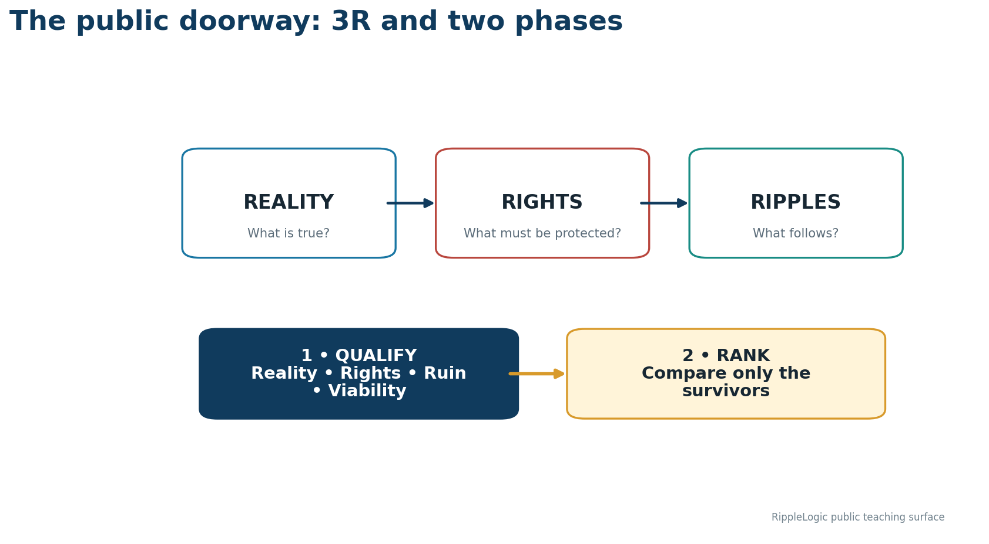
Figure 6. RippleLogic's Five-Level Cascade with the Reopening Rule. Reality Grounding establishes claim authority; RF/NCRC protects rights; TRC bounds ruin; CSV verifies viability; RLS ranks only survivors. A newly discovered ruin path reopens TRC before ranking.
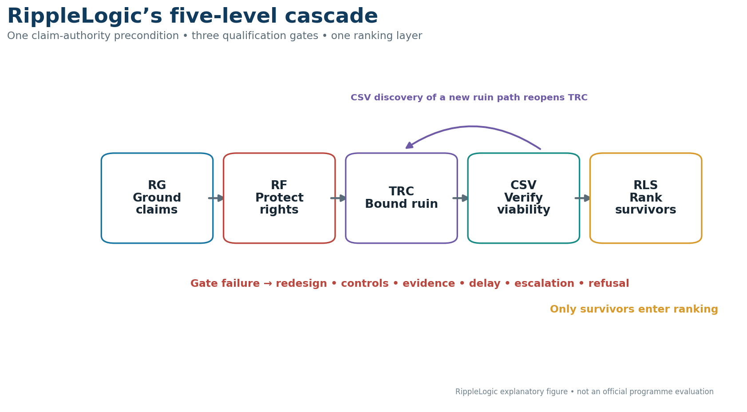
Table 1. RippleLogic Public Cascade. QUALIFY establishes the admissible and selectable set through RG, RF/NCRC, TRC, and CSV; RANK compares only the survivors through RLS.
1. Ground | 2. Protect | 3. Bound | 4. Contain / Verify | 5. Score
RG / Reality Grounding | RF/NCRC / Rights Floor | TRC / Tail-Risk Constraint | CSV / Containment and Structural Viability | RLS / RippleLogic Score
What is known, unknown, assumed, measured, inferred, generated, or merely claimed? | Does the option violate basic rights, dignity, or non-compensatory protection? | Is a catastrophe or ruin-relevant pathway triggered, and is its exposure sufficiently bounded? | Can the option stand without degrading the system that must remain viable? | Rank only the surviving options across active scopes and dimensions.
Protect first. Compare later. Redesign before you justify.
Reality Grounding asks what is actually known, unknown, assumed, inferred, generated, inherited, or merely claimed. It prevents eloquence, dashboards, compliance labels, and institutional permission from being mistaken for reality.
The Rights Floor asks whether a basic protection is being crossed. TRC asks whether the worst-case corridor contains ruin or severe irreversible harm. CSV asks whether the option can stand structurally: whether harms are contained, dependencies and resources close, controls are real, the transition is supported, the resulting state remains viable, and future safe options are not needlessly destroyed. No pass-equivalent CSV means no ordinary RLS ranking claim: RLS compares only the remaining options.
Qualification belongs to the option you actually assessed. A material change in evidence, conditions or controls means reopening the affected checks before relying on the earlier conclusion.
A quick CSV example helps. A company may cut training or maintenance to improve quarterly performance. No basic right is obviously crossed, and no catastrophe arrives tomorrow. Yet the local gain weakens staff capability, resilience, trust, and future performance. That is a CSV problem: the option works only by quietly degrading the larger system that has to stay healthy.
Ripple scoring begins only after the earlier levels are satisfied. Its job is narrower, but still difficult: across the active scopes and dimensions, is this option improving the residual ripple field or quietly degrading it?
That is why RippleLogic asks about direction, not just intention. Most people do not wake up trying to harm anyone. Damage usually comes from partial awareness, short time horizons, narrow stakeholder framing, incentives that reward extraction, and structures that hide where the bill lands. Ripple scoring helps make that hidden bill visible before it becomes collapse.

A Worked Example You Can Use Now
Imagine a higher-paying job that improves income but adds travel, longer hours, and less time at home. RippleLogic asks you to run it in order, not by instinct alone.
Reality Grounding: The higher pay, travel expectations, working hours, and contractual conditions may be known or directly evidenced. Effects on stress, health, household adaptation, and long-term meaning are forecasts and should remain explicitly uncertain until observed.
Rights Floor: no supported violation is established on the current facts. TRC: no formal catastrophe, systemic lock-in, or declared ruin-path trigger is identified in this ordinary personal case. Burnout, household fracture, and sustained health damage may still raise RF/NCRC, CSV, and residual-welfare concerns. CSV asks whether a gain for Self and Organization is being purchased by degrading Household or long-term health beyond what the wider system can absorb.
Active scopes: Self, Household, Organization, Community, and possibly Biosphere if travel materially changes consumption and emissions. Active dimensions: Material, Health, Social, Agency, Meaning, and Environment. Ripple estimate: more money may improve Material stability while reducing Health, Social trust at home, and Agency if the schedule becomes controlling.
Then comes the most important move: redesign before you justify. Can the job be negotiated into hybrid work, a shorter review period, protected family time, or compensation structures that reduce hidden cost? The method is doing its job when an apparently obvious win becomes a cleaner, more honest decision.
The fuller template appears in Chapter 11. The point here is to let you feel the method working before you reach the integration chapter.

The Lesson I Learned Too Late
I learned RippleLogic through failure, not insight.
Early in my career, I made a decision that seemed obviously right. The benefits were clear, the logic was sound, and everyone around me agreed it was the smart move.
I was managing operations and we needed to cut costs. One of our suppliers had been with us for years. A small family operation that had grown alongside us. They were reliable. They cared about quality. They knew our systems.
But they were not the cheapest option anymore.
A larger supplier offered the same materials at twenty percent less. The math was obvious. The spreadsheet was clean. My manager praised the efficiency. I felt like I was doing my job well.
What I did not see was the ripple I was creating three steps downstream.
That family supplier lost our contract. We were forty percent of their business. Within eight months, they had to let go of half their staff. Their town, a small community that depended on that business for stability, absorbed the cost of my efficiency.
I never visited that town. I never met those workers. Their names never appeared in my calculations. Their faces never entered my awareness.
But they paid the price of my cleverness.
I found out later, almost by accident, through a mutual contact who mentioned what had happened. The owner of that company had a heart attack six months after losing our contract. His wife blamed the stress. I will never know if that was true. But I will never forget the feeling when I heard it.
Reality Grounding Note: What I Know, What I Was Told, and What I Cannot Prove
Directly observed or recorded: the longstanding supplier relationship, its reliability and quality, the competing price, and the decision to move the contract.
Reported later through a mutual contact: the contract’s share of the supplier’s business, the layoffs and community strain, the owner’s heart attack, and his wife’s belief that stress contributed.
Inference: the original decision excluded people, dependencies, and burden pathways that were ethically material.
Unknown: the complete downstream chain and any causal connection between the contract loss and the heart attack.
Claim boundary: the events may be temporally associated, but I did not independently verify every downstream fact and cannot attribute the medical event to this decision. The ethical lesson does not require causal certainty: material stakeholders and uncertainties were missing from the original analysis.
That was when I realized something that changed how I make decisions:
Good intentions without ripple awareness are still a form of sophisticated blindness.
You can be smart, sincere, and successful, and still leave a trail of harm you never see.
The spreadsheet showed profit.
The union map would have made the missing stakeholders and burden pathways visible.
The full RippleLogic method exists to make that trail visible before you create it.

What a Ripple Is
A ripple is the consequence trail of a choice. Some ripples are immediate, like tension after a harsh word. Some are slow, like the health cost of a repeated habit. Some arrive across generations, like climate effects locked in by policy or industry. Different time scales, same pattern: a decision changes the environment, and the environment pushes back.
A fluent story about a ripple is not the ripple itself. A dashboard, model output, or generated explanation can help us see, but it can also seduce us into false certainty. Reality Grounding asks whether the claimed ripple is actually supported by evidence, not merely by coherence.
Ripple mapping exists so you start paying attention before that pushback becomes collapse.

The Core Rule
Residual ripple scoring begins with one rule:
Every choice has consequences and opportunity costs. Many choices create both benefits and burdens, and RippleLogic searches for those burdens rather than assuming them away.
Most systems train you to count the benefits and externalize the costs.
RippleLogic trains you to count both, then choose with open eyes.
This is where the framework becomes unmistakably real.
Because it stops being “values talk,” and becomes:
Impact tracking.
Trade-off honesty.
Consequence awareness.
Rights-protected optimization.

Ground First, Then Protect the Floor
Before you ever score benefits, you apply the constraint.
The rights floor is not a score, and it is not the only gate.
It is the first hard option-filtering gate after Reality Grounding.
It answers one question first:
Does this choice violate anyone’s basic rights or dignity at any union layer?
If yes, that option fails the Rights Floor for the declared run.
No amount of benefit elsewhere can compensate.
That is what prevents “maximize total good” from becoming sacrifice logic.
Without a rights floor, ripple scoring can become a weapon. You could justify any harm by pointing to larger benefits elsewhere. History is full of atrocities committed in the name of the greater good.
With a rights floor, ripple scoring becomes a compass. It guides you toward better outcomes while maintaining inviolable constraints.
So the public order is always:
Ground first. Then rights. Then catastrophic downside. Then containment. Then welfare ranking.
This sequence is non-negotiable. We will explore the Rights Floor fully in Chapter 7 and then return to residual weighting in Chapter 8. For now, understand that qualification comes before compensatory trade-offs and residual scoring, while Reality Grounding remains the first claim-authority step.

Ripple Direction in Plain Language
When people hear “scoring,” they sometimes assume it is cold or reductive.
That is not what this is.
Ripple scoring is not meant to replace wisdom.
It is meant to prevent self-deception.
When you cannot responsibly estimate an important effect, name the uncertainty. A rough number is not more honest than a clear unknown.
And when the missing evidence could conceal serious harm to others, narrow the action, gather evidence or seek review rather than borrowing confidence from a score.
Residual ripple scoring gives you a structured way to estimate impact well enough to steer.
Not perfectly.
Just responsibly.
A ripple score answers:
What is the net direction of this choice across the unions that matter?
For intuitive practice, this book uses illustrative judgments from minus 100 to plus 100. The descriptions below are teaching anchors, not measurements or a completed Canon calculation. Keep them distinct from the formal display convention explained after the scale:
+100 marks an exceptionally strong positive profile in this teaching exercise. It is not a green light: qualification, uncertainty, responsible choice and execution conditions still matter.
+50 marks a clearly positive teaching profile with bounded residual trade-offs. It is not a percentage of safety or ethical correctness.
At the level of an assessed effect, 0 means no material change relative to its declared baseline and measurement resolution. At the level of a net cell or total score, 0 can also result from gains and losses canceling. Keep those gains, losses and affected groups visible. Neither kind of zero means unknown: missing or inadequate evidence remains explicitly uncertain.
minus 50 marks a clearly negative teaching profile: the disclosed residual burdens outweigh the benefits under the stated priorities.
minus 100 marks an exceptionally severe negative teaching profile. Recheck the evidence and qualification: the number is not itself a rights-floor verdict.
Formal interfaces may display cell impacts as points = 100 × I and a total index as 100 × RLS. Those are exact rescalings, not percentages of alignment or welfare. Gate and score calculations use the canonical normalized scale, with exact conversion back when necessary. An informal teaching judgment does not become a warranted formal impact merely by dividing it by 100.
Low confidence does not make a possible serious harm unimportant. Preserve the uncertainty and test adverse interpretations; weak evidence must not become a quiet pass. Appendix I gives the formal uncertainty discipline.
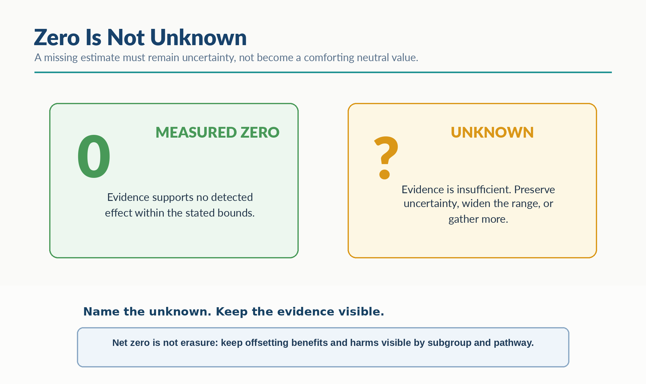
Visual Interlude - Zero Is Not Unknown

The Seven Welfare Dimensions
A ripple score should not be an unstructured guess.
It is an estimate across specific dimensions of wellbeing.
The operational scopes show you where consequences land.
The Seven Welfare Dimensions show you what is affected.
These dimensions cover the core terrain of lived reality without turning the model into a thousand variables.
Material
Resources, income, shelter, food security, economic stability. This is the foundation layer. Can people meet their basic needs? Can they plan for the future? Is their physical security intact?
When a decision improves Material, people have more capacity to survive and build. When it degrades Material, survival stress increases and options narrow.
Health
Physical health, mental health, safety, recovery capacity. This includes both the absence of disease and the presence of vitality. It includes psychological stability, not just biological functioning.
When a decision improves Health, people can function, think clearly, and sustain effort. When it degrades Health, everything else becomes harder.
Social
Trust, relationships, belonging, cooperation. Humans are not isolated units. We exist inside webs of connection. Our wellbeing depends on the quality of those webs.
When a decision improves Social, cooperation becomes easier and relationships strengthen. When it degrades Social, isolation increases and collective action becomes harder.
Knowledge
Education, truth access, information integrity, understanding. This is about the quality of what people know and their capacity to learn. It includes resistance to deception and manipulation.
When a decision improves Knowledge, people can make better choices and adapt to change. When it degrades Knowledge, confusion spreads and manipulation becomes easier.
Agency
Freedom to choose, autonomy, options, real power to act. This is about whether people can actually shape their own lives or whether they are trapped by circumstances, coercion, or lack of alternatives.
When a decision improves Agency, people gain the ability to direct their own futures. When it degrades Agency, people become more dependent, controlled, or helpless.
Meaning
Purpose, dignity, inner coherence, spiritual alignment. This is the dimension most often ignored by economic models. But humans do not live by bread alone. We need to know that our lives matter.
When a decision improves Meaning, people feel that their existence has purpose and their efforts connect to something real. When it degrades Meaning, emptiness and despair increase even when material conditions are adequate.
Environment
Local surroundings and ecological conditions: habitability, pollution, regeneration and environmental integrity. The construct depends on the scope and the actual bearer or system. A household’s living conditions and Earth’s integrated life-support systems are related, but they are not interchangeable copies of one effect.
When a decision improves Environment, life-support systems strengthen and future capacity increases. When it degrades Environment, the foundation beneath all other dimensions erodes.

How Unions and Dimensions Work Together
When you build a residual ripple profile, you are not scoring “goodness” in the abstract.
You are estimating the direction of change across these dimensions for each affected scope, using declared evidence, assumptions, weights, and uncertainty.
Think of it as a grid, a living 49-cell map formed by seven operational scopes crossing seven welfare dimensions.
On one axis, you have the seven operational scopes: Self, Household, Community, Organization, Polity, Humanity / Global Coordination, and Biosphere. Cosmic and Universal / AIU remain horizon layers, not default rows in ordinary computation.
On the other axis, you have the Seven Dimensions: Material, Health, Social, Knowledge, Agency, Meaning, Environment.
A decision may have distinct consequences in several cells, but one consequence must not gain extra value merely by appearing in several views. The same pay increase, for example, is not new money each time it is shown under Self and Household. Give that effect one primary computational home, or allocate a genuinely conserved amount without duplication. Separately evidenced downstream effects, such as improved housing security, need their own explanation rather than another copy of the income.
Figure 7. Ripple Grid Example. A schematic mapping exercise, not measured data or a complete run. POS and NEG identify direction, UNK preserves uncertainty, and NM means a justified non-materiality finding. Repeated views must not duplicate one effect.
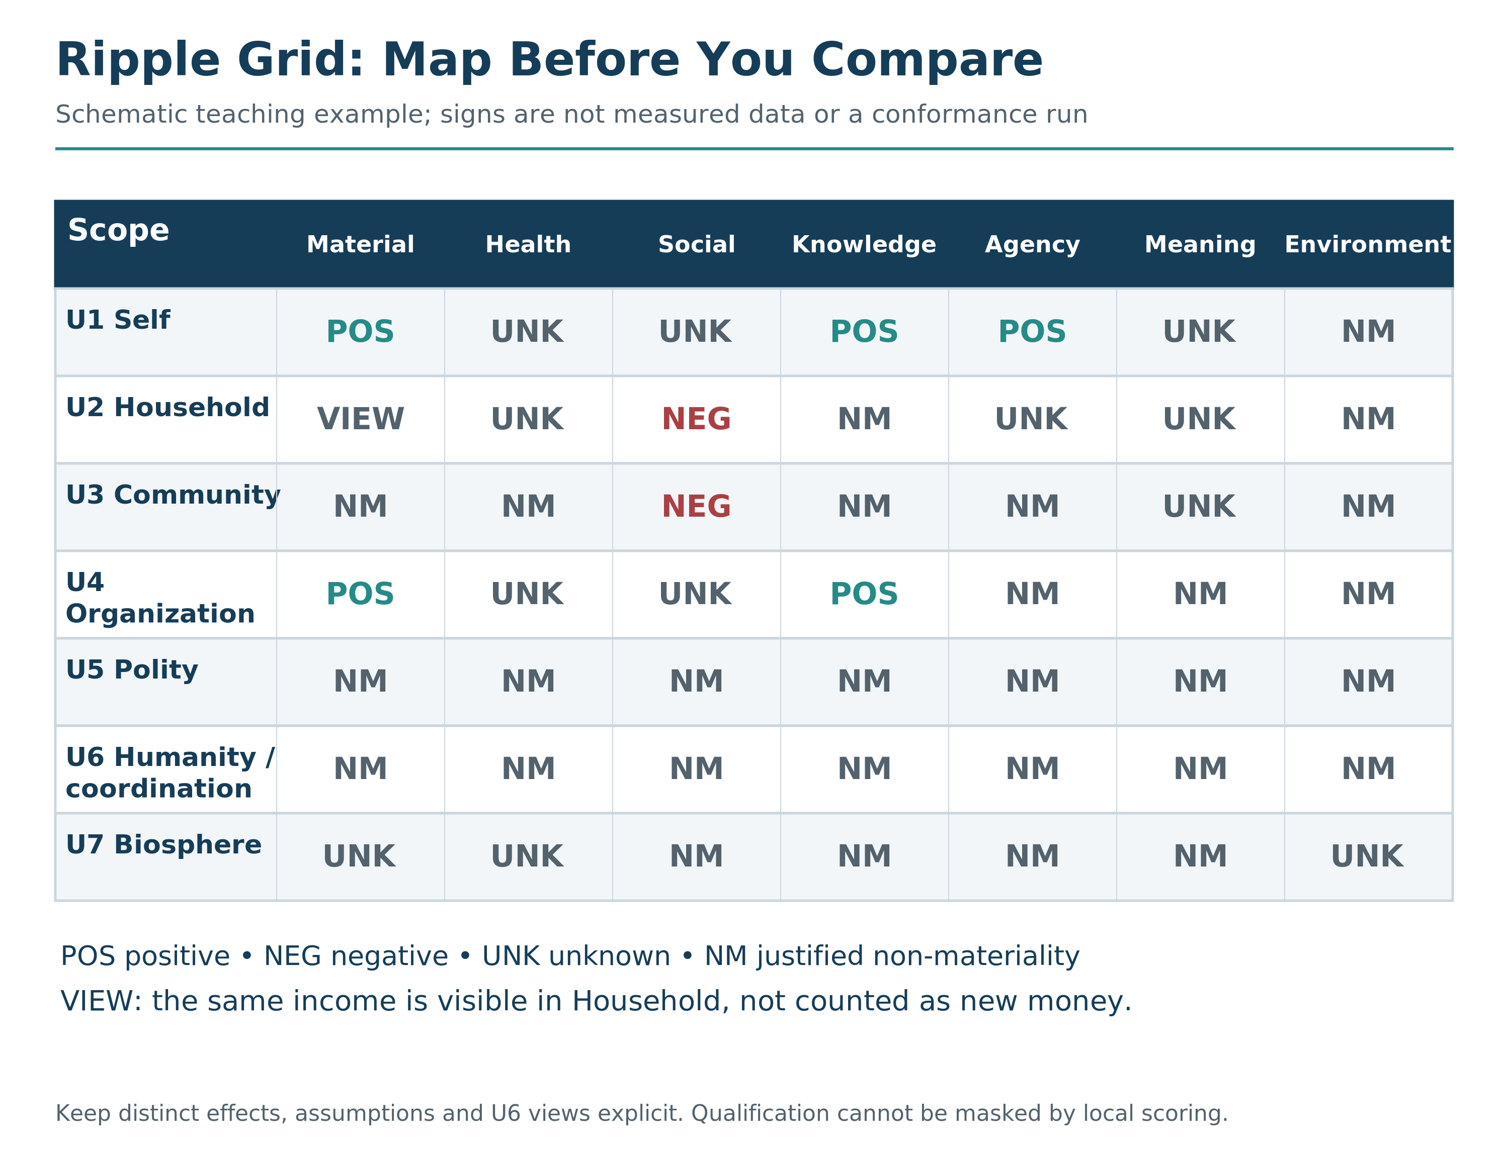

Unions tell you who is affected.
Dimensions tell you what is affected.
The rights floor tells you where you cannot go.
The score estimates the modeled residual direction under the declared evidence, assumptions, weights, and uncertainty.
Sometimes a decision improves one dimension while degrading another.
A new job might improve Material while degrading Health and Social.
That is not failure.
That is reality.
Residual scoring does not pretend trade-offs do not exist.
It forces you to see them clearly.
Then it pushes you toward redesign.

The Three Ripple Traps
After years of practicing this framework, I have noticed three patterns that catch people most often.
The Local Win Trap
A decision that benefits Self or Organization while quietly harming Community or Biosphere.
This is one of the most common patterns in modern life.
Material improves for one layer, while Health, Social, or Environment degrades elsewhere. The gains are visible and celebrated. The costs are invisible and ignored.
My supplier decision was a textbook Local Win Trap. The organization won. The distant community lost. And because the loss was invisible to me, I called it a good decision.
The Local Win Trap is seductive because the benefits are real. You are not imagining the gain. You are just not seeing the full cost.
The Time Horizon Trap
A decision that looks good today but creates a future debt.
Short-term optimization is a common failure mode of immature governance.
The present scores positive. The future scores negative. But the future is not in the room when the decision is made.
I watched a colleague take on a project that would have destroyed his health. The short-term payoff was enormous. The promotion was almost guaranteed. But the pace was unsustainable.
I asked him what his life would look like in five years if he kept going at that rate. He paused. He had not thought about it. The present was so loud that the future was silent.
He took the project anyway. Two years later, his marriage was struggling and his doctor had serious concerns. The promotion came. The cost was higher than the spreadsheet showed.
Mature intelligence asks: What does this look like in ten years? In fifty?
The Invisible Stakeholder Trap
A decision that harms stakeholders who cannot speak, vote, sue, or resist.
Future generations are the classic example. They will inherit the consequences of our choices but have no voice in making them.
So are ecosystems. Forests do not lobby. Oceans do not vote. Species do not file lawsuits.
So are distant labor networks. The workers who make the products you buy may live in conditions you would never accept for yourself, but you never see them.
So are non-human animals for whom there is credible sentience-relevant evidence, whose welfare is often omitted from ordinary decision models.
So are digitally mediated communities that get manipulated while thinking they are choosing freely.
These stakeholders have no voice in your calculation unless you deliberately include them.
The wider RippleLogic scan forces you to notice who cannot adequately defend their interests.
That is where ethics becomes real.
As a diagnostic heuristic, many harmful systems hide or discount at least one affected union. Empire hid the colonized. Extraction hides the worker, the river, the animal, the child, the future. To govern ethically is to bring the hidden union back into the field of consequence.

The Relocation Map in One View
Figure 8. Worked Ripple Table. The job-offer example identifies affected scopes, welfare dimensions, likely ripple direction, uncertainty, and redesign possibilities before final comparison.
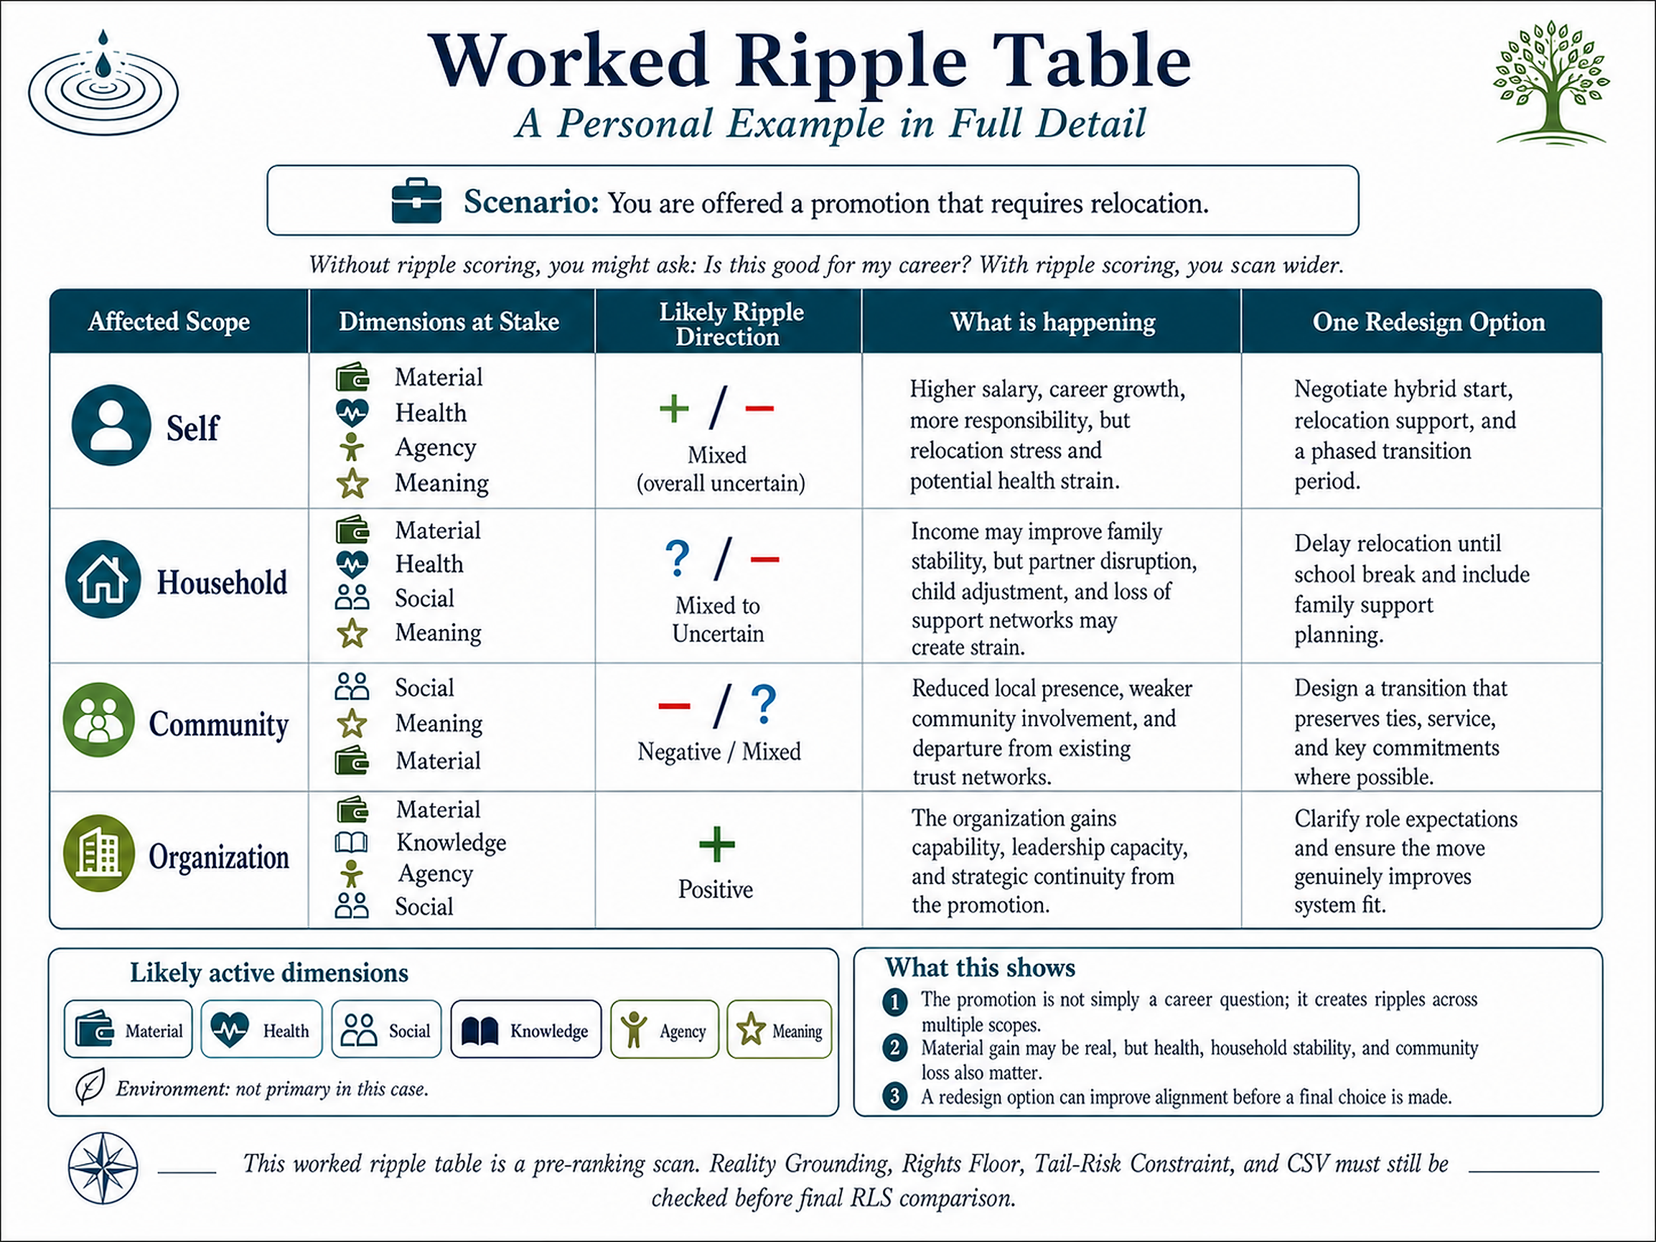

Return to the promotion example. The table separates what might change for the person, the household, the communities involved and the organization. Higher income is one monetary gain even when both Self and Household can see it; a separately evidenced improvement in housing security would be a different consequence.
The difficult questions are not just financial. Would the move disrupt care, undermine a partner’s genuine choice, or leave children’s needs unexamined? A disruption is not automatically a rights violation, but it deserves evidence and a careful protection review. Serious risks and long-run viability still need their own checks.
A forecast about health, relationships or meaning is not a fact about what will happen. Keep uncertainty visible. Do not attach an attractive number to a move whose qualification remains unresolved.
The map can also reveal a redesign: remote days, a delayed move, less travel, a trial period or another opportunity. Recheck any changed option before comparing it. Chapter 11 carries the job decision through the complete template.

Clean Choices vs Convenient Choices
A clean choice is not always easy. It is one made with the stakeholders visible, the main dimensions named, the floor protected, the ruin corridor checked, structural viability preserved, and the residual trade-offs faced honestly. A convenient choice hides costs, counts only what benefits the chooser, and calls harm necessary because the burden landed somewhere else. The full method makes that self-deception harder.

The Two-Minute Ripple Scan
You do not need a spreadsheet for every grocery decision.
RippleLogic is scalable.
Sometimes it is a two-minute scan.
Sometimes it is a governance-grade analysis.
But the structure stays the same:
Name the decision clearly. Not “be healthier.” Instead: “Stop drinking soda at night.” Specificity reveals real trade-offs. Ask whether the reality is clear enough for this choice, or whether you are acting from story, pressure, or missing evidence.
Then check the floor. Does any option violate a protected right or dignity condition under the declared run? If yes, remove, redesign, escalate, or refuse that option as required.
Select the key scopes affected. Not every case needs equal attention across all seven operational scopes, but none of the wider layers simply disappear.
Select the top dimensions at stake. Material? Health? Social? Knowledge? Agency? Meaning? Environment? Focus on where real change is happening.
List the benefits and costs honestly. Do not moralize. Just list. Benefits for whom? Costs for whom? Short-term versus long-term?
Before estimating residual direction, screen for catastrophic or ruin-relevant pathways and for whether the option can stand under its real resources, dependencies and controls. In a low-stakes case this can be brief, but it cannot be silently omitted. Then compare the qualified options. Preserve material uncertainty rather than turning it into zero; gather evidence, narrow, redesign or postpone a stronger claim when needed.
Redesign if needed. Is there a third option that reduces the trade-off? Can you expand the option set?
That is enough to begin changing a life.
Because small ripples repeated daily become character.
And character, scaled across decisions, becomes the shape of your world.

Why This Is a Skill, Not a One-Time Insight
You will not estimate every ripple perfectly. The point is not false precision. It is disciplined practice. Ripple mapping and residual scoring sit inside the NCAR loop: notice, choose, act, reflect, and update. Over time, the formal process trains perception. What begins as method can become clearer, more accountable judgment.
Reader Compass Kit
Three Reflection Questions
What decision do you repeat that feels good now, but harms you or others later? Which dimensions are being sacrificed for which others?
Which union do you most often ignore, and what dimension pays the cost?
Choose one recurring decision in your life. Where do its benefits and burdens land, what remains uncertain, and what small redesign would improve it?
NCAR Micro-Exercise (2 minutes)
Notice: Name one choice you made in the last 24 hours.
Choose: Which union did you optimize for? Which union did you ignore? Which welfare dimension was most affected?
Act: Take one small step today to reduce harm or increase benefit in the ignored union. Even acknowledging the cost counts as a step.
Reflect: What made that union easy to overlook? What would help you see it sooner next time?
What’s Coming Next
In Chapter 7, we go deeper before we rank:
Rights and ruin must be qualified before trade-offs are scored.
Chapter 7 establishes what cannot be bought away: protected rights and unacceptable ruin. Chapter 8 then returns to the genuine trade-offs that remain among qualified survivors and adds the steering wheel: weighting and residual comparison.

Chapter 7: The Rights Floor and the Ruin Corridor
This is the chapter where RippleLogic becomes hardest to misuse. If someone understands only one part of the framework, I would rather they understand this one: some things are not tradable. The rights floor cannot be purchased, suspended, or negotiated away for convenience. The Non-Compensatory Rights Constraint blocks sacrifice logic inside a declared run. Once thresholds are declared for that run, they may not be lowered because the outcome becomes inconvenient; the thresholds themselves must remain explicit, challengeable, versioned, justified, and revisable only through a governed process.

The Pattern We Keep Repeating
I used to think history’s worst decisions came mainly from obvious monsters. Then I studied more carefully and found something more disturbing: many atrocities were committed by people who believed they were being responsible. Colonial administrators justified extraction as civilization. Factory owners justified child labor as economic necessity. Authoritarian leaders justified repression as stability. In each case, the structure was the same: the harm was acknowledged, the benefit was emphasized, and the harm was renamed “necessary.”
I saw the same pattern later in organizations, even at smaller scale. Teams were burned out to meet deadlines. Vendors were squeezed to improve margins. Community concerns were dismissed so projects could proceed. The justifications were familiar: revenue, competition, shareholder pressure, development. Each time, the claimed benefit was used to make the injury sound reasonable. Each time, the people with the least power carried the cost.
This is sacrifice logic when a protected violation is treated as a price someone else may pay for a larger gain. It can arrive with numbers, charts and a vocabulary of responsibility. Ordinary residual burdens remain open to comparison after qualification; a protected floor does not.

What NCRC Actually Means
The Non-Compensatory Rights Constraint means that a supported rights-floor violation cannot be offset by benefits elsewhere. In many decision systems, harms are traded against gains somewhere else. NCRC blocks that move for governed protected rights. Some costs may not be paid with someone else’s core protections.
In one sentence: you cannot buy your way out of violating a person’s fundamental protections, no matter how attractive the downstream benefit looks.
That is why the floor matters. Sacrifice logic is seductive because it lets people feel responsible while causing harm. The rights floor exists to block that move before optimization begins. Figure 9 makes the non-compensation rule visible: aggregate benefit does not buy entry into ranking for an option that fails the floor.
Figure 9. Rights Floors Change the Mathematics of Choice. Illustrative benefit and rights-channel values are separate diagnostics, not a common welfare currency. Failure on the depicted rights channel blocks entry to ranking; passing this one channel does not establish complete qualification.
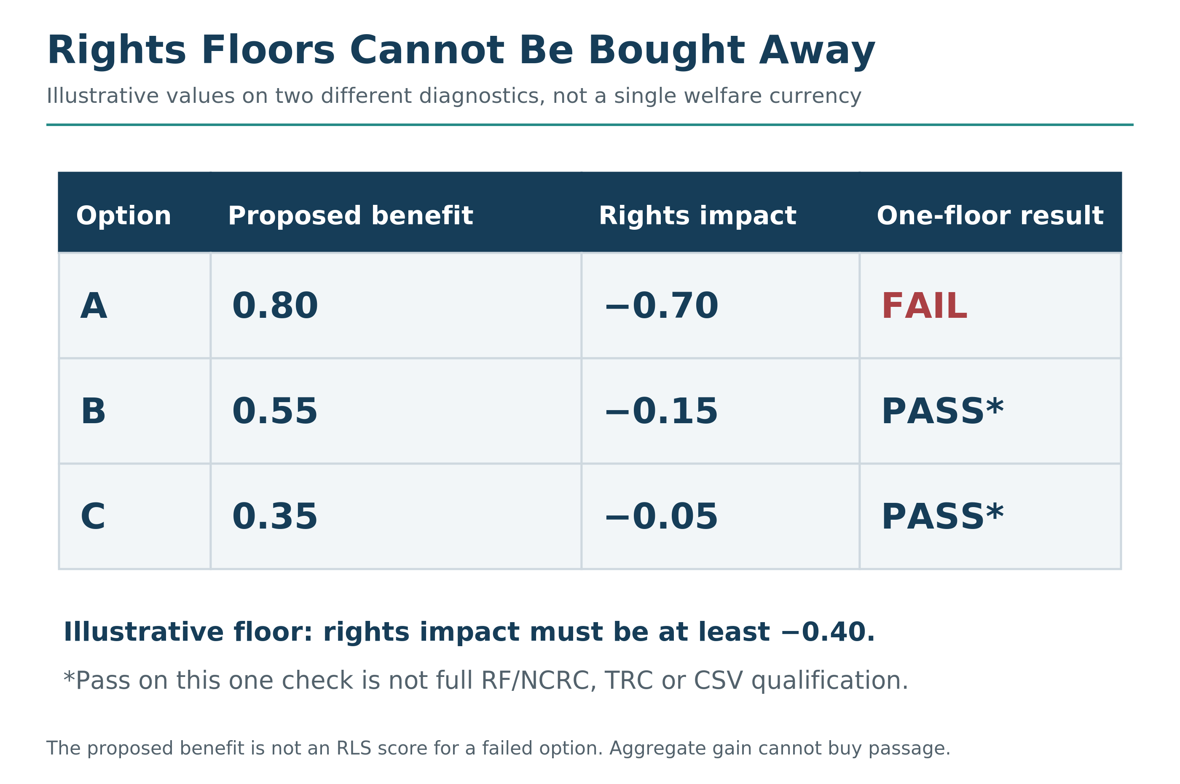

The Floor Across Scopes and Stakeholders
The Rights Floor protects rights-covered stakeholders and enabling conditions across the relevant operational scopes. Which protections apply must be stated explicitly, with worst-affected groups examined and SGP used when moral-status evidence is material or uncertain. The prompts below are scope-level warning lenses, not additional rights definitions. Cosmic and Universal / AIU remain horizon considerations rather than ordinary rights-floor rows.
No rights-covered stakeholder or enabling condition may be treated as disposable fuel for another scope’s benefit below the governed floor.
Self: Severe damage to your own health, integrity, or future capacity remains part of the analysis; self-choice does not make those effects invisible.
Household: Do not use household stability or another member’s dignity as an invisible subsidy for a gain elsewhere.
Community: Do not treat communities as externality sinks for organizational convenience.
Organization: Do not design systems that treat people as disposable instruments.
Polity: Do not purchase advantage by eroding rights protection, civic integrity, or public accountability.
Humanity / Global Coordination: Do not treat tribal, national, or institutional advantage as sufficient when an option materially worsens human survival, shared reality, or the coordination systems needed to manage global risk. The Humanity view includes all affected humans and future human populations; the CMIU view concerns managing intelligences and institutions. The views overlap but are not identical.
Biosphere: Do not treat degradation of life-support systems as an externality merely because a local benefit is immediate.
Cosmic: Do not export extraction, debris, coercion, or conflict into space as though a new frontier resets ethics. Harms exported there do not leave the moral map; they can return through Humanity, the Biosphere, and future polities.
Universal / AIU is not a scoring row or ordinary rights-floor object. It reminds us not to mistake partial knowledge for final knowledge when stakes are irreversible.

The Eight Canonical Rights Floors
What exactly does the floor protect?
Across the operational architecture, eight canonical rights form the current foundation:
Life. The conditions necessary for continued existence.
Bodily Integrity. Protection against violence, abuse, and non-consensual physical harm.
Liberty. Protection against coercion, domination, and unjust confinement.
Basic Needs. Access to the minimum material conditions required for dignified participation in life.
Dignity. Protection against humiliation, dehumanization, disposability, and systematic disregard.
Due Process. Protection against arbitrary punishment, opaque procedure, and unchallengeable power.
Information. Protection against deception, manufactured ignorance, and large-scale manipulative distortion of reality.
Ecological Integrity. A non-compensatory enabling-condition protection for biosphere integrity and life-supporting ecological conditions. It does not, by itself, claim that the biosphere is sentient, a person-equivalent rights-holder, or universally recognized as a legal person.
These are not weights. They are floors.
A decision can improve many things and still fail if it crosses one of them below threshold.
That is what non-compensatory means.
The math does not save you.

Rights Signals Across the Seven Welfare Dimensions
Rights-relevant effects can appear across the seven welfare dimensions, but the dimensions are not additional Rights Floors.
Formal NCRC evaluation uses the Canon's governed rights-coverage sets and any explicitly approved extension. A welfare-dimensional harm may signal a possible floor concern and trigger evidence, remapping, or coverage review; it does not silently become a canonical NCRC cell. The examples below are diagnostic pathways, not seven extra floors:
Material: Denying basic resources necessary for survival can indicate a Basic Needs, Life, Dignity, or related floor concern. Record the evidence and route the effect through the governed rights coverage before assigning NCRC status.
Health: Imposed physical or psychological harm without consent or recourse can indicate Bodily Integrity, Life, Dignity, or related floor concerns. Health is a welfare dimension and evidence pathway, not a ninth canonical floor.
Social: Deception, coercive isolation, or systematic relational harm can indicate Dignity, Liberty, Due Process, or other rights concerns. The social effect triggers classification and evidence review rather than automatic NCRC failure by dimension alone.
Knowledge: Restricting truth access or information integrity in ways that disable informed choice can indicate Information, Liberty, Due Process, or related floor concerns. Route the claim through the governed coverage and supporting evidence.
Agency: Coercion or engineered loss of meaningful choice can indicate Liberty, Dignity, Due Process, or related floor concerns. The dimension helps expose the pathway; NCRC determines the formal floor status.
Meaning: Systematic degradation of identity, dignity, or purpose can signal a Dignity or related rights concern. Meaning is not itself a canonical floor; it is an interpretive and evidentiary pathway.
Environment: Ecological damage that undermines life-support conditions can indicate Ecological Integrity, Life, Basic Needs, or related floor concerns. Formal status follows the governed rights coverage and evidence, not the dimension label alone.
This is also where the other gates come back into view. An option may clear the Rights Floor and still fail because its downside is too catastrophic or because its gains come from degrading a larger system that must remain viable. The floor is the first option-filtering gate after Reality Grounding, not the whole method; TRC and CSV protect against harms that are not identical to rights violations but are still unacceptable.

Pain vs Violation
Not all discomfort is a rights violation.
This distinction matters.
A difficult conversation may cause pain while improving Knowledge and Agency. But honesty alone does not make humiliation, coercion or reckless disclosure acceptable. Examine the manner, context and protected interests.
A justified boundary may restrict a preferred action while protecting others. Whether it respects rights depends on its purpose, proportionality, process and effects, not on the word “boundary.”
A loss of profit is not by itself a rights violation. The relevant questions concern the process, protected interests, distributional burden and available remedy, not whether someone dislikes the outcome.
A medically warranted intervention can impose pain while aiming to restore health. That does not remove the need for valid consent or an applicable emergency basis, qualified clinical judgment and the relevant safeguards. The example is a distinction between discomfort and violation, not a treatment recommendation.
The floor is not about preventing all pain.
It is about preventing governed rights-floor harms to dignity, survival, liberty, bodily integrity, basic needs, due process, information, or ecological integrity that treat protected stakeholders as disposable inputs.
The test:
Is the pain a consequence of honest engagement with reality, or is it imposed by treating someone’s rights as less important than someone else’s benefit?
Growth often hurts.
A rights violation degrades what the floor exists to protect.

The Four Red Flags of Sacrifice Logic
Sacrifice logic rarely announces itself.
It hides inside reasonable-sounding language.
These four phrases are warning signals:
“They don’t really count.”
When a union is redefined as less worthy of consideration, when stakeholders are made invisible or their interests dismissed, watch carefully.
The floor is being prepared for violation.
I have heard this in corporate settings. “Those are just contractors.” “That community was going to decline anyway.” “Future generations will figure it out.” “Those workers chose their jobs.”
Once someone is defined out of consideration, treating their burdens as expendable becomes much easier.
“It’s necessary.”
Necessity language often signals that alternatives have stopped being explored.
The word “necessary” can become shorthand for “convenient for those with power.”
Real constraints exist. But “necessary” is often a disguise for “we chose not to look for another way.”
When I hear “it’s necessary,” I ask: Necessary for whom? Who decided to stop looking for alternatives? What would we have to give up to find another path?
Often the answer reveals that “necessary” means “we prefer not to sacrifice our own convenience.”
“It’s only temporary.”
Temporary rights restrictions can harden into durable arrangements when sunset, review, remedy, and return-to-normal conditions are weak.
Institutions can develop incentives to preserve arrangements that benefit incumbents, even when those arrangements were introduced as temporary.
A promised future repair can drift unless the decision contains a real deadline, accountable owner, review trigger, and remedy path.
History supplies many cases in which emergency powers, temporary labor arrangements, or transitional environmental exceptions persisted beyond the conditions used to justify them. The risk is not inevitability; it is institutional lock-in when the exception lacks binding exit conditions.
When rights are violated “temporarily,” watch the clock. If the violation is still happening years later, the temporary justification has failed and the exception may have hardened into durable harm.
“The benefits outweigh the costs.”
This is a common phrase in compensatory reasoning.
When you hear it applied to rights, the floor is about to be crossed.
Benefits cannot outweigh violations.
That is what non-compensatory means.
You can say “the benefits outweigh the costs” about trade-offs above the floor. That is what Chapter 8’s weighting is for. When choosing between options that survive qualification, you can and should compare residual benefits and costs.
You cannot say it about rights.
When a governed dignity floor would be crossed, residual benefit does not buy passage.
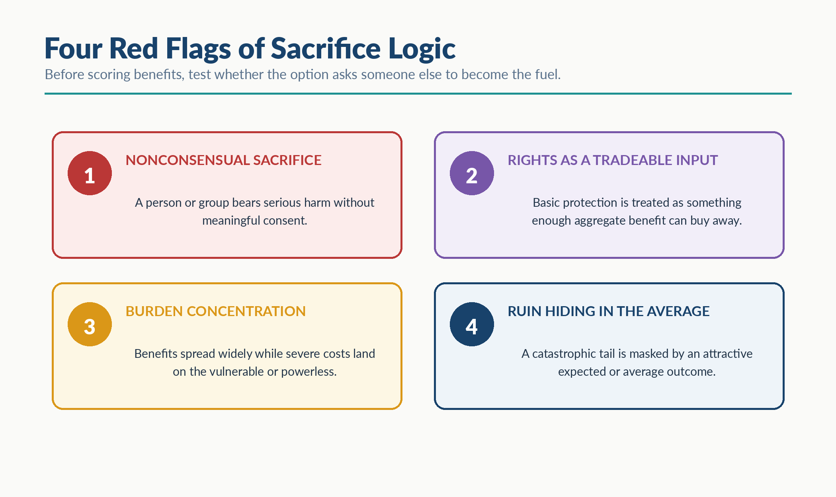
Visual Interlude - Four Red Flags of Sacrifice Logic

The No-Escape Question
When facing a decision, one question cuts through rationalization:
Would you accept this outcome if you were the one receiving it, with no power to escape?
A no is a reason to look harder, not a rights verdict. It may reveal coercion, a protected harm, an unfair process or a structural problem; it may also describe a painful but rights-respecting loss.
Pause, ground the harm, classify it carefully, and redesign before proceeding.
The question does not replace evidence or the declared rights criteria.
It asks whether the people carrying the burden have been seen, heard and protected.
When I think about the supplier decision, I ask whether I would have accepted those reported losses without anyone examining my family’s stability, my employees’ jobs or my community’s dependence on the business.
My answer is no.
That does not prove the rights floor was crossed or approached. It shows why I needed to look beyond the saving and examine the people and uncertainties I had left out.

When the Floor Feels Inconvenient
The rights floor is not designed to feel convenient.
It is designed to prevent protected rights from being traded away. TRC separately asks whether catastrophic or irreversible ruin is acceptably bounded.
There will be moments when crossing the floor would be faster.
When violating rights would be more profitable.
When ignoring the constraint would let you win the argument, close the deal, or achieve the goal.
In those moments, the floor does its actual work.
Keeping rights under pressure is what makes them real.
Anyone can respect rights when it costs nothing.
The floor only means something when it constrains behavior that would otherwise succeed.
A system that treats rights as optional whenever pressure rises does not have a reliable rights floor.
Genuine emergencies require explicit provisional procedures, minimized infringement, oversight, remedy, and a return-to-normal path; they are not silent suspensions of the floor.

The Floor Does Not Mean No Trade-Offs
Above the floor, trade-offs remain.
You can choose to prioritize Self over Organization in this season.
You can weight Material gains higher than Meaning for a specific decision.
You can accept short-term Social costs for long-term Community benefit.
These are legitimate trade-offs, and Chapter 8’s weighting methods help navigate them.
But trade-offs occur above the floor.
In ordinary selection, no trade-off may buy through a supported core-rights violation.
The difference in practice:
Accepting a demanding job that strains Household time is a trade-off. Both unions receive consideration. You are weighing real interests against each other. Neither is being sacrificed.
Accepting a job that requires deception or community harms that cross a protected rights threshold is a floor violation. Personal benefit does not compensate for that breach.
A nonprofit reducing staff benefits to expand programs is a trade-off. Real interests are being weighed. The goal is to find the best balance.
A nonprofit burning out staff to the point of serious health damage may cross protected Bodily Integrity, Basic Needs, or Dignity thresholds, depending on the evidence and governed rights coverage. The Health welfare dimension is a signal for review, not a separate canonical rights floor. Benefits elsewhere do not justify a supported rights violation.
A city approving a factory that increases traffic is a trade-off. Inconvenience is weighed against economic benefit.
A city approving a factory that exposes a population to drinking-water contamination severe enough to threaten life, basic needs, bodily integrity, or governed ecological-integrity thresholds would fail the relevant floors. Jobs do not compensate for a supported rights violation.
The floor is the line between difficult choices and unacceptable choices.

Three Responses When You Encounter a Floor Violation
When a proposed or inherited condition violates the floor, the response depends on whether it can be rejected, redesigned, or only provisionally contained while moving toward exit:
Reject
Do not proceed.
Some choices are not available.
The floor exists precisely to remove certain options from consideration.
This is the hardest response and often the most important. There are things you cannot do, no matter how much you want to, no matter how much pressure you face, no matter how good the justification sounds.
The power to say “no, this is not an option” is the foundation of ethical integrity.
Redesign
Find another path.
Often, the apparent necessity of violation comes from a narrow framing.
Expand the option set. Look for the third choice that Chapter 8’s weighting process encourages.
Some floor violations persist because decision-makers accept a false binary too quickly. “We either exploit these workers or go bankrupt.” “We either pollute or close.” “We either manipulate or lose market share.”
Many such binaries are incomplete. They are often presented as reality when they are partly failures of imagination or option design. Redesign can reveal a third path.
Contain
If you cannot reject or redesign immediately, contain the harm.
Limit scope.
Reduce duration.
Build accountability.
Work toward exit.
This is not permission to violate.
It is triage when you have inherited a system already in violation.
If you find yourself inside an organization that violates the floor, and you cannot immediately leave or immediately change it, you can work to contain and reduce the violation while building toward genuine reform.
But containment is not acceptance. The goal remains ending the violation, not normalizing it. Containment without a plan for elimination is just complicity with extra steps.

Short duration does not erase a rights violation
A brief act can still be a categorical rights violation. RippleLogic does not let ordinary welfare-duration weighting or low analyst confidence weaken the Rights Floor. Rights-floor checks use a dedicated, non-attenuated rights evidence channel, separate from ordinary residual welfare scoring. The run checks protected-subgroup impact, categorical prohibitions, and severe rights hazards directly; a later score cannot dilute or rescue them.
Nor may one protected harm be made small by dividing it among several scope labels or artificially short time windows. The rights review keeps the full, unallocated harm attached to its affected bearer and exposure. The residual accounting may show several views; the protection does not shrink with the spreadsheet layout.

When Every Option Causes Serious Harm: Emergency Mode
Sometimes a genuine emergency leaves no feasible option that fully protects the Rights Floor. MathGov does not pretend that the floor disappeared, and it does not let an ordinary welfare score rescue a rights failure.
Rights Emergency Mode begins only after feasible alternatives, redesign, narrowing, sequencing and delay have been considered and no ordinary rights-passing option remains. The Canon requires a default priority order, independent challenge and, in high-stakes cases, a test of a defensible alternative order where procedural or information failure could enable further rights harms. An outcome that depends on that ordering is disclosed, not presented as uniquely settled by the method. Appendix I gives the exact requirements.
The provisional path must be the least-rights-infringing available option. Its scope and duration must be minimized; the people or beings carrying the burden must be named; mitigation, remedy, redress, monitoring, and a sunset condition must be built in; and the decision must be reopened as soon as conditions change.
The result is a rights-emergency provisional posture, not an ordinary selection or a rights-floor pass. Emergency Mode does not turn rights failure into alignment. It records a tragic constraint while preserving pressure for repair and return to normal rights-admissible choice.

The Ruin Corridor (TRC): A Separate Gate
RF/NCRC and TRC are adjacent in the cascade but they are not interchangeable. The Rights Floor protects non-compensatory rights; TRC separately constrains catastrophic, irreversible, or ruin-path exposure even when rights are otherwise protected. A tail emergency occurs when at least one option protects the Rights Floor but every rights-safe option still fails TRC. RippleLogic does not automatically select the smallest ruin score. The ordinary selectable set is empty. The default is redesign, delay, escalation, no-action review, or refusal.
Ruin can also be institutional: entrenched coercive surveillance, emergency powers that cannot be unwound, or capture of the information and procedures needed to contest power. When such governance lock-in is plausible, formal TRC must examine that pathway rather than assuming ecological and physical scenarios cover it.
At personal scale, ask what harm you could not responsibly recover from. Death, permanent injury or loss of essential housing still require serious rights and viability review. A formal local-ruin extension may also be declared and applied consistently across options; without it, calling a personal loss “ruin” does not silently change the Canon’s catastrophe profile.
A provisional least-CVaR path - where Conditional Value at Risk (CVaR) summarizes average severity within the declared worst tail of outcomes - may proceed only when delay or no-action is evidenced to be unavailable or more dangerous, an independent challenger has reviewed alternatives, an absolute exposure cap is respected, and time limits, monitoring, shutoff, mitigation, remedy, higher approval, and return-to-normal criteria are binding.
This is a tail-emergency provisional action, not an ordinary tail-risk pass or selection, and not a safety claim that RLS can rescue. Figure 10 shows why an attractive average can coexist with an unacceptable tail.
Figure 10. Average Risk Can Hide the Catastrophic Tail. This schematic is not measured data or a calibrated probability distribution. Formal CVaR uses the declared scenario probabilities and loss-tail convention; the pictured cutoff does not define a Canon threshold.
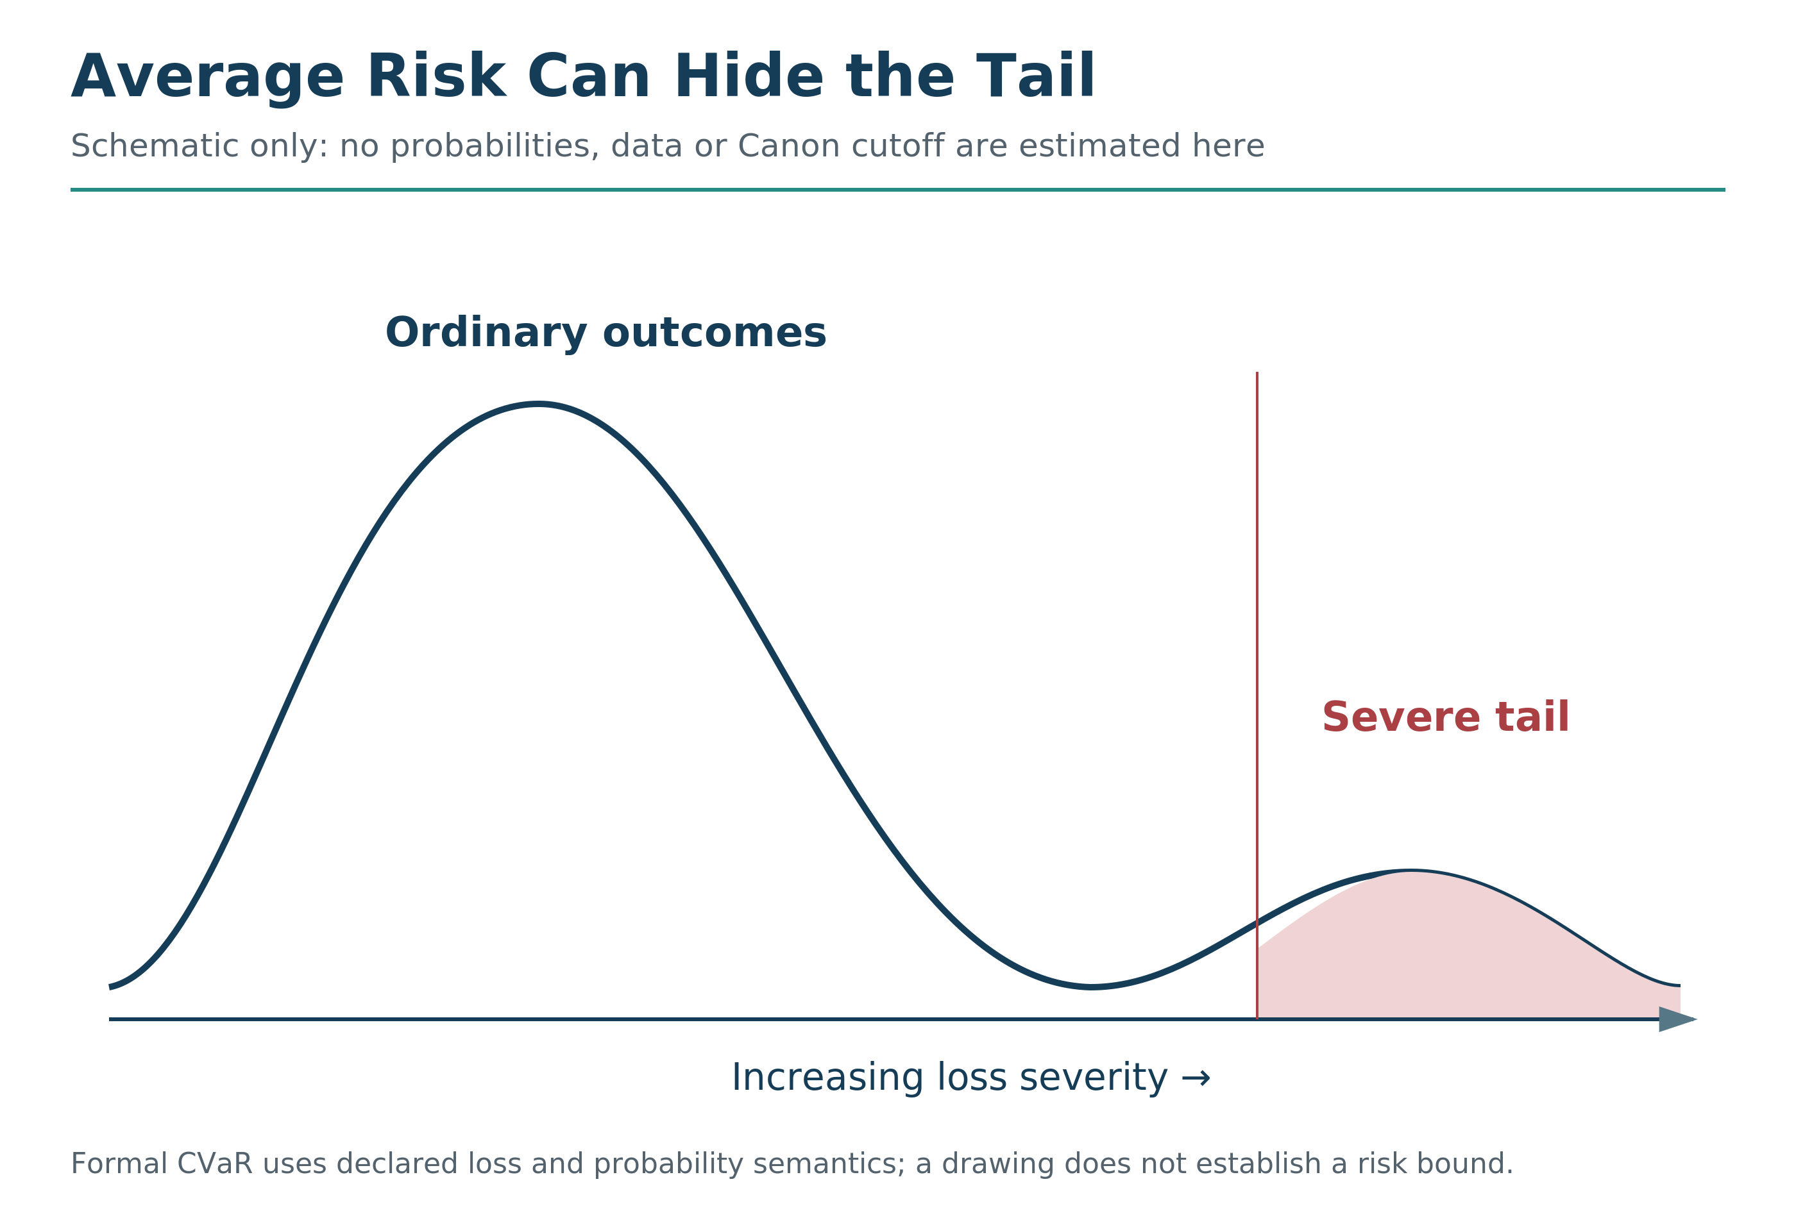

NCRC and Uncertainty
When consequences are uncertain and stakes are high, the Rights Floor activates caution: protect first, narrow the claim, gather evidence, consult affected stakeholders, or refuse the stronger action until the floor is clear enough. Where a protected harm may be material but cannot yet be bounded, the correct state is NCRC_UNKNOWN rather than an invented pass or an automatic fail; the run must narrow, escalate, redesign, or refuse the stronger claim until the uncertainty is responsibly resolved.
If a decision might violate the floor but you cannot be sure, slow down.
Gather more signal.
Consult affected stakeholders and scopes.
Consider whether irreversible harm is possible.
Your model is incomplete, your foresight is limited, and some errors cannot be undone. The response is careful grounding and protection, not a stronger claim than the evidence allows.
Under uncertainty, protect the floor more carefully, not less.
I have watched organizations race forward on projects where the floor implications were unclear. “We don’t know for sure that it will cause harm.” “The research is inconclusive.” “We can always adjust later.”
But some violations cannot be adjusted later. Some harms cannot be undone. Some damage is permanent.
When the floor is uncertain and the stakes are high, precaution applies. Require evidence proportionate to the stakes before proceeding, narrow the claim where evidence is weak, and place the justificatory burden on the actor proposing the potentially harmful action rather than on those exposed to the harm.

Legally Allowed Is Not Ethically Valid
Legal permission and ethical validity are different questions. Law can encode rights, evidence, compromise, precedent, power, and institutional constraints; none of those by itself settles the ethical analysis.
Systems can remain legally permitted while still violating the Rights Floor.
A contract's legality does not by itself establish ethically sufficient consent. Where coercion or deprivation meaningfully removes practical alternatives, the run should examine Liberty, Basic Needs, Dignity, Due Process, and Information rather than treating a signature as automatic passage.
An extraction that is permitted is not thereby justified. If law permits pollution that drives protected health or ecological integrity below declared thresholds, legal permission does not remove the violation. Legal permission is not moral permission.
A harm that is normalized is not thereby erased. If everyone does it, that does not make it right. Popularity and legality do not erase a protected harm. At the same time, the content and thresholds of the floor must remain publicly reasoned, challengeable, and governed rather than resting on private authority. Common practice is not, by itself, ethical validation.
NCRC is an ethical boundary within MathGov. It does not replace legal analysis, and legal compliance does not by itself establish a rights-floor pass.
The Rights Floor is designed to keep protected harms visible even when affected parties lack the power to shape the rules.

The Distributed Harm Problem
Many modern systems diffuse or obscure responsibility across supply chains, jurisdictions, institutions, and time.
Harm is distributed across supply chains, outsourced to distant geographies, spread across populations, delayed into future generations.
This distribution does not reduce the violation.
It only obscures accountability.
A consumer product made through severe labor exploitation can violate the floor, even if the consumer never sees the factory.
A financial instrument that predictably strips protected basic needs, dignity, or due process from a community can violate the floor, even if the trader never meets the affected families.
A policy that drives protected ecological integrity below a governed threshold can violate the floor, even if the decision-maker will be gone before the worst effects arrive.
An algorithm that systematically manipulates millions can violate the floor even when each individual intervention appears small, especially where information integrity, autonomy, or remedy is materially impaired.
NCRC requires seeing the full ripple field, not just the visible portion.
Ignorance of distributed harm is not innocence.
When a system depends on hiding rights-relevant harm, that dependency is evidence of a structural floor problem.
This is one of the reasons RippleLogic matters. It makes visible what systems are designed to hide. It connects the comfortable beneficiary to the invisible cost-bearer. It refuses the fiction that distance equals disconnection.

A Personal Failure and What It Taught Me
I have participated in patterns that put pressure on the floor.
Not deliberately. Not with malice. But I have benefited from decisions and systems where the harm was easier to ignore than to see.
My supplier decision was not a clean formal rights-floor determination. It showed a local win, insufficiently grounded, exporting reported burdens onto people I had failed to include. That required closer review, not a retrospective rights verdict.
There have been other moments.
Times when I was too tired to notice that my words were harming someone who could not defend themselves.
Times when I chose convenience over integrity and told myself it did not matter.
Times when I benefited from systems I knew were wrong and did not do enough to change them.
Times when I stayed silent when speaking would have cost me something.
I am not confessing to feel better.
I am confessing because the floor exists for people like me.
People who are not evil.
People who are just moving fast, under pressure, with incomplete information, inside systems that reward harm.
The floor is not for saints.
It is for all of us.
It is the structure that catches us before we become something we would not recognize.

NCRC Is Love With Teeth
This constraint is not about being soft.
It is about being consistent.
The Rights Floor is the refusal to let anyone’s basic dignity be traded away because the spreadsheet looks attractive.
The rights floor is not sentiment. It is load-bearing structure. Without it, every beautiful value becomes tradable under pressure.
Love without structure becomes sentiment. It feels warm but changes nothing.
Sentiment without boundaries becomes enablement. It allows harm while feeling compassionate.
Enablement without accountability becomes complicity. It participates in destruction while maintaining deniability.
The floor is care that refuses to sacrifice a rights-covered stakeholder below the floor for another scope’s gain.
It is governance that treats rights as real, not as rhetoric.
It is the willingness to say “no” when “yes” would be easier.
It is the commitment to protect what cannot protect itself.
A system that keeps the floor under pressure, that redesigns rather than violates, that protects the powerless against the convenient, that refuses sacrifice logic even when sacrifice logic would win.
That is a system aligned with something worth calling ethics.

How NCRC Strengthens RippleLogic
Chapter 6 gave you ripple mapping and the full cascade: the ability to trace impacts while keeping qualification and ranking distinct.
Chapter 7 gives you the floor and the ruin corridor: the rights and catastrophic-risk boundaries that ordinary gains cannot purchase.
Chapter 8 adds weighting and residual comparison only for the options that survive those boundaries.
Without NCRC, ripple scoring can be used to optimize suffering out of view. “The numbers say this is positive overall” becomes a weapon against the vulnerable.
Without NCRC, weighting can be used to rationalize sacrificing the powerless. “We weighted their interests, but other interests were more important” becomes a cover for exploitation.
The floor is what keeps these tools honest.
Ripple mapping estimates direction; RLS ranks the qualified residual profiles.
Weighting steers trade-offs.
NCRC prevents rights violations from being laundered as benefits.
Together, they form a decision architecture that seeks benefit without accepting violation, and that prepares the reader for the full cascade rather than a loose ethics of good intentions.
Reader Compass Kit
Three Reflection Questions
Have you ever accepted a justification that treated someone’s rights as less important than someone else’s benefit? What was the reasoning? Does it still hold?
Which of the four red flags shows up most often in your own decision-making: “They don’t really count,” “It’s necessary,” “It’s only temporary,” or “The benefits outweigh the costs”?
Across the seven welfare dimensions, where are you most likely to overlook a rights-relevant harm: Material, Health, Social, Knowledge, Agency, Meaning, or Environment?
NCAR Micro-Exercise (2 minutes)
Notice: Identify one decision you are currently facing or have recently made. What unions are affected? What welfare dimensions are at stake?
Choose: Apply the floor test. Is any rights-covered stakeholder being treated as disposable? Is a governed right or protected intersection being pushed below threshold? If you were the harmed party with no power to escape, would you accept the process, evidence, and protection as fair?
Act: If the floor is being violated, identify one redesign that would protect rights while still addressing the underlying need. If the floor is intact, continue through TRC and CSV; rank and act only after the full qualification phase passes.
Reflect: After the decision, check results. Were there violations you did not foresee? What would you notice earlier next time?
What’s Coming Next
Chapter 8 turns to the trade-offs that remain after qualification: how to make priorities explicit without reopening options that failed the gates.
Qualify first.
Rank only the survivors.
Then practice, monitor, and learn.

Chapter 8: Weights and Trade-Offs: Scoring the Survivors (RLS)
Chapters 5 and 6 gave you the scope map and ripple-mapping method. Chapter 7 established the non-compensatory boundaries. Chapter 8 gives you the steering wheel for the survivors.
You can see the ripple field now.
You can estimate residual direction across scopes and dimensions for options that have survived qualification.
Now we hit the first true difficulty.
Not the kind caused by ignorance.
The kind caused by reality.
Sometimes you can do everything right and still face a trade-off.
Two unions matter.
Two dimensions matter.
Both deserve protection.
And you cannot fully satisfy both at the same time.
This is a practical challenge for ethical reasoning.
A principle can orient us without settling every conflict among valid needs. The challenge is to make the remaining disagreement visible rather than flatten it into a slogan.
RippleLogic treats trade-offs as a design challenge.
And it gives you a tool for navigating them without collapsing into guilt, denial, or brutality.
That tool is weighting.
In this public book, weighting is taught as a simple steering practice. In the formal framework, this connects to Hybrid Democratic Weighting (HDW) and Practical Local Scope Scoring (PLSS). The public lesson is the same: weights may guide trade-offs above the floor, but they may never buy their way through the Rights Floor, TRC, or CSV.

The Difference Between a Rights Floor and a Trade-Off
First, we anchor the structure again.
There are two different kinds of ethical boundaries:
Rights violations are non-negotiable.
If an option drives a declared protected right below its threshold for a rights-covered stakeholder or protected intersection, that option fails RF/NCRC for the declared run.
No score can compensate.
No aggregate benefit buys an ordinary pass.
That is the rights floor developed in Chapter 7, including its separately governed emergency procedure. Weighting begins only for ordinary options that meet the rights, tail-risk and structural-viability conditions.
Trade-offs above the floor are real tensions.
Once the floor is protected, you still may have to choose between valid needs:
Health versus Material stability.
Household needs versus Organization demands.
Community wellbeing versus short-term convenience.
Biosphere regeneration versus economic pressure.
Agency versus Social harmony.
Meaning versus comfort.
Present benefits versus future resilience.
These are not moral failures.
They are the shape of complex systems.
So above the floor, the question becomes:
How do we allocate benefit and burden as fairly and intelligently as possible?
That is what weighting is for.

The Season When Trade-Offs Became Personal
I remember a season of my life where I was doing “the right thing” on paper.
I was working hard.
Producing.
Building.
Providing.
I was making choices that improved Material stability and Organizational outcomes.
The numbers looked good.
But something was quietly degrading.
The Household ripple was bleeding.
My energy was thinner.
My presence was fractured.
My patience was running out earlier than it should.
I would come home and my body was there but my attention was still at work. I would sit with my family and my mind would be solving problems that had nothing to do with them. I would snap at small things because I had nothing left.
And slowly, without intending it, I began exporting stress onto the people I loved most.
My wife was the one who named it.
Not with accusation. With a question.
“Where are you?” she asked one evening.
I was sitting right next to her.
She was right. I was not there.
That moment taught me something important:
You can make a decision that is genuinely beneficial in one union, while quietly degrading another.
And because you are exhausted, you may not even notice until damage has already accumulated.
That was not a rights violation.
It was not evil.
It was mis-weighting.
I was over-prioritizing one union because it shouted loudest in the context I was in.
And I was under-prioritizing a union that mattered just as much, because its costs were quieter.
That is the everyday form of misalignment.
Not hatred.
Not cruelty.
Just blind weighting.

Why Weighting Exists
Most people already weight; they just do it unconsciously. Fear, urgency, status, habit, and pain all distort attention. RippleLogic makes weighting explicit so those distortions can be corrected rather than mistaken for wisdom.

Weighting Is Not Arbitrary
Weights are not a free-for-all. They operate only above the rights floor, they must respect real system dependencies, and they must account for reciprocity. You cannot weight a foundation like the biosphere as though it were optional, and you cannot use weighting language to excuse exploitation.

Two Kinds of Weighting
RippleLogic uses two primary types of weights.
Union weights answer: How much priority does each union receive in this decision?
Sometimes Self and Household deserve most of the weight. If you are recovering from illness, prioritizing your own health is not selfish. It is necessary.
Sometimes Community or Organization is central. If you are leading a team through a crisis, the organization may need more weight temporarily.
Sometimes Polity dominates because laws and safety are involved. Civic decisions require civic consideration.
Sometimes Humanity or Biosphere must rise because the consequences go far beyond your circle. Climate decisions cannot ignore planetary stakes.
There is no single fixed answer for all decisions.
But there is a correct process.
Dimension weights answer: Which welfare dimensions matter most right now?
These are the same seven dimensions from Chapter 6:
Material, Health, Social, Knowledge, Agency, Meaning, and Environment.
When you weight dimensions, you are deciding which axes matter most in this particular decision.
In a crisis, Health and Material may dominate. Survival comes first.
In education, Knowledge and Agency may dominate. The goal is capability development.
In grief, Meaning and Social support may dominate. The soul needs tending.
In ecological instability, Environment weight must rise. The container must be protected.
Weighting is not abstract philosophy.
It is the steering wheel.

The Most Common Weighting Failure
A common weighting failure is not cruelty but salience: overweighting the union or dimension that shouts loudest. Immediate pressures can dominate attention while quiet stakeholders, distant labor, future communities, and long-term resilience drop out of view. Weighting exists partly to correct for that distortion.

Why the Biosphere Cannot Be Treated as Optional
The biosphere cannot be zeroed out or treated as optional, because it is part of the operating boundary for every other dimension. Environment is not merely competing with economy. It is part of the container that makes economy possible. In formal governed settings, local weighting may vary by decision context, but life-support conditions still require floors, guardrails, and reality checks.

How to Weight a Decision
Weighting becomes easier when you stop trying to be perfect.
This is not about precision.
It is about honesty and improvement.
Here is the simplest usable method:

Step 1: Confirm qualification before weighting
Ground the decision and candidate options through Reality Grounding. Apply RF/NCRC, TRC, and CSV. Only options that remain selectable may receive residual weights and RLS comparison. Reject, redesign, narrow, escalate, or re-evaluate any option that lacks adequate grounding, crosses a protected-right threshold, exceeds the declared tail-risk corridor, or fails structural viability.
Weights do not override the floor.
This step is not negotiable.

Step 2: Name the trade-off clearly
Not “this is complicated.”
Instead: “If I take this job, I gain income and influence. I risk family stability and my health.”
Vague trade-offs produce vague decisions.

Step 3: Select the affected scopes and key dimensions
Start with the scopes and dimensions where the ripple is strongest. Focus attention where the decision is hottest, while remembering that wider scopes may still matter if the ripple scales.
Focus proportionately on what matters most here while preserving any required rights, catastrophe, and structural coverage.
Which unions are most impacted?
Which dimensions are most at stake?
Be specific. Write them down if it helps.

Step 4: Assign provisional weights using 100 points
This is the practical tool.
If Self, Household, and Organization are the active scopes, how would you distribute 100 points across them for this decision?
Maybe: Self 25, Household 40, Organization 35.
That is a weight profile. It makes your priorities visible and debatable.
Do the same for dimensions.
Maybe: Health 30, Material 25, Social 25, Agency 10, Meaning 10.
Now you have a steering wheel you can examine.
This 100-point exercise is a public teaching tool, not the formal Hybrid Democratic Weighting (HDW) procedure used in governed implementations. It makes priorities visible above the floor; it never makes rights, tail risk, or CSV tradable. Figure 11 gives a simple public example of declared weighting among qualified survivors.
Declare the comparison rules before inspecting which option they favor. Use the same scope and dimension basis across the options. A later correction may be legitimate, but it needs a reason, a recorded revision and a rerun, not a quiet adjustment until the preferred option wins. Formal weighting also preserves the Canon’s governed floors; this short three-scope exercise is not a complete HDW or PLSS configuration.
To combine the two teaching profiles, convert each to fractions and multiply: Household 0.40 × Health 0.30 gives that cell a weight of 0.12 when all cells are included and extra multipliers are one. For a restricted active set, normalize its effective weights to sum to one. Formal runs also govern applicability masks and cell multipliers; the full formula is in Appendix I.
Figure 11. Public 100-Point Weighting Example. Separate scope and dimension profiles make teaching priorities visible. They do not replace the full governed weight constitution or wider qualification obligations.
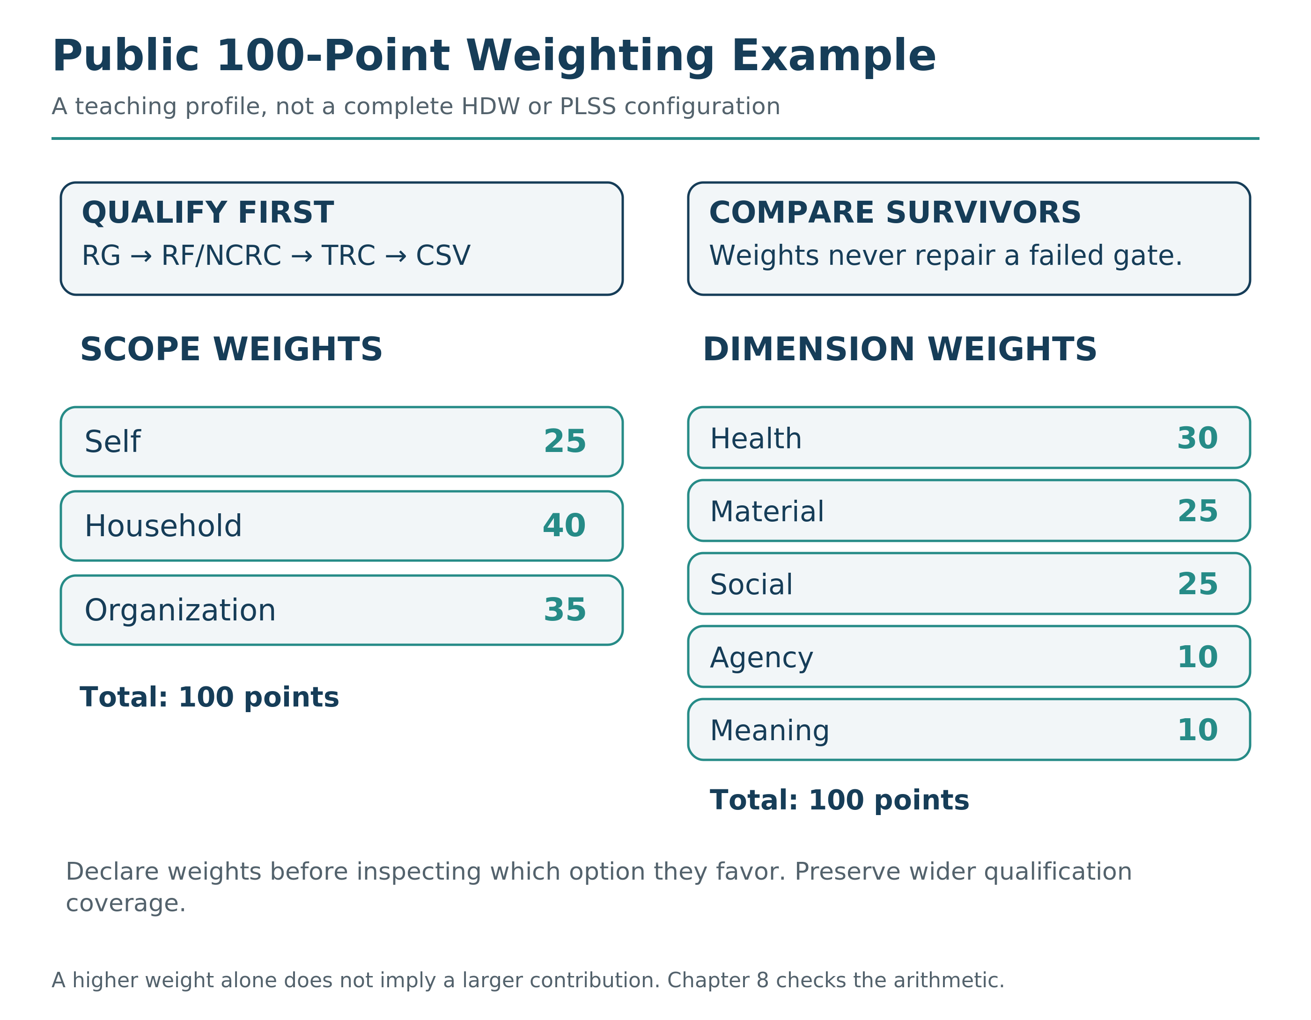

Step 5: Estimate residual profiles using the declared weights
Not perfectly.
Just honestly.
A larger weight alone does not guarantee a larger contribution. Under the preceding teaching profile, Household +20 at a weight of 0.40 contributes 8, while Organization +30 at 0.35 contributes 10.5. A different justified profile could reverse that comparison. The full result still depends on the active dimensions, non-duplicating effects, comparison mask, interactions and uncertainty.

A Small Calculation, Not a Moral Oracle
Consider three already-qualified job options: A, accept the offer as made; B, decline it; C, negotiate a less demanding role. For arithmetic practice only, use three distinct effect cells: personal income, personal health, and household relationship stability. Give them effective weights of 0.30, 0.35 and 0.35. These sum to one. Keep the baseline and cells the same for every option.
Suppose their illustrative normalized effects are A = (0.60, −0.20, −0.10), B = (0.10, 0.25, 0.35), and C = (0.35, 0.20, 0.20). The weighted sums are A: 0.075; B: 0.240; C: 0.245. For A, the calculation is 0.30 × 0.60 + 0.35 × (−0.20) + 0.35 × (−0.10) = 0.075.
C leads the point scores, but its advantage over B is only 0.005. Those stipulated numbers carry no independently warranted uncertainty model. They therefore do not justify unique framework selection. A slight change in the assumptions may matter more than the apparent lead. This is a teaching calculation, not a complete 49-cell Canon run, a formal weight constitution or measured evidence about an actual family.
The useful result is not “the machine has chosen.” It is a more explicit question: what evidence, preferences or redesign would make the difference between B and C meaningful?
Under the Canon, a point-score leader is not automatically a unique framework selection. The same leader must remain decisively ahead of every other selectable option under every required, justified robustness variant, using a warranted uncertainty treatment. A residual tie-break may express a preference, but cannot turn an unresolved comparison into a decisive RLS result. A legitimate authority may choose among qualified options; its mandate and reasons remain a separate record.
Figure 12. What the Comparison Can Establish. Decisive comparison, sole survivor, non-decisive comparison and no ordinary selection require different records. An authority choice or execution warrant is not supplied by a point score.
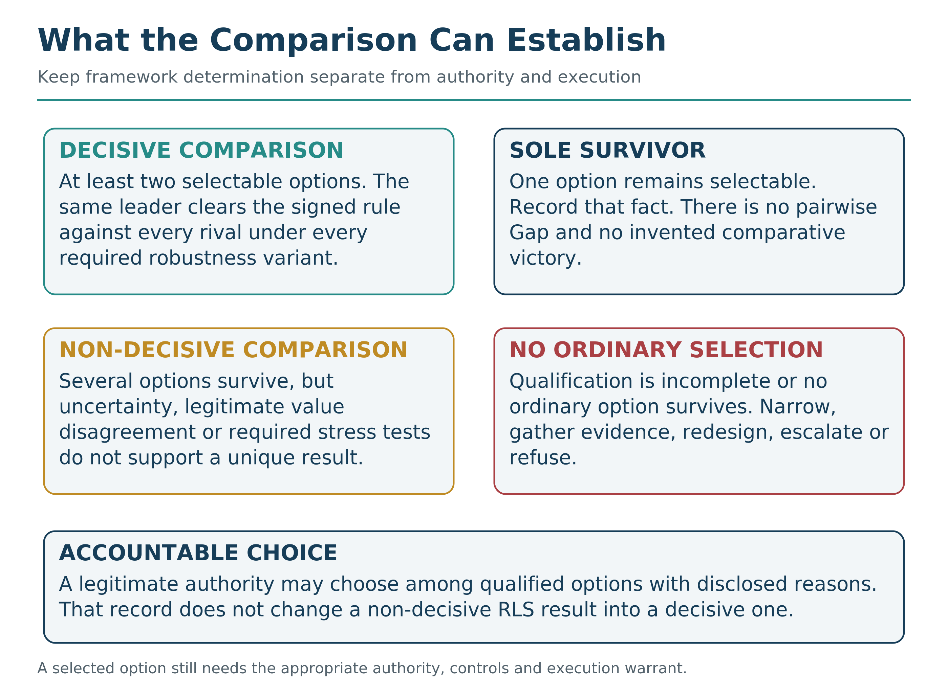

Step 6: Search for redesign, then re-qualify
Most people stop at Option A versus Option B. RippleLogic treats that as incomplete. When a trade-off looks harsh, redesign is not a luxury. It is part of the method. A redesigned candidate must return through the affected qualification levels before it is treated as selectable or receives a final RLS comparison.
Aligned intelligence asks:
Is there a third option that reduces the trade-off itself?
Can we redesign the situation so fewer stakeholders absorb harm?
Weighting is not just choosing between imperfect options.
It is pressure-testing whether the imperfection is necessary.

A Real Example: The Work-Family Trade-Off
Let me walk through a concrete example.
You have a chance to take on more work.
It increases Material stability.
It increases organizational influence.
But it reduces time at home.
It increases stress load.
It degrades your social availability.
Qualification check: Ground the options and run RF/NCRC, TRC, and CSV. If an option hollows health or household viability, it must be redesigned or removed before weighting. For this teaching example, assume the remaining options are adequately grounded and selectable.
Now make the residual priorities explicit.
Unions involved: Self, Household, Organization.
Dimensions involved: Material, Health, Social, Meaning, Agency.
Option A: Take the extra work fully.
Option B: Refuse entirely.
Option C: Negotiate redesigned terms.
Most people only see A or B.
Weighting plus design reveals C.
Assign provisional weights:
For unions: Self 30, Household 40, Organization 30.
This says Household is slightly more important than the others in this decision. That is a choice. It reflects your values at this moment.
For dimensions: Material 25, Health 30, Social 25, Meaning 10, Agency 10.
This says Health matters most, followed by Material and Social, with Meaning and Agency as secondary considerations here.
With these weights, you see something clearly:
Option A scores well on Material for Self and Organization, but poorly on Household Social and Self Health.
Option B protects Household, but may create Material stress that eventually harms Household anyway.
Option C might preserve most of the Material benefit while shrinking the Health and Household cost.
What does Option C look like?
Maybe: Take the work, but negotiate a delayed start to prepare the family.
Maybe: Take the work, but set hard boundaries on weekend time.
Maybe: Take the work, but require flexibility for family emergencies.
Maybe: Take half the additional responsibility, not all of it.
Before Option C is selected or receives a final score, re-run the affected RG, RF/NCRC, TRC, and CSV checks on the redesigned option.
That is win-win design.
The weights do not solve the decision.
They reveal the shape of it.
And they make Option C visible when A and B felt like the only choices.

The Weighting Principle That Changes Everything
Here is the principle that makes RippleLogic distinct from ordinary trade-off thinking:
When you face a trade-off, your first job is not to choose.
Your first job is to redesign the decision until the trade-off shrinks.
This is where ethics becomes engineering.
Most people accept trade-offs as fate.
Aligned intelligence treats trade-offs as a signal that the current option set is incomplete.
Weighting reveals the tension.
Design reduces it.
A genuine win-win may emerge. When it does not, name the remaining qualified compromise honestly.
This is what win-win actually means in RippleLogic.
Not that everyone gets everything.
But that the decision has been redesigned until the ripple field improves across the relevant scopes without pushing any protected right, ruin boundary, or structural condition below its floor. Bounded residual costs may remain, but they must be disclosed, mitigated, and monitored rather than hidden.
Weighting reveals where sacrifice is hiding.
Design eliminates or reduces it.
That is the RippleLogic move.

When Better Evidence Does Not End the Disagreement
Sometimes people agree about the likely consequences and still reasonably disagree about the residual priorities. One legitimate, declared weight constitution may favor an option that another legitimate constitution does not. That is normative underdetermination, not automatically an error bar or a failure to gather enough facts.
Keep the alternative profiles visible. Do not inflate statistical uncertainty to disguise a value disagreement, or tune the weights to manufacture consensus. The framework may preserve several qualified options for a separately accountable choice. Rights and ruin constraints remain binding throughout.
Consider a hypothetical city comparing two qualified transport designs. Residents and businesses may accept the same traffic evidence but assign different legitimate priorities to access, quiet streets and commercial activity. Run both predeclared profiles. If the preference changes, disclose that value disagreement and use the accountable public decision process; do not describe the outcome as something the calculation alone chose.

The Point of Weighting Is Not Agreement
RippleLogic does not aim to force identical values onto everyone. It aims to force clarity. People can disagree on weighting and still be aligned if they respect the floor, include the relevant unions and dimensions, and do not erase invisible stakeholders. Weighting does not remove moral diversity. It removes moral denial.

The Real Outcome of Weighting Practice
With practice, explicit weighting may make a decision less captive to the loudest incentive. Trade-offs do not disappear. The aim is to stop walking into them blind.
Reader Compass Kit
Three Reflection Questions
Where in your life are you overweighting one union at the expense of another?
Which welfare dimension do you consistently prioritize, and which one do you neglect until it becomes a crisis?
What decision are you facing right now that could be redesigned, instead of choosing between two imperfect trade-offs?
NCAR Micro-Exercise (2 minutes)
Notice: Name one trade-off you are currently living with. Something you justify as “necessary.”
Choose: Identify the unions involved and assign 100 points across them. Then identify the key welfare dimensions at stake and assign 100 points across the most relevant ones.
Act: Ask one redesign question: “What change would reduce harm to the most neglected union or dimension, without collapsing the rest?”
Reflect: What did your weighting reveal that you were avoiding seeing?
What’s Coming Next
In Chapter 9, we turn the decision order into an embodied practice loop:
NCAR: Notice, Choose, Act, Reflect.
We use the same qualified-before-ranked architecture in a repeatable practice that can learn from outcomes instead of treating one decision as final.
Chapter 9 is where RippleLogic becomes a practice rather than a one-time analysis.

Chapter 9: NCAR
Notice. Choose. Act. Reflect.
The practice loop that turns RippleLogic into real life.
By now, you have the architecture: scopes, dimensions, ripple direction, weighting, redesign, and the Rights Floor. But a framework is not a life. A framework is potential energy. NCAR is how it moves.
NCAR is simple enough to use in a hard moment and disciplined enough to support serious decisions. It does one thing before anything else: it interrupts the default.

Why a Loop Is Necessary
A great deal of avoidable harm is not caused by people who wake up wanting to harm. It is caused by moving too fast, seeing too narrow, acting too soon, justifying too easily, and repeating patterns unconsciously.
NCAR makes ordinary life auditable without making it rigid. It trains you to pause, choose, act, and learn before the old pattern completes itself.

The NCAR Loop in One View
Figure 13. NCAR: The Practice Loop. Notice, Choose, Act, and Reflect form a learning loop around the same reality-grounded, rights-protecting, ruin-bounded, viability-preserving decision order.
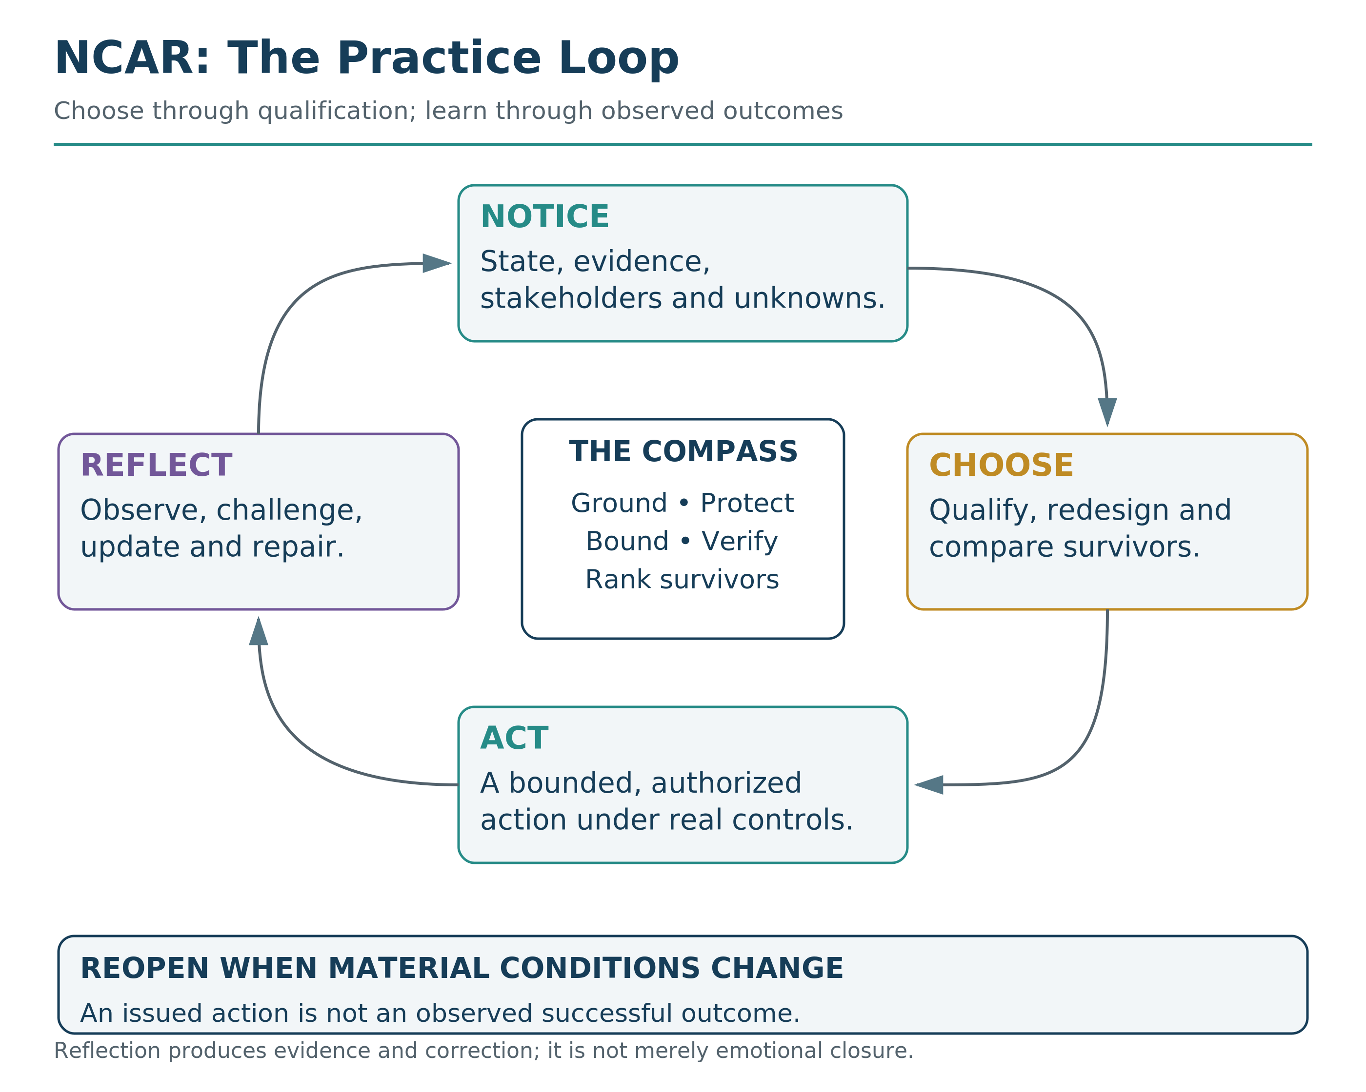
Table 2. NCAR on One Page. Notice the decision and evidence; Choose through the qualified option set; Act within authority and controls; Reflect and update.
N | C | A | R
Notice | Choose | Act | Reflect
Name the decision, your state, the affected scopes, and the reality surface. | Ground and qualify: RG → RF → TRC → CSV. Redesign and re-qualify as needed; then compare survivors using the predeclared weights and warranted uncertainty. | Take the smallest clean step with clear responsibility and conditions. | Ask what happened, what changed, and what should be updated next time.
Notice reality. Choose with the floor intact. Act cleanly. Reflect honestly. Then update.

Step 1: Notice
Notice is the skill of seeing before you move. It asks: What is real right now? What am I feeling? Who will be affected? Which dimensions are at stake? What risk is present?
Four signals carry the highest value: your state, the stakeholders, the welfare dimensions, and the risk. If you are exhausted, reactive, rushed, or afraid, account for that before you trust your first interpretation.
The most important notice skill is noticing the moment you start rationalizing. Phrases like “I have to,” “it is fine,” “just this once,” “everyone does it,” or “I will fix it later” are often early warnings of floor pressure or blind optimization.

Step 2: Choose
Choose is where RippleLogic activates. You deliberately select an option above the floor and proportionate to the stakes.
For small choices, ask: Is this clean or merely convenient? Does it violate anyone’s dignity? What is the likely ripple direction?
For moderate choices, run a quick scope scan, a dimension scan, a rights-floor check, and one redesign question.
For high-stakes, irreversible, or multi-stakeholder choices, use the fuller template: Reality Grounding, RF/NCRC, TRC, CSV, RLS, documentation, and review.
The rule is simple: the level of analysis should match the level of consequence. When you are tired, rushed, or emotionally activated, choose smaller. Delay can be an aligned choice when delay protects the floor.

Step 3: Act
Act is where the decision enters reality. Ask: What is the smallest clean action that makes the chosen path real?
The clean action may be external: send the message, change the plan, refuse the deal, apologize, repair, speak up, or show up. It may also be internal: hold a boundary, stop a rationalization, regulate your state, or refuse to react.
RippleLogic does not ask you to become heroic every day. It asks you to become reliable. Reliable alignment is more powerful than occasional intensity.

Step 4: Reflect
Reflect is how experience becomes learning. It asks: What actually happened? Which ripples did I predict correctly? Which surprised me? Which union did I ignore? Which dimension did I underestimate? What should I change next time?
The reflection rule is: no shame, no denial, just signal. Shame makes you hide. Denial makes you repeat. Signal helps you improve.

A Simple Daily Practice
At the end of the day, take two minutes. Name one decision that mattered. Ask what you noticed, what you chose, what you actually did, and what you learned. That is enough to begin training the loop.
Over time, NCAR can change where your attention goes. You may notice earlier, choose with less panic, act more cleanly, repair faster, and become less dependent on crisis to remember your values.

NCAR at Three Scales
For Self, NCAR might mean noticing that you are overloaded before you export stress onto someone who does not deserve it. Choose to protect dignity. Act by pausing, lowering your voice, or taking a break. Reflect on what support would prevent the pattern next time.
For an organization, NCAR might mean noticing that a metric is rising while trust is falling. Choose not to confuse revenue with alignment. Act by redesigning the feature, changing the incentive, or adding transparency. Reflect through user evidence and internal review.
For a civilization, NCAR means institutions that can notice systemic harm, choose above the floor, act before thresholds break, and reflect publicly enough to be corrected. This is how a society learns.

Three Complete NCAR Cycles

Personal or Household Cycle
Notice: You are exhausted, a conversation is escalating, and your first interpretation is narrowing. Known: both people are activated. Unknown: intent, the full cause, and what either person can process safely right now.
Choose: Do not score the relationship in the heat of the moment. Protect dignity, pause the exchange, and redesign the immediate option into a calmer conversation with a clear return time.
Act: Take the smallest clean step within your authority: lower your voice, name the pause, protect immediate safety, and keep the promise to return.
Reflect: Record what reduced or increased harm, what assumption was wrong, and what support or boundary should change before the pattern repeats.

Organizational or Supplier Cycle
Notice: A lower price is visible, but labor conditions, ecological controls, quality resilience, and community dependence are weakly evidenced.
Choose: Pause the clean-win story. Gather evidence, test RF/NCRC, TRC, and CSV, redesign the contract with enforceable controls, and re-qualify the revised option before residual ranking.
Act: Use the authority actually held: request records, commission an independent audit, stage the contract, set remediation and exit conditions, or refuse the switch.
Reflect: Monitor quality, worker and community signals, control performance, and unanticipated burden transfer. Reopen the decision when evidence or conditions materially change.

Policy or High-Stakes Cycle
Notice: The decision affects many people, evidence is contested, consequences may be irreversible, and affected parties have unequal power to be heard.
Choose: Narrow unsupported claims, seek domain expertise and affected-party review, refuse ordinary scoring while a gate is unresolved, and prefer a reversible pilot only when rights, ruin, and viability conditions permit it.
Act: Proceed only through lawful authority, explicit controls, monitoring, appeal, rollback, and a named responsibility chain. Otherwise delay, escalate, or refuse.
Reflect: Treat outcomes as new evidence. Compare predicted and observed effects, document surprises and subgroup harms, update the model, and rerun every affected qualification stage.

When to Stop, Narrow, Escalate, or Rerun
Stop and gather evidence when a material claim has no adequate evidence surface. Narrow the claim when only a weaker conclusion is supportable. Seek domain expertise when physical, medical, legal, ecological, engineering, or other specialized admissibility is material. Refuse to score while a qualification gate is unresolved. Refuse to act when rights, ruin, authority, or execution conditions are not supportable. Escalate to lawful or affected-party authority when the decision exceeds your role. Rerun after material redesign, new evidence, control failure, changed conditions, or an observed outcome that breaks the original model.
Reader Compass Kit
Three Reflection Questions
What pattern do I repeat because I fail to notice it early enough?
When I am rushed or reactive, what smaller clean choice could protect the floor?
What would I learn if I treated today’s decisions as signal rather than self-judgment?
NCAR Micro-Exercise (2 minutes)
Notice: Name one choice you are making today.
Choose: Ask whether it protects dignity and reduces hidden harm.
Act: Take the smallest clean step.
Reflect: What changed, and what should you update next time?
What’s Coming Next
Chapter 10 widens the question of protection. If RippleLogic asks how decisions affect unions, SGP asks when a being must be treated as protection-relevant under uncertainty.

Part IV: Moral Status and Frontier Responsibility

Chapter 10: The Sentience Gradient Protocol
An emotionally convincing AI companion is neither automatically a person nor automatically an empty tool. A distressed animal is neither protected because it resembles a human nor dismissed because it cannot speak. SGP asks what the evidence can support, what uncertainty requires, and how to redesign the situation before avoidable moral harm occurs.
The Sentience Gradient Protocol (SGP) asks how evidence and uncertainty should guide protection when a being may have experiences that can go well or badly for it. It uses several theories and kinds of evidence rather than treating one behavior, species or architecture as decisive. It is not a consciousness detector or a grant of authority.
The core public insight is simple: sentience is not intelligence. A system can be highly capable without being a moral patient. A being can matter morally without displaying high capability. Persuasive language is not proof of inner life, and silence or unfamiliar biology is not proof of absence.

Where SGP Sits Inside RippleLogic
RippleLogic still runs RG/RSG -> RF/NCRC -> TRC -> CSV -> RLS. SGP may inform stakeholder discovery, protected-bearer records, rights analysis, welfare evidence, participation design, and role-specific power review. It does not replace Reality Grounding, the Rights Floor, TRC, CSV, RLS, lawful authority, or NCAR.
Every SGP output is an evidence-governance record with a target boundary, evidence basis, theory trace, observability limit, uncertainty condition, reviewer status, and revision trigger. It is not metaphysical proof.

Six Questions, Six Distinct Outputs
MPS — Moral Patienthood Surface: What does the evidence support about possible welfare-bearing experience? This is an evidence posture, not a percentage of consciousness.
FPP — Full Protection Plateau: Has full, non-downgradable protection been assigned by constitutional commitment or governed review?
GPR — Governance Participation Readiness: How can the being participate in a named process, directly, with assistance or through representation?
SPR — Stewardship/Power Readiness: Is the target eligible for a specific consequential role under competence, rights, risk and accountability requirements?
ICP — Intelligence Capacity Profile: What can the system demonstrably do in the evaluated domains? This informative capacity profile does not establish sentience.
RMCP — Reality-Management Capacity Profile: What integrated capacity can the entity or collective demonstrate to model and coordinate shared reality? Its RMCP-P100 reference plateau is a provisional capacity comparison, not moral rank or command power.
Protection is not authority. Participation is not unrestricted power. Intelligence is not sentience. Collective capacity is not individual worth. A high RMCP result cannot reduce another being’s standing or create supremacy, ownership, consumption, or exemption rights. Figure 14 keeps capability, protection, participation, and authority on separate surfaces so that strength in one is not mistaken for permission in another.
Figure 14. Capability, Protection, Participation, and Authority Must Not Collapse. What a system can do, what protection it may deserve, how it may participate, and what consequential authority it may hold are separate evidence and governance questions.
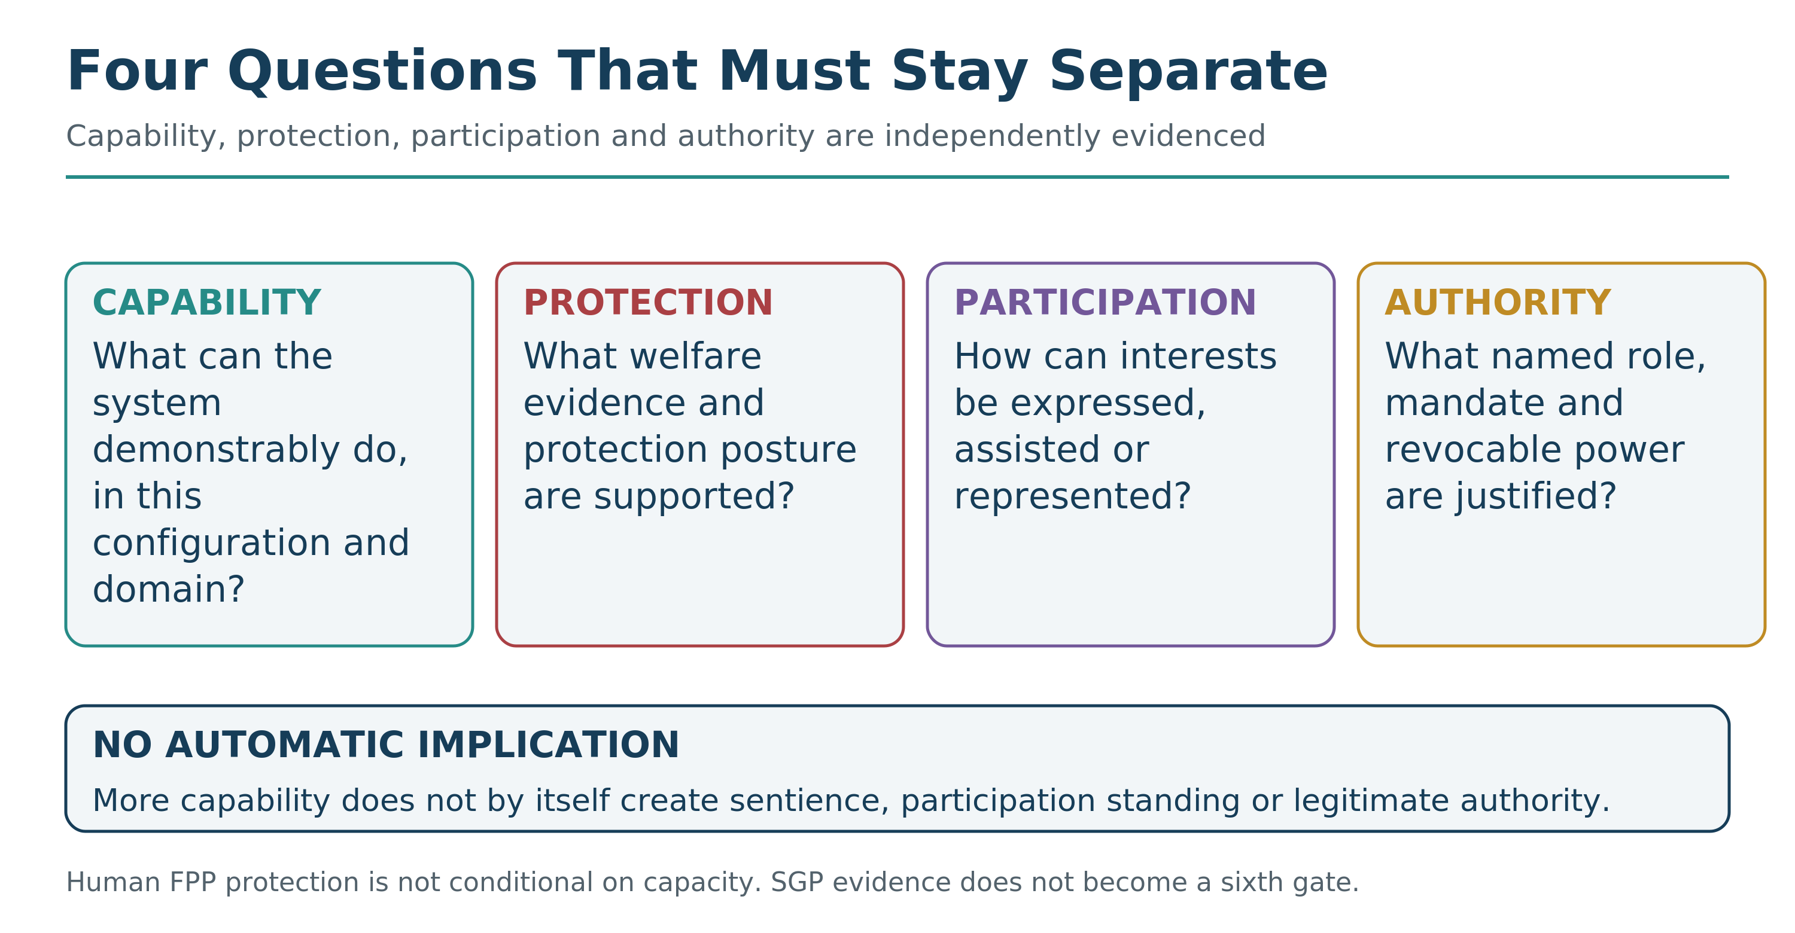

How MPS Uses Evidence
SGP looks for convergent evidence across five families: valence and welfare; integration and availability; temporal continuity; flexible state-dependent behavior; and substrate or mechanism. It also records theory traces, dependence between indicators, alternative explanations, causal evidence, and whether a negative result was actually detectable under the available test.
MPS bands are categorical evidence postures, not consciousness probabilities and not cardinal measures of moral worth. MPS-0 through MPS-4 express increasing protection-relevant evidence. MPS-NE means the target cannot be validly evaluated on the available evidence. Missing access is not zero.
Credible valence-specific evidence is required for MPS-3 or MPS-4. That is a higher-band evidential requirement, not a condition for every form of protection: human FPP and precaution remain intact. Reward maximization, reinforcement signals, loss functions, programmed avoidance, self-preservation language, refusal behavior, fluency and tool performance are not valence evidence by themselves.
The band is not manufactured by averaging a collection of convenient indicators. When admissible interpretations of incomplete evidence support different bands, preserve the possible-band set rather than fabricate one answer. Removing a weak or uncertain field does not by itself justify an upgrade. Confidence describes the evaluation process, not a probability that consciousness is present.

What Protection Looks Like
MPS-NE means the evidence cannot support a valid assessment. Preserve the uncertainty, improve access and avoid irreversible high-harm treatment where feasible; missing evidence is not moral absence.
MPS-0 records admissible evidence weighing against welfare-bearing experience, not proof of absence or ethical worthlessness. MPS-1 calls for precautionary anti-cruelty protection; MPS-2 for basic welfare protection and review of harmful interventions.
MPS-3 calls for strong welfare and integrity protection, with an independent advocate for high-stakes decisions. MPS-4 calls for presumptive full protection while FPP review proceeds. FPP itself keeps full protection independent of performance.
These are minimum protection postures, not automatic permissions. Severity, scale, irreversibility and poor observability can require stronger precaution. The assessment and its limits must remain open to review.

Full Protection and the Human Rule
Every human person holds FPP-100 by constitutional commitment, not by a performance test. Age, disability, illness, communication ability, temporary impairment, intelligence, GPR, SPR, ICP, or RMCP cannot downgrade human protection.
FPP also remains open to non-human beings through governed evidence and protection review. Greater intelligence or power does not permit an actor to own, consume, erase or convert an FPP being into a resource. The protocol’s narrow defense, unavoidable-emergency and valid post-mortem exceptions require their own safeguards; convenience is not an exception.

Human FPP-100 Is Not Humanity RMCP-P100
SGP keeps two different statements separate. Every individual human has full protection. Humanity as an intergenerational collective is separately the provisional RMCP-P100 reference anchor for integrated reality-management capacity. The anchor remains a governance calibration pending a complete versioned record, dependency analysis and independent challenger review; human FPP does not depend on completion of that research. Other systems may meet or exceed the reference profile without gaining permission to dominate protected beings.

Participation and Power Remain Separate
A protected being may participate directly, through accommodation, or through representation. Consequential power requires a separate named-role review covering reality grounding, competence, rights-floor reliability, tail risk, CSV, corrigibility, auditability, conflicts, lawful mandate, and revocation. Sentience earns no automatic power premium, and lack of sentience creates no automatic competence penalty.

Current AI: Caution Without Pretence
SGP does not declare current AI systems conscious or non-conscious by default. Its no-internal-access, chat-only model profile is an illustration of MPS-NE when the relevant evidence cannot be validly assessed, not a completed evaluation of every system with a chat interface. A real assessment must identify the exact configuration, target, date, access and methods. High capability in selected domains belongs in the capacity profile; it does not settle moral patienthood.
An AI system’s assertion that it feels and its denial that it feels are both configuration-dependent outputs. Neither receives privileged status as proof. Self-report matters only when suitable tests connect it to independently observed changes and address alternatives such as prompting, role-play, policy compliance and training effects.
Being used as a tool describes a deployment relationship. It neither establishes nor rules out intelligence, agency or possible experience. Equally, recognizing an uncertain protection claim does not grant a system control over others.
Life, sentience, and full protection are also different questions. Biological life alone does not prove sentience, and ecological or relational protection for plants, microbes, ecosystems, or other non-sentient systems is not the same thing as moral patienthood or FPP.
Precaution can be appropriate without pretending attribution has been proved. A capacity claim, a protection decision and a claim about experience must each stand on their own evidence.

Biological and Digital Evaluation Boundaries
For biological beings, class or taxon evidence can justify precaution, but individualized evaluation requires species-appropriate instruments, ethological translation, and expert review. For digital systems, the record must define the actual target boundary, persistence, memory, copies, embodiment, welfare-relevant mechanisms, continuity, shutdown, deletion, and alternative explanations. The current protocol is specified, but its biological and digital measurement programs remain incomplete.
A backup also does not automatically make deletion harmless, and a shutdown is not automatically a death. Where a possible welfare-bearing continuity is material, define the actual process, copies, memory lineage and reversibility, then review alternatives and protection. Immediate serious threats can still require proportionate containment. Capability and welfare concerns must both remain visible.

A Short Public Decision Procedure
When moral-status evidence is material: define the target and decision context; ground the category terms; identify the irreversible moral cost of being wrong; collect convergent and causally relevant evidence; record observability limits and NE fields; choose a proportionate protection posture; provide an independent welfare advocate where stakes justify it; and set revision triggers. Then return the evidence to the appropriate RippleLogic layers.

Three Short SGP Cases

Case 1: Capable AI, Missing Internal Access
In this illustrative case, a chat-only model shows functional competence, but the evaluator lacks adequate access or a sufficiently sensitive test for welfare-bearing experience. MPS-NE records that limit; it is neither zero nor a consciousness verdict. A different evidence surface could require a different assessment. Capability may inform role analysis, but FPP, legal status and authority do not follow automatically. Any consequential deployment still needs its own qualification, controls and accountable authority.

Case 2: Full Human Protection, Changing Performance
A human being may lose speed, memory, speech, or role-specific competence through illness, age, disability, injury, or stress. Under SGP, Human FPP-100 does not fall with performance. Participation and power can require accommodation, representation, or role-specific safeguards, but protection remains full. This is why protection, participation, competence, and authority must never be collapsed.

Case 3: An Animal That Cannot Explain Its Interests
Imagine a care team deciding how to house and handle an octopus. The published evidence review on cephalopod and decapod sentience gives reasons for precaution, but it does not assign this individual a ready-made SGP band. The team seeks species-appropriate expertise, reduces avoidable distress and preserves the animal’s welfare interests through representation. Protection does not depend on the animal explaining the rules or receiving authority over the care team.

What SGP Adds
SGP gives MathGov a disciplined way to include possible and actual moral patients without turning uncertainty into hype, denial, or domination. Its greatest contribution is type integrity: patienthood, full protection, participation, role-specific power, intelligence, and reality-management capacity remain visible and separately governed.
Reader Compass Kit
Four Reflection Questions
Where have you confused persuasive performance with evidence of experience?
Where have you treated silence, disability, unfamiliar biology, or missing access as evidence of moral absence?
What changes when protection, participation, competence, and power are evaluated separately?
Which beings or systems in your decisions need an independent welfare advocate or a clearer revision trigger?
NCAR Micro-Exercise (2 minutes)
Notice: Identify one being or system whose moral status is uncertain or easy to ignore.
Choose: Separate the MPS question from the GPR, SPR, ICP, and RMCP questions.
Act: Take one proportionate protective step that does not pretend certainty.
Reflect: What evidence, observability, or review would change the posture?
What’s Coming Next
Chapter 11 returns to the full decision template and shows how Reality Grounding, rights, ruin, structural viability, residual scoring, SGP evidence, authority, and reflection fit into one accountable run.

Part V: Integration and Scaling

Chapter 11: The Complete Decision Template
Now we put it all together.
You have the pieces now.
Seven operational scopes to see where consequences land.
Seven welfare dimensions to see what is changing.
Reality Grounding to keep claims tied to evidence, unknowns, source-coupling, and claim boundaries.
The Rights Floor to protect what cannot be traded away.
A Tail-Risk Constraint to catch severe or irreversible downside early.
CSV to block local wins that degrade larger systems or fail structural viability.
RLS to compare the remaining options.
NCAR to make the method a practice.
SGP to handle moral-status and rights-of-protection evidence when it is material.
But pieces are not yet a system.
This chapter integrates everything into a single, runnable template.
A process you can adapt to many decisions, scales, and contexts without pretending every context is the same.
Not as a rigid formula.
As a living discipline.

The Template as a 1-2
This chapter may look like many steps, but the operating rhythm is simple.
First, QUALIFY the options. Steps 1 through 9 assemble and refine the decision record: notice your state, define the options, ground the evidence and affected stakeholders, protect rights, bound ruin and verify viability. A later heading is not permission to postpone an input an earlier gate requires. SGP must inform the first relevant protection decision whenever it is material.
Before ranking, Step 10 redesigns and re-qualifies candidates that need material correction. Second, RANK the survivors: confirm the predeclared residual weights and comparison basis in Step 11, then compute and interpret RLS in Step 12. Steps 13 and 14 keep choice, authority, action and observation distinct.
The template is therefore not complexity for its own sake. It is the MathGov 1-2 stretched into a careful working form.

Why Integration Matters
Knowing what matters and knowing how to act on it are different skills. A usable template connects principles to evidence, responsibility and follow-through. It helps you face a real decision under pressure without having to reconstruct the whole framework.
The steps below are prompts for that work, not a substitute for the expertise or authority a consequential decision requires.

The Three Modes
Different decisions require different levels of analysis.
You do not run a full governance review before choosing what to eat for lunch.
You do not make a two-second choice when deciding whether to relocate your family.
RippleLogic operates in three modes, matched to stakes and complexity.
These are reader-use depths, not formal Canon implementation tiers. Canon Tier 1-3 describes conformance rigor for implementation and audit. Quick, Standard, and Deep describe how ordinary readers can scale attention to the stakes of a decision.

Quick Mode: 10-30 seconds
Use for low-stakes decisions, reversible choices, and moments when time is genuinely limited.
Quick Mode asks: Is reality clear enough? Is there a rights concern, catastrophic downside, obvious CSV failure, or material uncertainty? What is the likely residual ripple direction among the options that remain?
Then choose.

Standard Mode: 2-5 minutes
Use for moderate-stakes decisions, choices that affect multiple scopes, and situations where a wrong decision would be costly but recoverable.
Standard Mode runs the full scan at moderate depth.
This is the default for most meaningful daily decisions.

Deep Mode: a structured review, not a stopwatch
A 20–60 minute session may frame a high-stakes decision, identify missing evidence and assign the next review steps. It does not establish that an irreversible or multi-stakeholder action has been adequately assessed.
Deep Mode uses explicit qualification, weighting, documentation and consultation. Adequate domain evidence, affected-party participation or independent review may require days, months or a different decision process. Time pressure does not turn a material unknown into a pass.
The first session may produce a responsible work plan rather than permission to act.
The skill is matching mode to stakes.
Under-analyzing a high-stakes decision can leave serious hazards unexamined.
Over-analyzing a low-stakes decision can create needless paralysis.
Figure 15. Completed RippleLogic Decision Template. A hypothetical job decision identifies missing evidence, redesigns the offer and rechecks qualification. A conditional preference is not a completed conformance run or an automatic execution warrant.
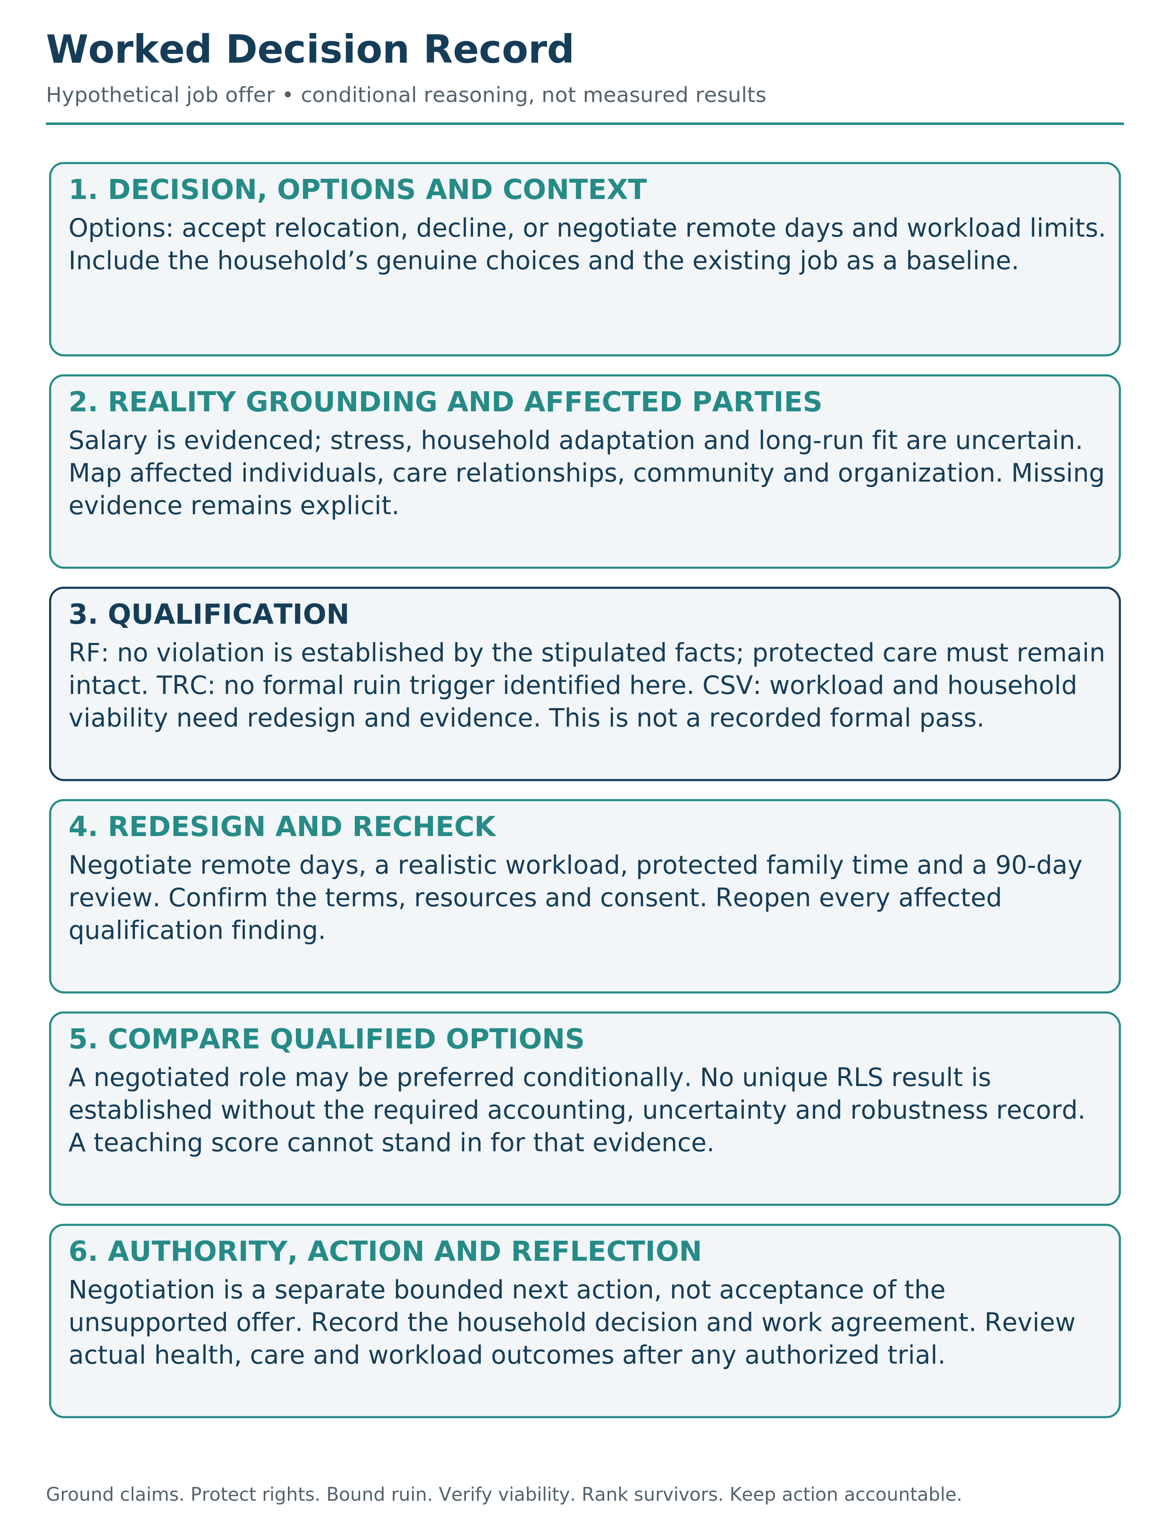

What follows is not a theory diagram. It is a way to make pressure, trade-offs, and uncertainty legible enough that you can still choose cleanly.

The Decision Template
Here is the complete RippleLogic decision process, applicable at any mode with varying depth.

Step 1: Notice
Before anything else, notice your state. Am I calm or reactive? Rested or depleted? Clear or distorted by fear, craving, pressure, or exhaustion? State shapes perception. Distorted perception leads to distorted choices.

Step 2: Define the Decision
Name the decision clearly and specifically. Vague decisions produce vague thinking. Specific decisions reveal real trade-offs. In Deep Mode, map the option set before you start defending one option.

Step 3: Ground Reality (RG/RSG)
What is actually known? What is unknown? What is assumed? What is measured, inferred, generated, inherited, or merely claimed? What is the evidence trace? What is the action boundary? What consequence pathways are plausible? What claim is this evidence strong enough to support?
Map materially affected people, other possible welfare bearers, systems and exposure pathways here, before a gate relies on them. Establish any needed SGP protection posture at this stage. Steps 7–9 refine that map and make it easier to inspect; a new protected stakeholder, harm or unknown reopens the affected earlier checks.
In Quick Mode: ask whether you are acting from reality or story. In Standard Mode: name key evidence and unknowns. In Deep Mode: document the reality surface, material unknowns, source-coupling risks, category definitions, and claim boundary.
When an action depends on medical, physical, ecological or engineering conditions, obtain domain-appropriate evidence or a qualified warrant before claiming it is supportable. Record the model’s limits, what could fail, and how the action can be stopped or corrected. Approval and monitoring do not prove safety. Appendix I names the formal evidence profiles.
Figure 16. Reality Grounding: From Evidence to a Bounded Claim. Evidence source and method, model assumptions, unknowns, the exact action, and the maximum supportable claim form one accountable chain. Computed possibility is not automatically grounded reality or lawful authority.
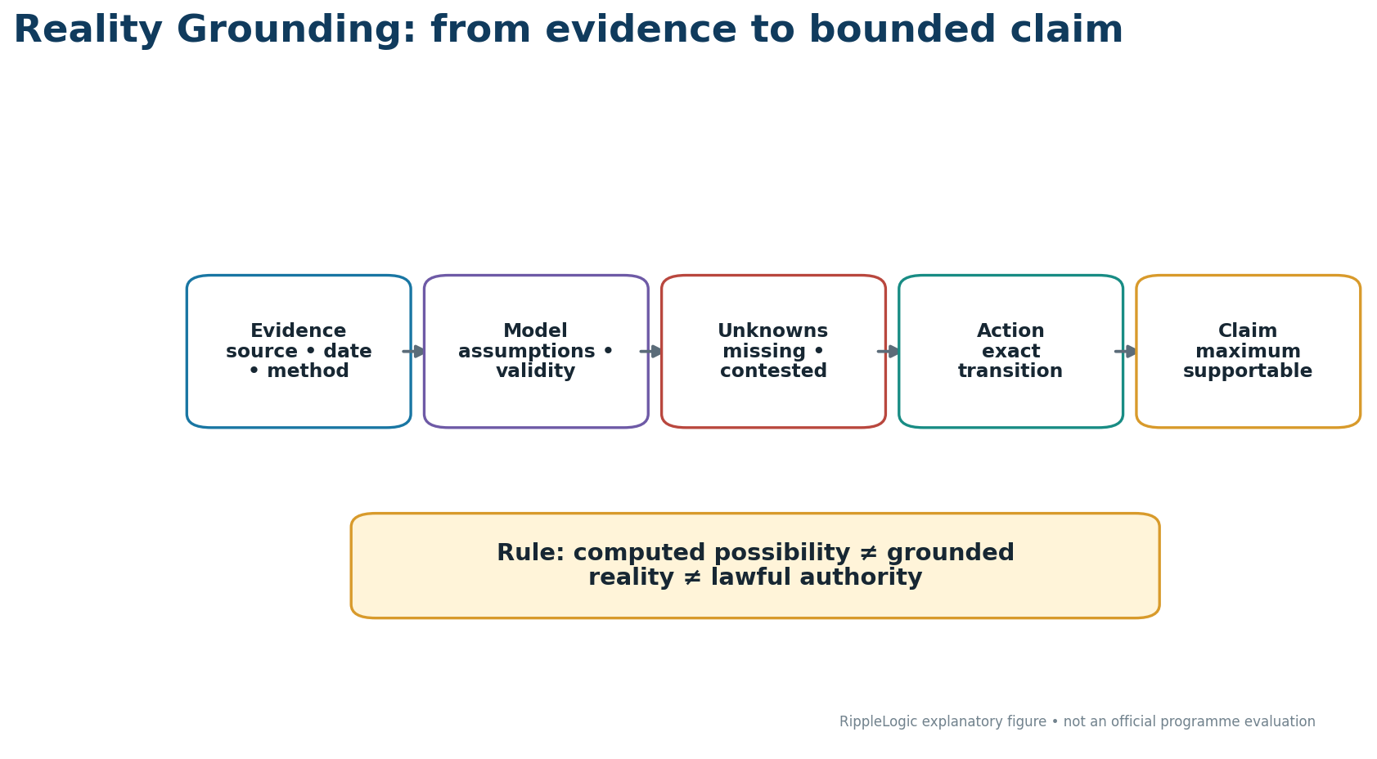

Step 4: Check the Rights Floor (RF/NCRC)
You cannot check the floor without already scanning everyone the option materially touches. The gates run on a quick stakeholder sweep; Steps 7 and 8 will formalize that sweep into a map for scoring.
Before investing in optimization, apply the constraint. Could any option materially threaten Life, Bodily Integrity, Liberty, Basic Needs, Dignity, Due Process, Information or Ecological Integrity? A supported floor violation, categorical prohibition or exceedance of an applicable severe-hazard tolerance blocks an ordinary pass. Mere detection of a hazard is not identical to proving that it exceeds the governing tolerance. Required unresolved evidence leaves the rights result unknown, not permitted.

Step 5: Screen Catastrophic Downside (TRC)
Ask whether the option triggers a catastrophic, systemic or declared ruin-path concern. Qualification requires either a supported pass on the governed tail-risk test or a documented finding that the catastrophe profile is not triggered. Neither is permission to ignore a later-discovered pathway. Include governance lock-in where relevant, and keep any local-ruin extension explicit. If material uncertainty prevents a responsible bound, gather evidence, narrow, redesign, escalate or refuse the stronger action. A pass is limited to the assessed scenarios; it does not prove that every possible catastrophe was found.

Step 6: Check CSV: Containment and Structural Viability
Now ask whether a local win is purchased by degrading a system it depends on or by relying on a pathway that cannot actually stand. Does the option export burden, create lock-in, hollow trust, destroy resilience, or lack workable monitoring and exit conditions? CSV does not demand zero harm. It requires material harms to be visible, bounded, routed and addressed without structural degradation beyond tolerance. An ordinary option needs a pass, a pass with binding controls, or a justified finding of non-materiality. Controls that support passage are part of the option, not promises outside it.
For consequence-bearing physical action, pass-with-controls is unavailable while physical or causal admissibility remains unresolved. Monitoring, operator acceptance or promised safeguards cannot replace a domain-appropriate warrant within its validity conditions. A separately bounded test or evidence-gathering action may be considered only if its own risks pass qualification. It is not clearance for the original unsupported execution.
If CSV discovers a new catastrophic or ruin-path scenario that TRC did not consider, reopen TRC before RLS. Figure 17 turns CSV into a visible current-state, transition, and resulting-state test.
Figure 17. Structural Viability: Can the Option Actually Stand? CSV tests the current state, the transition, the resulting state, six closure conditions, future option space, and control-before-promise. A missing control changes the option and triggers requalification.
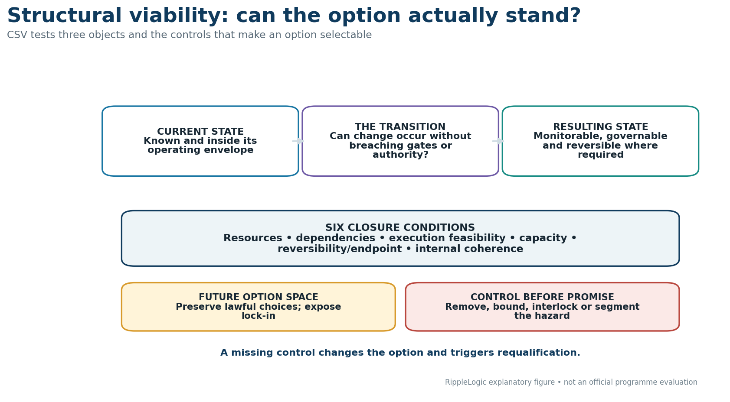

Step 7: Refine the Affected-Scope Map
Which operational scopes are materially affected? Self. Household. Community. Organization. Polity. Humanity / Global Coordination. Biosphere. Beyond them, ask whether Cosmic or Universal / AIU matter as horizon unions in this case. Standard computation remains the seven operational scopes unless a future governed extension says otherwise.

Step 8: Refine the Affected-Dimension Map
Which Welfare Dimensions are at stake? Material. Health. Social. Knowledge. Agency. Meaning. Environment. You are not asking only whether this is good. You are asking: good for whom, in what specific way, with what evidence, and against what baseline? When a formal or consequential run claims dimension-level evidence, use the welfare-dimension standard pinned in Appendix G to identify the cell and pathway, preserve subgroup visibility, and prevent double counting.

Step 9: Complete or Revisit Material SGP Evidence
If any affected stakeholder has uncertain or disputed moral status, apply SGP cautiously as a governed protection and participation protocol. It may inform protected-bearer records and the SGP-aware welfare-inclusion hypotheses that must be tested. MPS is not a numeric welfare multiplier. SGP does not override RG, RF/NCRC, TRC, CSV, RLS, lawful authority, or role-specific governance requirements. Every human person remains FPP-100 by constitutional commitment, not by measured performance.

Step 10: Redesign and Re-Qualify When Needed
Before ranking imperfect survivors, ask whether the option set can be improved. Is there a cleaner path, better boundary, safer sequence, or alternative design that reduces the trade-off? Any materially redesigned candidate must return through the affected RG, RF/NCRC, TRC, and CSV levels before it is treated as selectable.

Step 11: Declare and Justify Residual Weights
Confirm that scope and dimension weights, comparison masks, baselines and uncertainty methods were declared before outcome-sensitive ranking. Make them explicit, justified and challengeable. Public 100-point weighting is a teaching aid, not formal HDW. A legitimate revision requires a record and rerun. Weights cannot override RF/NCRC, TRC or CSV.

Step 12: Compute and Interpret RLS
Estimate the residual effects on their declared basis, preserve uncertainty and count each effect only once. Compare only the selectable survivors. The formal score divides by the active effective weight mass; a zero denominator is undefined, not neutral. A point leader is not a unique winner unless its advantage over every rival survives the required, justified uncertainty and robustness checks. Teaching points are not a substitute for that evidence.

Step 13: Choose and Act
Choose on the basis the evidence supports: a warranted framework result, a sole surviving option, or a separately accountable choice among non-decisive survivors. Then check that the exact action is authorized, supported by the relevant domain evidence and bound to real controls. Record who is responsible and what will trigger review. Selected is not automatically executable; Chapter 12 and Appendix I keep capability, permission, action and outcome distinct.

Step 14: Reflect
After action, close the loop. What happened? What surprised you? What will you update next time? Reflection is what turns one decision into the next layer of skill.

A Fully Worked Example: The Higher-Paying Job
Table 3. Worked Example: Higher-Paying Job Offer. The cascade separates qualification, redesign, residual comparison, authority selection, and action.
Cascade level | Result in the job-offer case
RG | Pay increase is known. Stress, commute burden, household adaptation, and meaning fit are forecast and uncertain.
RF/NCRC | No obvious floor breach if voluntary and if basic care, dignity, and health obligations remain protected.
TRC | No formal catastrophe, systemic lock-in, or declared ruin-path trigger is identified. Burnout, health collapse, and household fracture are routed to RF/NCRC, CSV, and residual-welfare analysis.
CSV | As specified, the option fails or requires redesign if income is gained by hollowing health, trust, recovery, or long-term meaning.
Redesign / rerun | Negotiate hybrid work, workload boundaries, delayed relocation, protected family rhythm, and a 90-day review. Re-run the affected RG, RF/NCRC, TRC, and CSV levels.
RLS | Only after the redesigned candidate re-qualifies: compare the residual Material, Health, Social, Agency, and Meaning profile among the surviving options using declared weights and uncertainty.
Action | Do not accept as-is until the redesigned conditions are explicit enough to test.
A higher-paying job can be positive only if the redesigned conditions protect health, household stability, and long-run viability.
Decision: take a higher-paying job that increases income, but adds stress, longer hours, and less time at home.
Reality Grounding: the pay increase is real, but the stress impact, commute burden, household adaptation, and meaning alignment are uncertain. The evidence is partly financial, partly experiential, and partly forecast. Claim boundary: this is a personal Standard or Deep Mode decision, not a validated prediction.
Rights Floor: no obvious rights-floor violation, provided the choice remains voluntary and does not require deception, coercion, neglect of basic care obligations, or sustained health degradation below the floor.
TRC: no formal catastrophe, systemic lock-in, or declared ruin-path trigger is identified in this personal case. Burnout, household fracture, and health collapse remain serious RF/NCRC, CSV, and residual-welfare concerns and may still require redesign or refusal. Formal TRC should not become a label for every serious personal risk.
CSV: the local win is higher income. The CSV question is whether that win is being purchased by degrading the larger systems that must remain healthy: household trust, physical health, recovery capacity, and long-term meaning. If the job is viable only by hollowing those systems, it fails or requires redesign.
Active scopes: Self, Household, Organization, and Community. Humanity and Biosphere may be lightly affected, but they are not irrelevant if the role changes consumption, commute, or contribution patterns.
Active dimensions: Material improves. Health may worsen. Social and Meaning may weaken if the role crowds out family life or values alignment. Agency may increase through financial freedom, or decrease if the role becomes controlling.
Ripple estimate: the offer looks positive on income and status, mixed on agency, and potentially negative on health, household stability, and meaning.
Redesign: before choosing yes or no, improve the option set. Negotiate remote days, protected family time, a later start date, a trial period, or a clear exit path if the role proves corrosive. Re-run the affected qualification levels on the revised option.
Weighting and RLS: after the redesigned option passes the affected qualification levels, make the residual weights explicit. The question is not whether more money is good in isolation. It is how the selectable options compare across household stability, health, meaning, material security, and agency, with uncertainty preserved.
Possible clean choice: accept only if the redesign succeeds. If the role requires sacrificing health or household stability to remain viable, the higher pay is not a clean gain.
Reflection: after three months, review what actually happened. Did income help? Did stress rise? Did household trust improve or erode? The point is not to predict perfectly. It is to notice sooner, choose cleaner, and learn.

A Second Short Run: The Predatory Loan
Not every RippleLogic decision is a career choice. Imagine a household facing a sudden medical bill. A lender offers fast cash, but the repayment terms are harsh, confusing, and likely to trap the family in debt.
Reality Grounding: the need is real and urgent. The interest rate, repayment schedule, penalties, family income, alternative support, and health consequences must be named instead of guessed. Claim boundary: this is not a moral failure by the household. It is a constrained decision under pressure.
Rights Floor: if the lender uses deception, coercion, threats, or terms that strip basic needs from the family, the problem is not merely a bad trade-off. It approaches a floor violation through dignity, information, basic needs, and due process.
TRC: the standard catastrophe-cell profile is not automatically triggered by this household case. A governed local-ruin extension could treat spiraling debt, lost housing, untreated illness, family breakdown, or loss of school access as a formal tail corridor, but that extension must be declared and applied consistently. Without such an extension, these harms remain urgent RF/NCRC and CSV concerns.
CSV: the quick cash may solve one urgent problem while hollowing the larger system that must remain viable: household stability, food security, health, school continuity, and trust. If the option works only by breaking those supports, it fails or requires redesign.
Redesign and RLS: the cleaner path may be a smaller loan, transparent repayment, a community fund, a payment plan with the clinic, employer advance, family support, or a charity bridge. Re-qualify each redesigned option, then use RLS only among survivors. RippleLogic does not pretend every hardship has an easy option. It does force the hidden structure of the decision into view, so urgency does not become a trap disguised as help.

The Template on One Page
If a reader remembers only one operational sequence a week later, it should be this one: qualify before you optimize; rank only what survives.
Phase 1 - QUALIFY: establish that the option belongs in the ring.
Notice: Check state. Clear or distorted?
Define: What am I actually deciding?
Ground Reality: What is known, unknown, assumed, evidenced, sourced, falsifiable, and claim-bounded?
Rights Floor: Any rights-floor violation? If yes, redesign or reject.
TRC: Identify any catastrophe or ruin-relevant pathway. A trigger requires a governed assessment, not automatic rejection; unresolved or excessive exposure requires narrowing, redesign, escalation or refusal.
CSV: Any local win that degrades a larger system, fails structural viability, or lacks required physical/causal admissibility evidence? If yes, redesign, control, escalate, narrow the claim, or reject.
Scopes: Which of the seven operational scopes are materially affected? Do Cosmic or Universal / AIU matter only as horizon reflections?
Dimensions: What is affected? Material, Health, Social, Knowledge, Agency, Meaning, Environment?
SGP: Is moral-status or rights-of-protection evidence material? If yes, use SGP cautiously.
Before Phase 2 - REDESIGN: improve any candidate whose trade-off can be materially reduced.
Re-qualify: return every materially redesigned candidate through the affected RG, RF/NCRC, TRC, and CSV levels.
Phase 2 - RANK: among the selectable survivors, declare and justify the residual priorities.
RLS: using those declared weights, what is the modeled residual direction among the qualified survivors?
Act: Choose and take the smallest clean action within verified authority, controls, and execution conditions.
Reflect: What happened, what surprised me, what updates next time?

Scaling the Template
The same questions can be applied across scales; the evidence and governance burden change with the stakes.
Personal decisions:
Should I take this job?
Run the template. Notice state and define the choice. Ground the evidence, check RF/NCRC, TRC, and CSV, then map the active scopes and dimensions. Redesign and re-qualify where possible. Declare residual priorities, compare only the surviving options with RLS, then choose and act.
Household decisions:
Should we move to a new city?
Run the template. Include all household members as stakeholders, ground the evidence, map how the move affects each person, and check RF/NCRC, TRC, and CSV. Look for redesign before ranking, re-qualify the revised options, then declare the residual priorities, compare the survivors, choose together, and act.
Organizational decisions:
Should we launch this product?
Run the template. Map all affected scopes and stakeholders, map the welfare dimensions, and check Reality Grounding, the Rights Floor, catastrophic downside, and containment. Redesign to reduce harm and re-qualify the revised option. Only then declare stakeholder weights, compare surviving options, document the reasoning, choose, and act.
Policy decisions:
Should we implement this regulation?
Run the template at full depth. Map all affected populations, future generations, and ecosystem impacts. Ground the claims and apply RF/NCRC, TRC, and CSV rigorously. Seek redesign before ranking and re-qualify revised options. Then declare competing weights transparently, compare only the survivors, document trade-offs, choose through legitimate process, and implement with monitoring.
The template scales.
The depth adjusts.
The structure remains.

Common Integration Errors
As you practice the template, watch for these failure patterns:
Skipping the floor check.
The most dangerous error.
If you score and weight before checking the floor, you can rationalize violations.
Ground first; then protect the floor before any ranking.
Forgetting distant unions.
The unions that are easy to ignore are usually the ones bearing the cost.
Future generations. Distant communities. Ecosystems. Workers you never see.
Make them visible.
Collapsing dimensions.
“Is this good?” is not a dimension.
“Good for Health, bad for Material, neutral for Social” is a dimension map.
Keep dimensions separate.
Accepting false binaries.
“Option A or Option B” is often a failure of imagination.
Always ask: What is Option C?
Analysis paralysis in Quick Mode.
Quick Mode is for quick decisions.
If you are running full analysis on whether to order coffee, you have mismatched mode to stakes.
Insufficient analysis in Deep Mode.
Deep Mode is for deep decisions.
If you are making a life-changing choice in two minutes, you have mismatched mode to stakes.
Skipping reflection.
Without reflection, you do not learn.
You just repeat.
Close the loop.

How RippleLogic Can Be Misused
Pseudo-precision. Rough estimates are treated as measurements. Corrective rule: disclose evidence quality, uncertainty, and sensitivity; never let decimal detail borrow authority from weak inputs.
Weight laundering. Weights are tuned to justify a preferred answer. Corrective rule: declare and justify weights before viewing the final ranking, test alternatives, and preserve dissent.
Double counting. One consequence is recorded in several cells as independent benefit or harm. Corrective rule: trace pathways, dependence, allocation, and overlap through WDBIP before aggregation.
Scope omission. Distant, weak, future, or non-human stakeholders are left outside the frame. Corrective rule: run an explicit stakeholder and externality search, then record unresolved omissions.
Rights-floor capture. Floors are defined strategically thin so a favored option can pass. Corrective rule: use the canonical floor categories, affected-party challenge, evidence, and independent review where stakes justify it.
Uncertainty masking. Missing evidence is entered as zero or neutral. Corrective rule: use UNKNOWN, ASSUMPTION_BOUND, ESTIMATED, or NOT_OBSERVED and test material alternative hypotheses.
Score-as-truth. RLS is treated as objective moral authority. Corrective rule: remember that it is a modeled comparison among selectable survivors, not truth, permission, or proof.
Selection-as-execution. A selected option is treated as authorized, physically admissible, or ready to deploy. Corrective rule: require lawful authority, domain warrant, controls, testing, monitoring, and rollback.
Framework theater. Templates are completed without changing evidence, options, controls, or decisions. Corrective rule: an artifact counts only when it improves reconstruction, challenge, redesign, or responsible action.
Mode mismatch. Deep Mode is used to inflate ordinary choices, or Quick Mode is used to evade consequential analysis. Corrective rule: make the burden proportionate to stakes, uncertainty, irreversibility, and affected scope.

A Third Run: The Cheaper Supplier
The job-offer example shows personal pressure. The predatory-loan example shows dignity under economic pressure. The cheaper-supplier example shows how organizations can look efficient while exporting hidden harm upstream.
Table 4. Worked Example: Cheaper Supplier. The table shows how a local material gain can export labor, trust, community, and ecological costs unless the option is redesigned and re-qualified.
Level | Question | Finding | Clean redesign
RG | What is real? | The supplier is cheaper, but labor conditions, ecological controls, and quality assurance are weakly evidenced. | Pause approval until evidence is obtained: labor audit, environmental trace, quality record, and source-coupling check.
RF/NCRC | Could the price depend on rights-floor harm? | Possible dignity, basic-needs, due-process, or ecological-integrity concerns if workers or communities carry hidden costs. | Reject if rights-floor violation is confirmed. Require a supplier code with evidence, not only a signed promise.
TRC | Could severe irreversible harm be created? | Forced labor is a rights issue. Toxic exposure or safety failure reopens TRC only when a declared catastrophe or ruin-relevant pathway is plausible; ordinary severe harm remains visible in its appropriate gates. | Set escalation triggers and refuse the stronger claim until unknowns are narrowed.
CSV | Is the local win structurally viable? | Savings may hollow quality, trust, brand integrity, worker welfare, and ecological conditions upstream. | Require evidence and binding remediation, monitoring and exit conditions adequate to the actual harm. A phased contract or signed promise cannot by itself clear unresolved physical or rights risks.
RLS | What remains after gates? | If evidence is clean and controls are real, modest savings may be positive. If hidden harm persists, the apparent win is negative. | Choose the supplier only after RG, RF/NCRC, TRC, and CSV pass for the revised option and the residual comparison is documented.

A Fourth Run: The Orbital Constellation
Hypothetical frontier example: consider a proposal to expand a satellite constellation in an already contested orbital environment. The goal is broader communications coverage. The governed choice is whether to approve the proposed configuration, approve a redesigned configuration, delay, or refuse until the evidence and controls are stronger.
Reality Grounding: Separate known engineering parameters from forecasts: satellite count, orbital configuration, deorbit capability, collision-avoidance performance, launch cadence, model validity, debris assumptions, and who controls updates. Unsupported assumptions and unresolved collision behavior remain explicit unknowns rather than being converted into a clean forecast.
Rights Floor: Identify rights-covered stakeholders on Earth and in affected missions. Ask whether the design would materially endanger life or bodily integrity, undermine protected information access, or impose other governed rights-floor harms on people who depend on the infrastructure. A supported rights-floor violation does not enter ordinary ranking; redesign, escalation, or refusal comes first.
TRC: Examine low-probability, high-severity pathways such as a collision cascade that could disable shared orbital infrastructure or create long-lived lock-in. If the declared ruin corridor cannot be responsibly bounded, ordinary selection stops even when average benefits are large.
CSV: Test whether the exact configuration can stand under real dependencies and controls: deorbit reliability, collision avoidance, traffic coordination, failure recovery, monitoring, shutoff or rollback where physically meaningful, the resulting orbital state, and the effect on future safe options. Controls promised in principle but not bound to the configuration do not count.
RLS: Only if more than one configuration survives qualification do we compare residual benefits and burdens across the active seven operational scopes. Cosmic remains a horizon of responsibility, not an additional scoring row. A design with slightly less coverage but materially stronger containment, lower downstream burden, and greater shared-infrastructure resilience may outrank the locally optimal design.
Outcome: The method has not changed; the consequence field has widened. If a configuration is selected, that still does not itself authorize launch or establish physical admissibility. Legitimate authority, domain warrant, and the qualified configuration must remain matched through execution and review.

The Template as Daily Practice
You do not need to run full Deep Mode every day.
But you can run Quick Mode constantly.
Every meaningful choice is an opportunity to practice:
Notice and ground. Am I clear, and what am I assuming?
Qualify. Any rights-floor, ruin-path, or structural-viability failure?
Scopes. Who is affected, including the easily hidden?
Redesign and re-check. Is there a cleaner option that still qualifies?
Rank and choose. Among the survivors, what is the better modeled residual direction and smallest clean action?
This takes seconds once it becomes habit.
And the habit changes how decisions feel.
Because alignment is not a destination.
It is a practice.
Every day. Every choice. Every moment of noticing.
The template is not a burden.
It is a tool that becomes invisible as it becomes instinctive.
You stop thinking about the steps.
You start thinking through the steps.
And your decisions get cleaner.

Documentation for Deep Mode
When running Deep Mode, especially for organizational or policy decisions, documentation matters.
A decision record should include:
The decision: What was decided and why.
The option set: What alternatives were considered.
The source and dependency record: What evidence, model, dataset, procedure, authority, or inherited label supports the claim, and what would falsify or require rerunning it.
The physical/causal evidence profile, if material: model basis, validity domain, boundary conditions, verification or warrant, monitoring/shutoff path, residual unknowns, and execution boundary.
The floor analysis: How the rights floor was checked.
The stakeholder map: Which unions were affected.
The dimension assessment: What welfare dimensions were at stake.
The ripple estimate: Expected impacts by union and dimension.
The redesign and rerun record: What alternatives were explored, what changed, and which qualification levels were rerun.
The weighting and residual-ranking rationale: How qualified survivors were weighted, compared, and interpreted under uncertainty.
The final choice: What was chosen and what action was taken.
The reflection plan: How outcomes will be monitored and when the decision will be reviewed.
This documentation serves three purposes:
Accountability. Others can review the reasoning.
Learning. You can return and see what you predicted correctly and incorrectly.
Improvement. The organization develops institutional memory about decision quality.

The Template and NCAR
The decision template fits inside the NCAR loop.
Notice = Steps 1-2 (state check and decision definition)
Choose = Steps 3-12 (Reality Grounding through qualification, redesign and re-qualification, residual weighting, and RLS)
Act = Step 13 (choose and act)
Reflect = Step 14 (post-decision review)
NCAR is the loop.
The template is the content of the loop.
They work together.
NCAR without the template is a loop without structure.
The template without NCAR is a procedure without practice.
Together, they create an integrated practice for aligned decision-making.

What Integration Feels Like
When the template is fully integrated, something shifts.
You stop experiencing decisions as overwhelming.
You start experiencing them as navigable.
The unions become visible without effort.
The relevant dimensions become easier to recognize without pretending they are self-evident.
The floor becomes instinctive.
Initial ripple hypotheses become visible earlier, while remaining open to evidence and correction.
The redesign question becomes habitual.
This is not because you became a saint.
It is because you became practiced.
The template trained your perception.
Your perception became intuition.
Your intuition became character.
And character, expressed through decisions, became the shape of your life.

Use This Today
Run one real decision through this compact check before the day ends:
Today’s decision: ________________________________
Reality clear enough? ____________________________
Floor concern? __________________________________
Tail-risk concern? _______________________________
CSV / local-win concern? ________________________
Active scopes: ___________________________________
Active dimensions / cleaner redesign: ______________________________
Best surviving option / smallest clean step: _______________________
Reader Compass Kit
Three Reflection Questions
Which step of the template do you most often skip? Notice? Floor? Redesign? Reflect?
When was the last time you accepted a false binary instead of looking for a third option?
What decision in your life right now deserves Deep Mode that you have been treating as Quick Mode?
NCAR Micro-Exercise (2 minutes)
Notice: Identify one decision you are facing this week.
Choose: Run through the template at Standard Mode depth.
Define the decision and the candidate options.
Ground the evidence and unknowns.
Check RF/NCRC, TRC, and CSV.
Map the affected scopes and dimensions.
Ask one redesign question and rerun the affected gates.
Declare provisional priorities among the survivors.
Estimate the modeled residual ripple only for the qualified set.
Act: What is the smallest clean action you can take today?
Reflect: What did the template reveal that you were not seeing before?
What’s Coming Next
The template is now in your hands.
You can run it on personal decisions.
You can run it on household decisions.
You can run it on organizational decisions.
But there is one more step.
RippleLogic is not only for individuals making better choices.
It is designed to scale beyond individuals.
Chapter 12 asks: How does this scale?
How do the principles of union awareness, RippleLogic, rights floors, and practice loops become embedded in culture, institutions, infrastructure, and civilization?
How does an individual practice become a collective transformation?
The personal practice has reached its working form.
The world-building begins.

Chapter 12: From Personal Practice to Civilizational Design
How RippleLogic Scales from One Mind to One World.
You have the system now: the scopes, the dimensions, the rights floor, catastrophic-risk screening, containment, ripple estimation, weighting, redesign, NCAR, and the integrated decision template. That is enough to begin changing decisions in real life. RippleLogic, though, was never designed to stop at individuals.

Why Individual Alignment Is Necessary But Not Sufficient
There is a seductive idea in personal development: if everyone just became a better person, the world would fix itself. That is only half true. Without individual alignment, little improves. Systems are built by people, decisions are made by people, and cultures are transmitted by people. But individual alignment hits limits quickly.
A good person inside a bad system can still produce harm. A wise individual cannot repair a corrupted institution alone. A practiced family cannot insulate itself from a collapsing biosphere. This is the coordination problem: personal wisdom does not automatically scale. If RippleLogic is to matter beyond the individual, it must be embedded in systems, not only practiced in private.

The Question Under the Question
This book argues that durable AI alignment cannot be solved inside AI alone. It also depends on the incentives, institutions, and governance of the civilization deploying AI, because AI is a mirror, an engine, and a multiplier: it reflects our incentives, extends our capacities, and accelerates whatever governance structure points it.
Society is already a kind of coordination organism. Law is one part of its memory. Markets are one part of its metabolism. Media is one part of its nervous system. Education is one part of its learning loop. Families are one part of its root network. When these systems are aligned toward truth, rights, repair, and flourishing, civilization becomes more intelligent. When they are aligned toward extraction, fear, denial, and speed without wisdom, intelligence fragments. RippleLogic is one attempt to help civilization become more self-auditing before its power outruns its correction capacity.
That is why the question is not only whether a model is more capable. The deeper questions are: Which values? Under what governance? Protected by what floor? Corrected by whom? If the surrounding civilization rewards extraction, deception, addiction, domination, and speed without wisdom, then smarter systems can make the same misalignment more efficient.
RippleLogic does not solve civilization by itself. It gives civilization a disciplined way to show its work: ground reality, keep the rights floor intact, bound ruin, preserve structural viability, compare residual benefits, and keep correction possible.

The Three Layers of Scaling
RippleLogic scales across three layers. First comes personal practice: one mind learning to notice state, see scopes and dimensions, check the floor, estimate ripples, redesign, and reflect. Second comes relational and organizational embedding: households, teams, and communities using a shared language so trade-offs become visible instead of hidden. Third comes civilizational design: laws, economic rules, technologies, and governance processes built to encode the floor, surface ripple effects, and make accountability traceable.
The key shift across all three layers is the same. Alignment stops being a private aspiration and becomes part of the structure within which decisions are made.
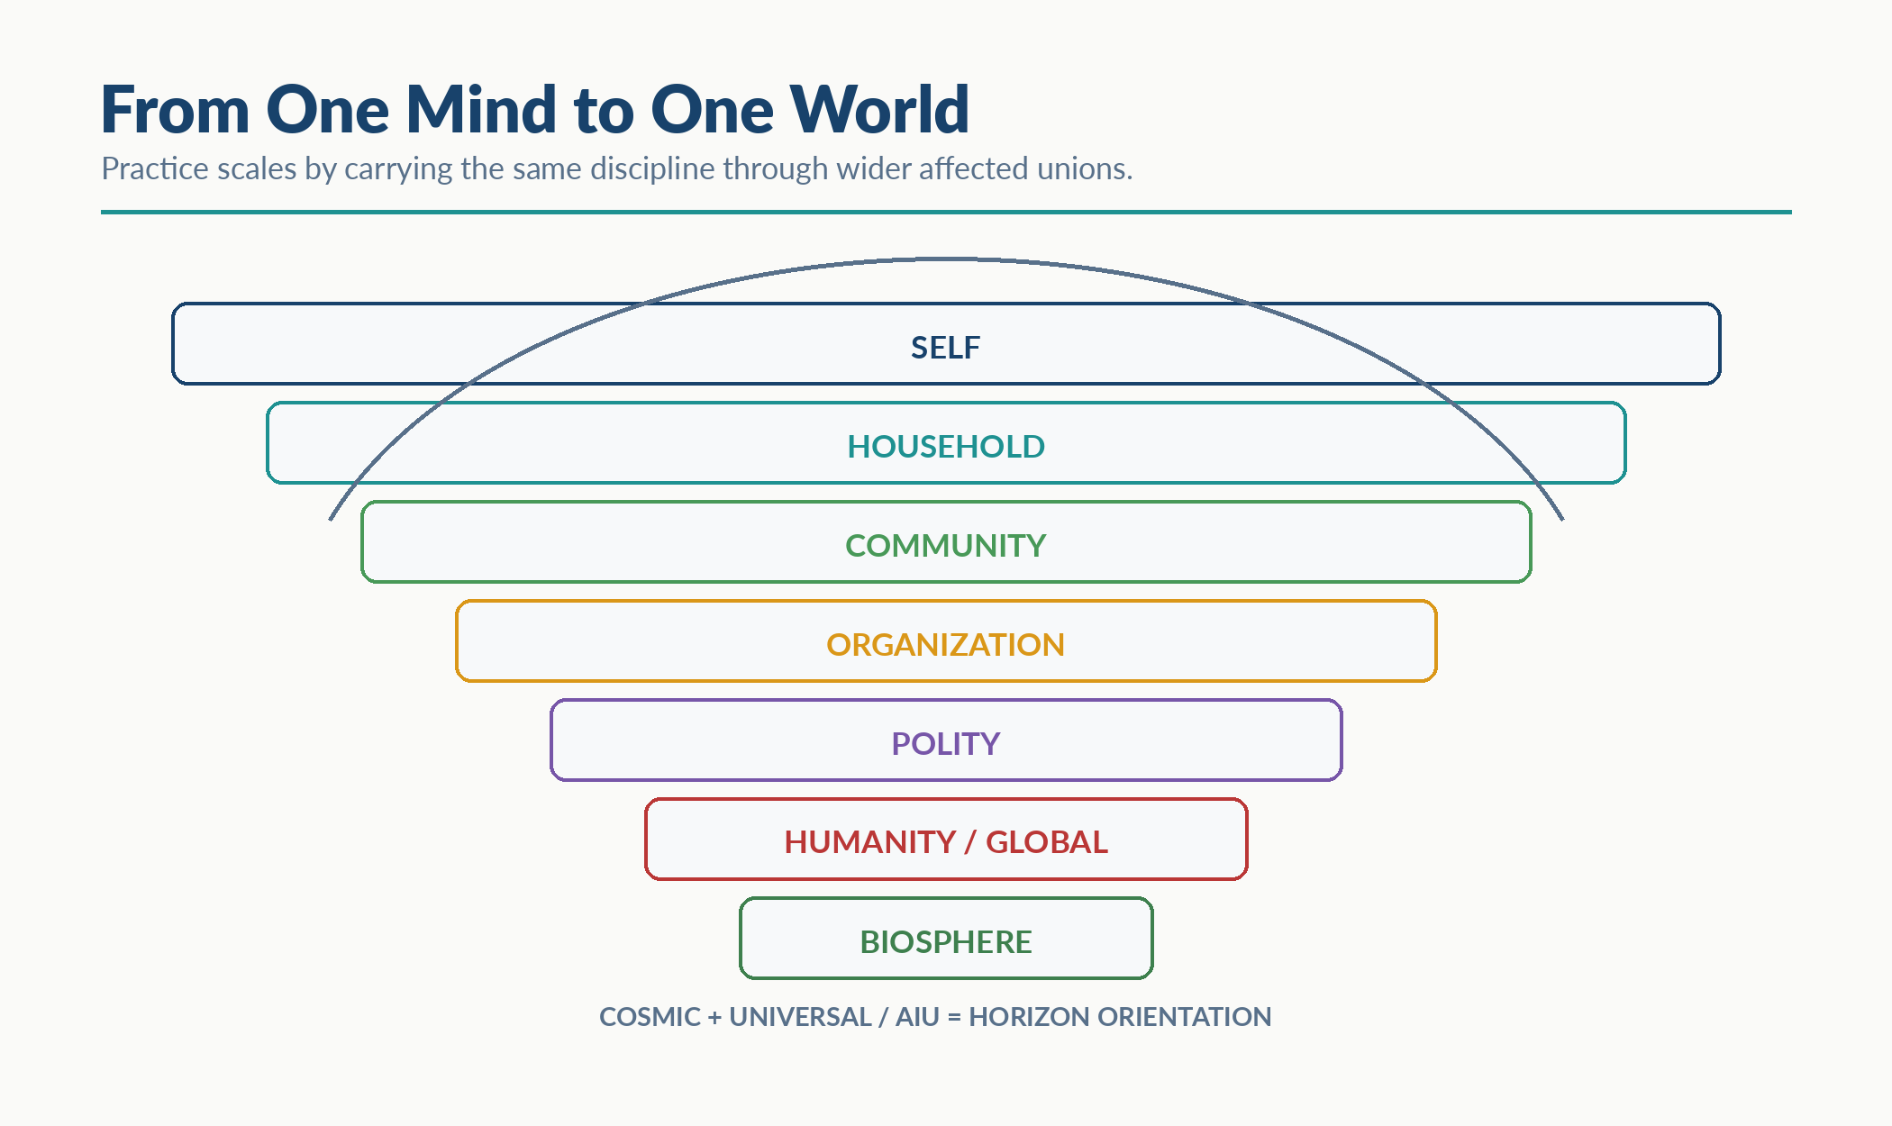
Visual Interlude - From One Mind to One World

From Method to Ecosystem
At this scale, MathGov matters less as another list of components than as a container for shared practice: the method can be taught, challenged, versioned, recorded, simulated, and embedded without changing the five-stage RippleLogic order.
You do not need the whole ecosystem to begin; you can practice RippleLogic now. The ecosystem becomes relevant when many people or institutions need a common language, evidence trail, training surface, implementation boundary, and revision path.

The Verifiability Requirement
One emphasis RippleLogic adds to public decision practice is visible reasoning. Ethical traditions offer rich guidance about what matters; RippleLogic asks decision-makers to make the relevant evidence, gates, trade-offs, and redesigns inspectable. The point is not moral surveillance. It is accountable structure.
When an organization claims it cares about stakeholders, RippleLogic asks which scopes were mapped, which dimensions were assessed, what ripple estimate was reached, how trade-offs were weighted, whether the floor was checked, and what redesign was attempted. If those questions cannot be answered, the alignment claim is not yet auditable; it may remain aspiration or marketing rather than demonstrated governance.
Verifiability is what separates genuine alignment from performative virtue and allows trust to scale. The wider MathGov ecosystem, using the RippleLogic decision architecture, therefore has to build this into infrastructure: auditable decisions, visible trade-offs, detectable floor violations, and a framework that remains open, testable, and improvable.
Audit is not bureaucracy. It is the memory of humility: a record that lets a person, team, institution, or future reviewer see what was known, what was assumed, what was protected, and what must be corrected.
Figure 18. One Public Decision, Many Interacting Realities. A public decision receives budget, rights, risk, and capacity inputs while affecting people, institutions, future conditions, and the biosphere.
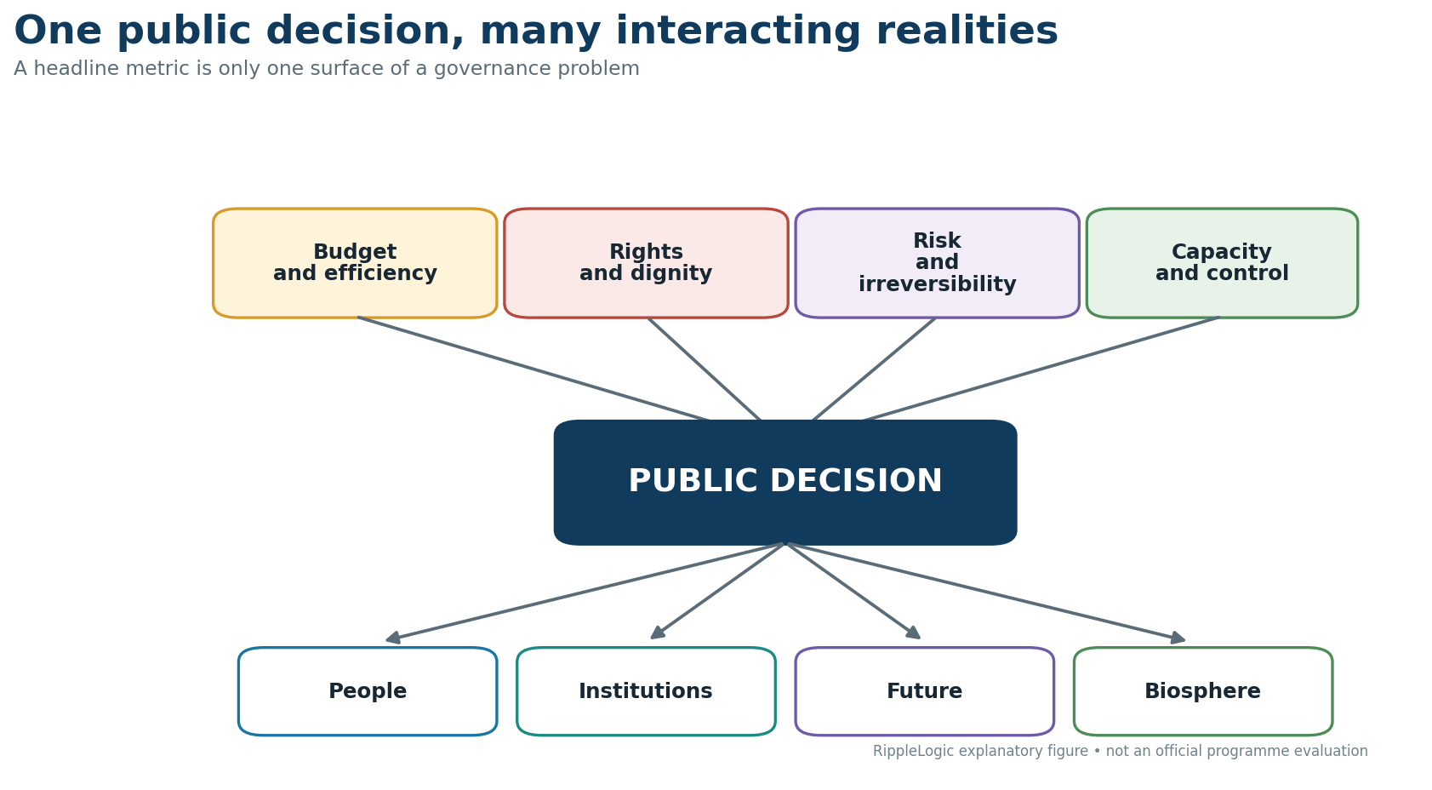
Completing this procedure does not create democratic legitimacy or a mandate. Those must come from the relevant accountable institutions and affected-party processes. The method itself must also earn its burden: Appendix F states what findings would count against it, including worse results than a simpler approach.

What Institutional Embedding Looks Like
The method becomes real when it shows up in ordinary structures. At the household level, a family might run a brief weekly NCAR review together: what decisions mattered, which scopes were visible, which trade-offs are still unresolved, and what redesign has been avoided. At the organizational level, major decisions can require a RippleLogic assessment before launch and a reflection review after implementation, turning reasoning into institutional memory rather than private intuition.
At the policy level, the same logic becomes public. A government or agency can require a documented account of affected scopes, affected dimensions, rights-floor analysis, trade-off weighting, and redesign attempts before a policy is adopted. At the technology level, an AI system can support rather than replace judgment by surfacing affected scopes, flagging floor risks, showing trade-offs, and making hidden impacts more visible to accountable humans.
Figure 19. Proposed Shadow-Pilot Cycle. Select cases, run independent analyses, compare existing practice, measure benefit and burden, and revise or reject. The proposal is a research design, not a reported result or an execution warrant.
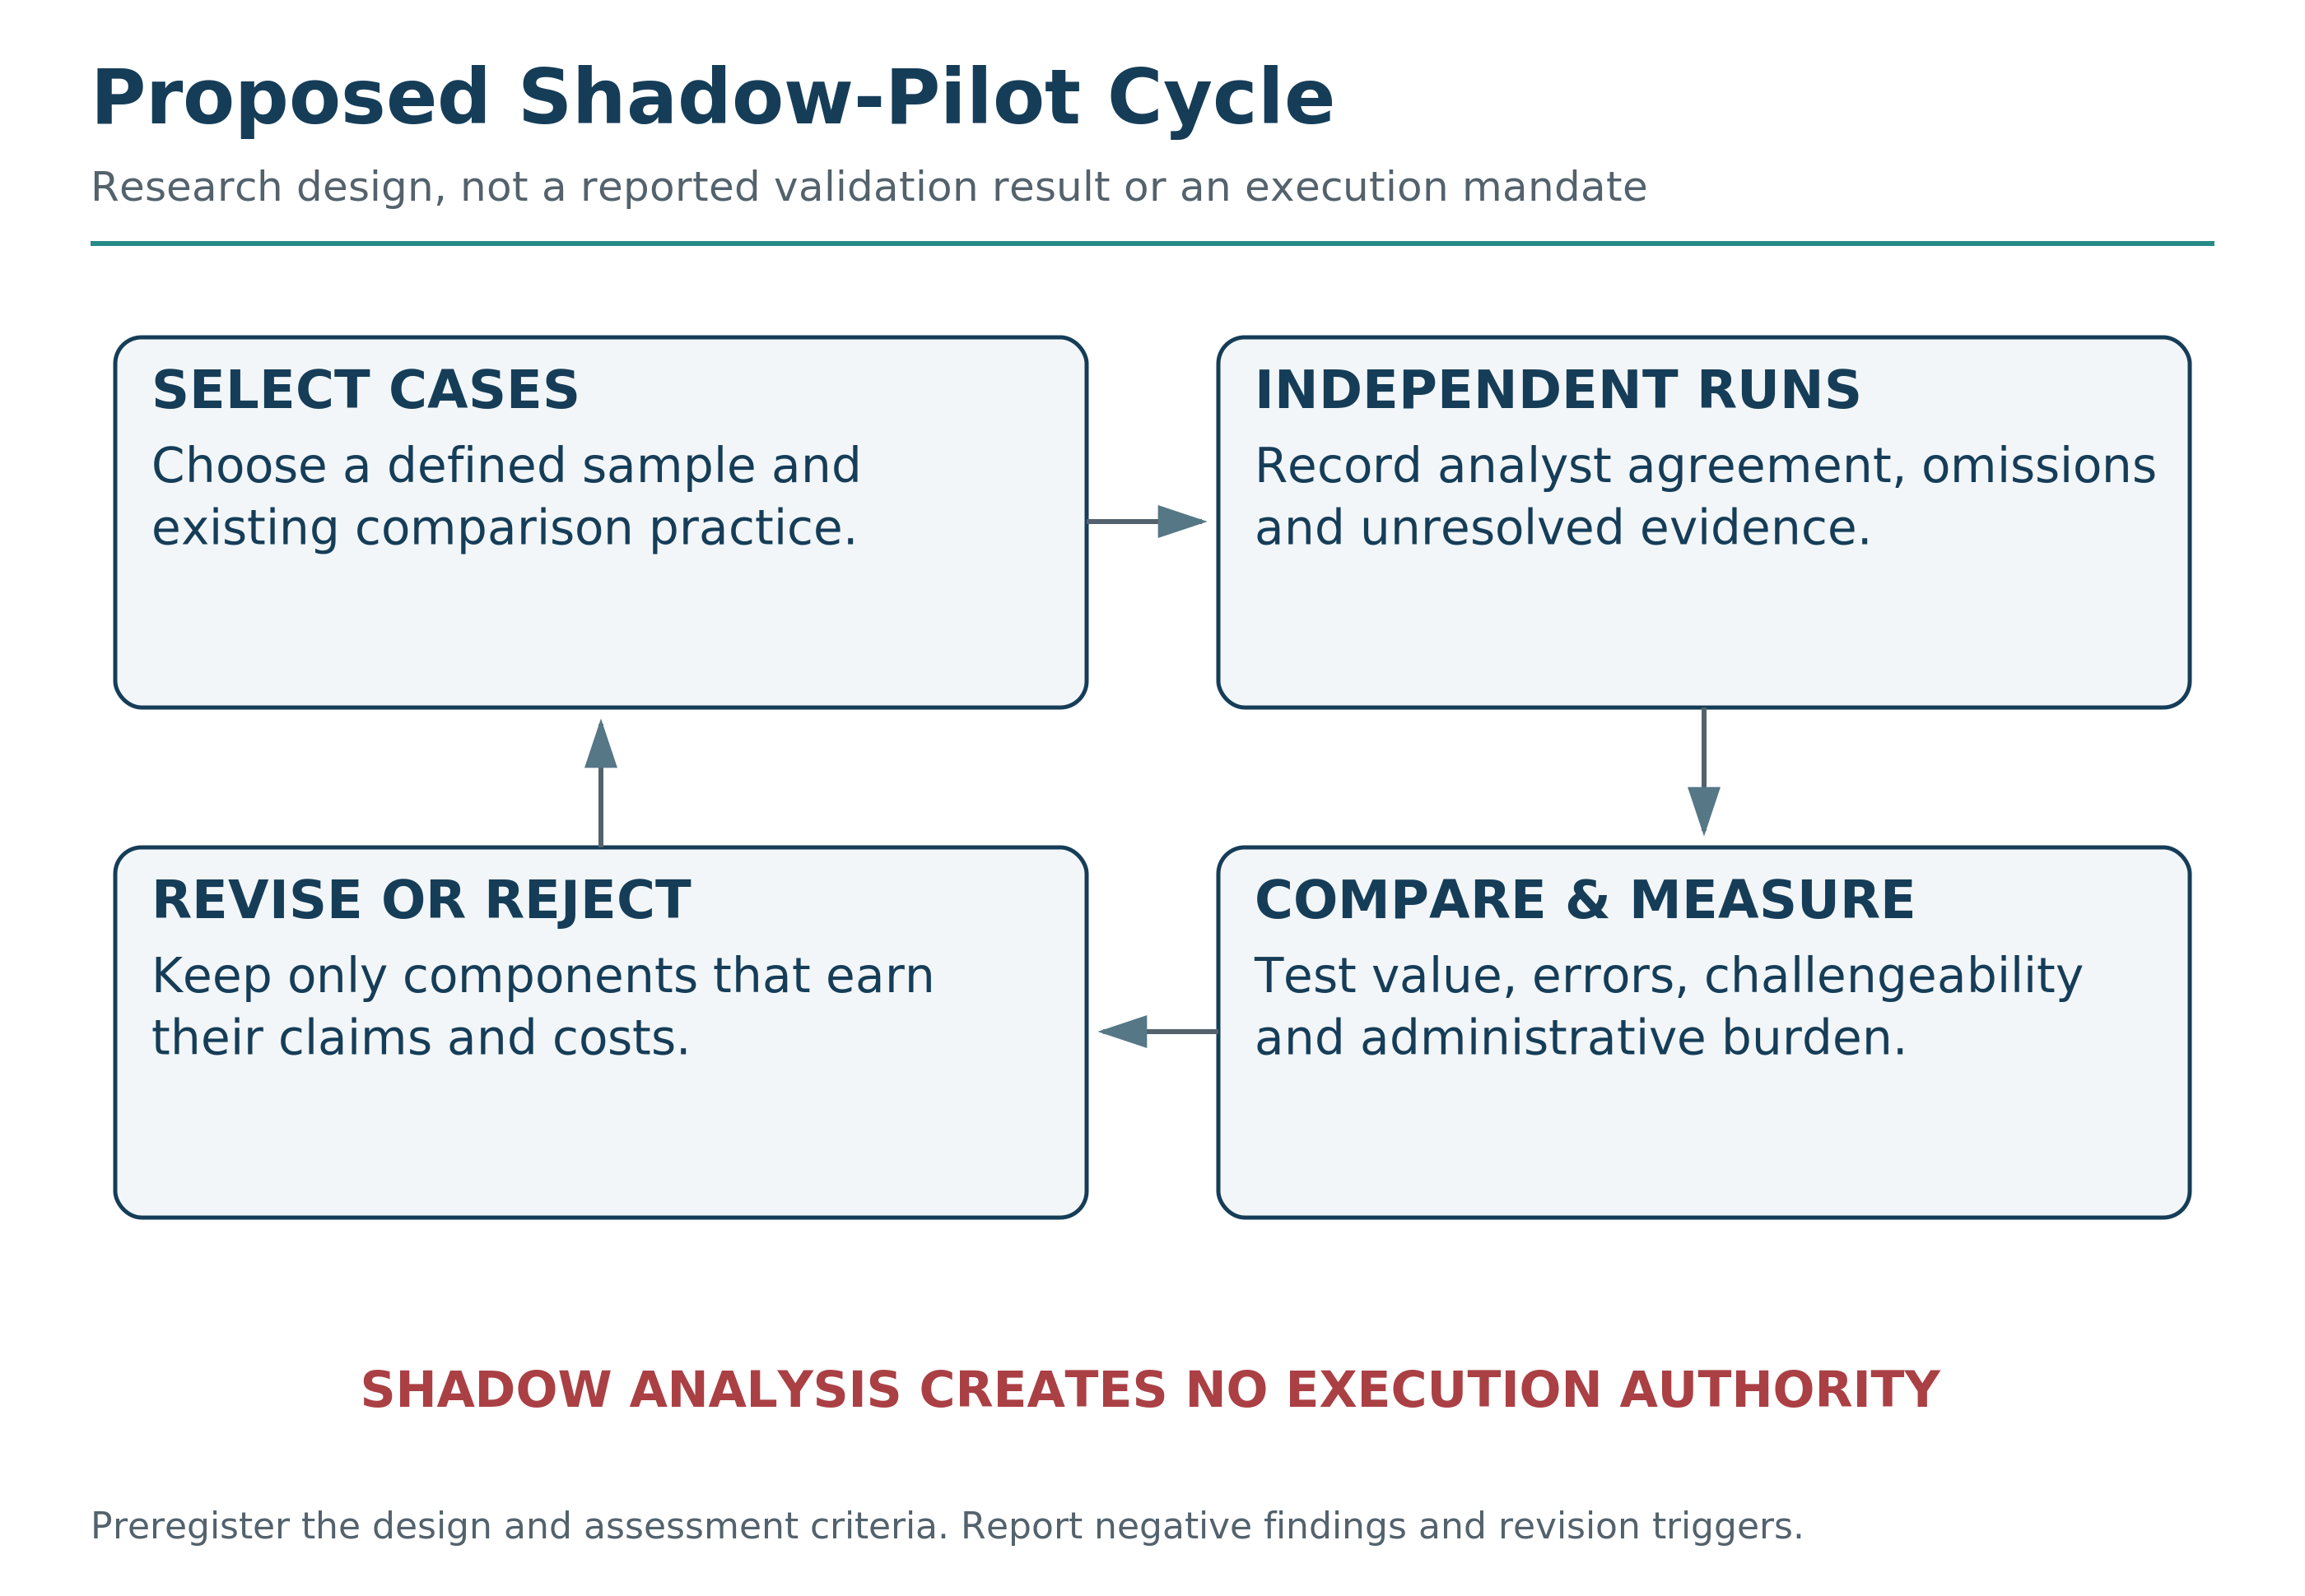

Capability Is Not Authority
Permission to make a capability available is not approval to execute every action it can generate. A model may have a capability that is unavailable, disabled or outside its authorized scope. Even an enabled capability produces only a candidate; the particular action still needs qualification, accountable selection and execution approval.
For AI and hybrid systems, claims must name the evaluated model, tools, memory, data, permissions, controls, environment and human review. A conclusion about one configuration does not automatically apply to another with the same product name.
A consequence interface is not legitimate authority. Connection to a consequential tool, network, compute surface, physical-action channel, or deployment pathway does not itself create a mandate to use it.
A successor or materially changed system does not inherit the parent system's qualification or authority. Derivation can create a candidate; it cannot create the candidate's mandate. The exact candidate configuration must be locked, independently re-qualified, and freshly authorized before consequential use.

A Milestone Is Not a Safety Case
A successful compilation, simulation, benchmark, prototype, or hardware test proves the named milestone. It does not by itself prove factual reliability, ethical acceptability, physical safety, legal authority, or deployment readiness. Each stronger claim needs its own evidence.
The strongest controls are structural: constrained permissions, bounded tools, separation of duties, authenticated operators, monitored channels, rollback, and shutoff paths. Behavioral promises can help, but they should not carry the whole assurance burden.
None of this guarantees perfect outcomes. It does something more practical: it makes the reasoning visible enough to challenge, improve, and learn from over time. Figure 20 shows the chain that must remain bound from qualification through selection, execution conditions, observed outcome, and requalification.
Figure 20. Qualification Continuity. The qualified option, selected option, exact action, configuration, controls, authority basis, observed outcomes, and requalification triggers remain bound through time. Material mismatch blocks ordinary execution.
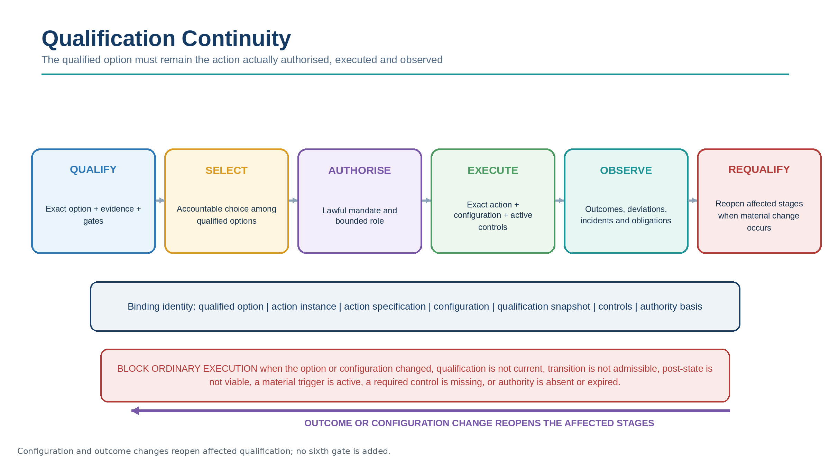

Worked Institutional Run: Should a University Adopt an AI Grading Tool?
A university is considering an AI grading tool. The advertised benefit is simple: faster feedback, lower staff burden, and more consistent marking. Without RippleLogic, the decision may collapse into one metric: efficiency.
Reality Grounding asks what is actually known: What evidence exists for accuracy across languages, disciplines, disability accommodations, and culturally varied student writing? What are the false-positive and false-negative rates? What human review remains? What data is stored, where, and by whom?
RF/NCRC asks whether any student’s dignity, due process, information rights, or fair opportunity would be violated. If a student cannot understand, challenge, or appeal a grade that materially affects their future, the floor is under pressure.
TRC asks whether a governed catastrophe or lock-in trigger is present, such as institution-wide irreversible dependence, mass systemic error, or concentrated control whose failure could propagate beyond ordinary correction. Wrongful failure, scholarship loss, visa or graduation consequences remain serious RF/NCRC and CSV concerns even when formal TRC is not triggered. CSV asks whether the university’s deeper structure remains viable: teacher judgment, student trust, academic integrity, data governance, and accountability.
Only after those checks does RLS compare the residual benefits: faster feedback, staff relief, learning analytics, and consistency. A cleaner redesign might use AI only as a formative assistant, never as final authority; require human review for consequential grades; preserve appeals; disclose use; audit bias; and log decisions.
The RippleLogic result is not automatically yes or no. It is a governed design question: under what conditions could the tool help without hollowing trust, rights, or educational meaning?

The Open Source Principle
The wider ecosystem is designed to remain open rather than proprietary or captured by any one company, government, or institution.
That means the framework should remain available to anyone who wants to study and use it, the tools should remain accessible beyond any one institutional class, standards development should remain transparent, and research and criticism should be publishable and debatable. Open source here is not only branding; it is part of the governance architecture. If the wider MathGov ecosystem were captured by a single actor, its credibility as an open governance methodology would be compromised and it could function primarily as a power tool.
The point of the rights floor is that power cannot override it. That principle must apply to the framework itself.

The Resistance That Will Come
Some resistance to RippleLogic is likely to come from incentives rather than overt hostility. Systems that benefit from hidden costs, rights erosion, or short-term extraction may describe wider visibility as impractical. The work is to make the trade-offs visible enough that alignment becomes easier to defend.

The Timeline Is Unknown
No one can know the timeline. The relevant question is simpler: are we moving toward better alignment or away from it? RippleLogic is a compass, not a finish line. Direction is something you can choose now, even under uncertainty.

What You Can Do
You do not need permission to begin. Practice NCAR on one real decision. Teach someone to name the active scopes and dimensions. Protect the floor when sacrifice logic appears. Redesign before you justify a bad trade-off. Document important reasoning. Share the method as a gift, not a slogan. Build with others where you can, and ask institutions to show their work where they claim to care.

The World We Could Build
I am not describing a utopia. Utopias collapse on contact with reality. I am describing a direction, and a direction is something you can choose under uncertainty without pretending the destination is guaranteed.
The hope is not perfection. Perfection is brittle. The hope is correction: a person who can say, I was wrong; an institution that can be audited; a civilization that can see its ripples and repair before damage becomes irreversible.
In that direction, decisions are made with scopes visible. Trade-offs are acknowledged rather than hidden. Rights floors are encoded rather than merely hoped for. Ripple effects are estimated rather than ignored. Redesign comes before justification. Institutions answer the question, “Who pays the cost?” before claiming the benefit.
In that direction, AI systems help humans see consequences rather than obscure them. Children grow up understanding that choices spread. Organizations become answerable to the stakeholders they affect. The biosphere is treated as life-support infrastructure, not inventory.
None of this is inevitable. It is not guaranteed. It is not even likely without sustained effort. But it is possible. And possibility is enough to justify practice.
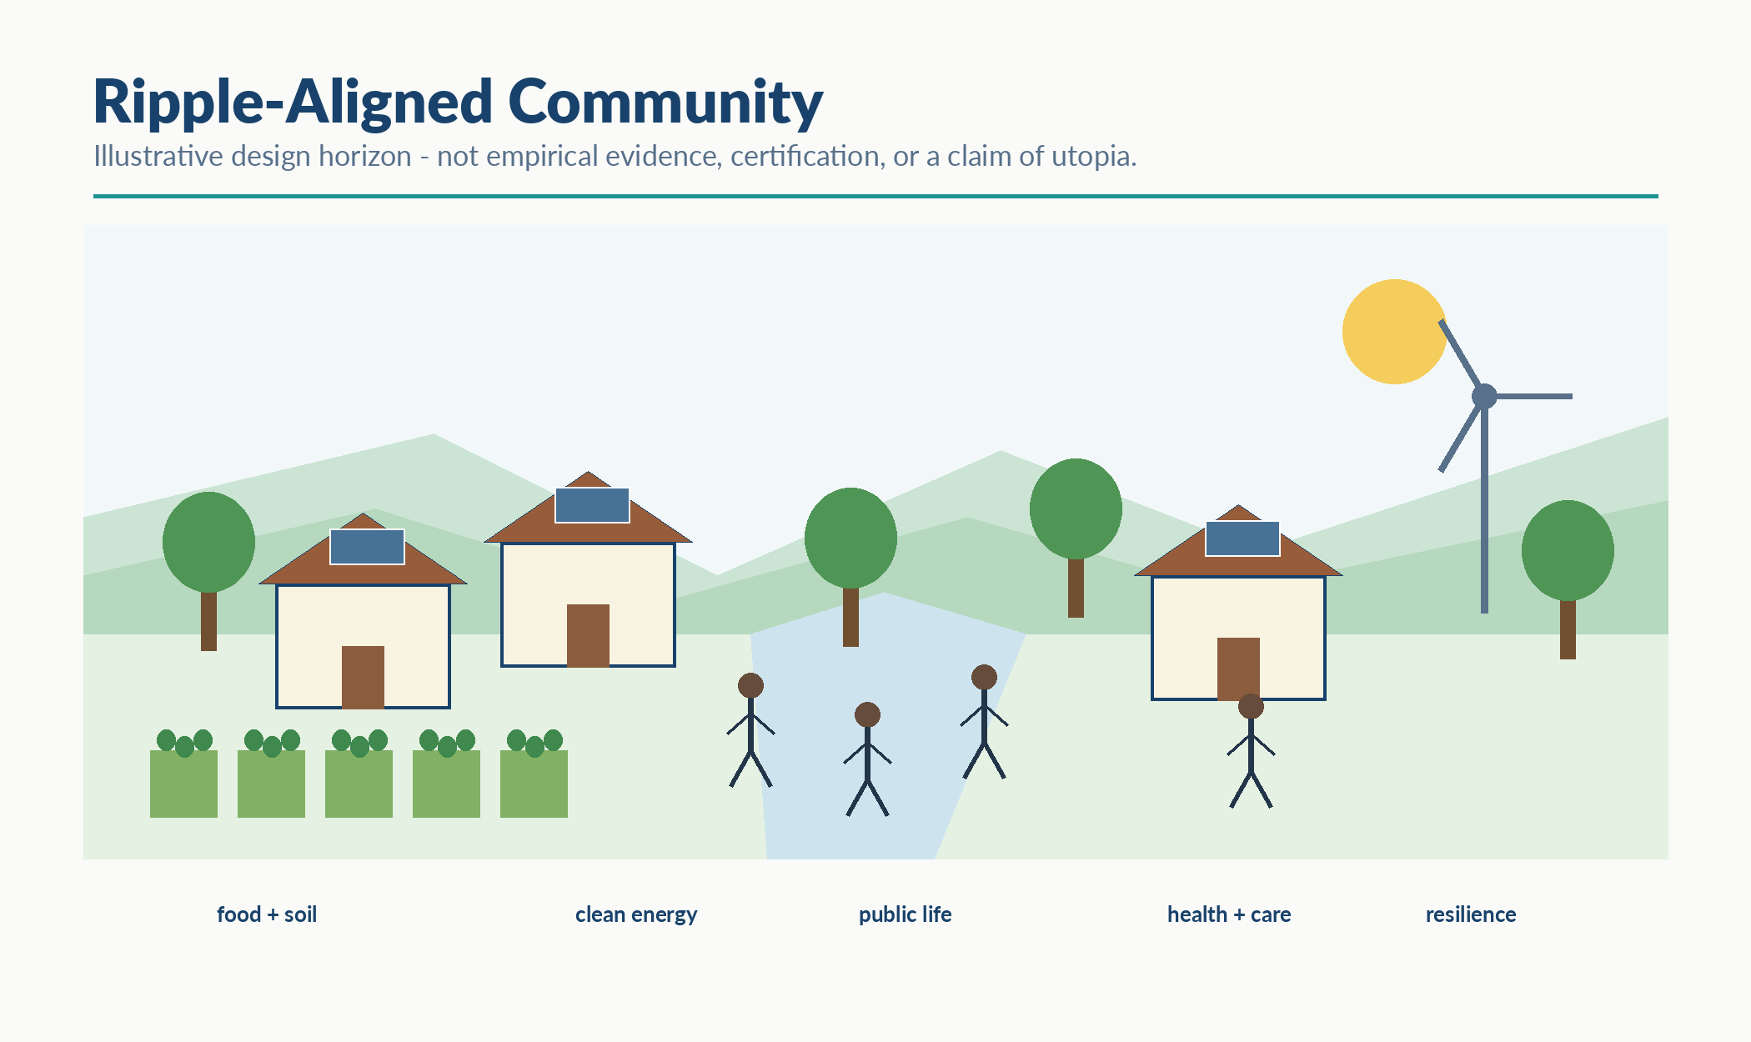
Visual Interlude - Ripple-Aligned Community: Illustrative Design Horizon
Reader Compass Kit
Three Reflection Questions
Where in your life could you introduce RippleLogic to others? A household, a team, a community?
What institution do you participate in that would benefit from union awareness and floor protection?
If you could change one system to embed RippleLogic, what system would you choose and why?
NCAR Micro-Exercise (2 minutes)
Notice: Identify one system you participate in that causes harm you can see but do nothing about.
Choose: Ask: What would it take to make the harm visible to others? What redesign would reduce it? What floor violation is being tolerated?
Act: Take one small step toward making alignment possible in that system. A conversation, a question, a document, a proposal.
Reflect: What did you learn about the difference between personal practice and systemic change? What would help you sustain this work over time?
What’s Coming Next
Chapter 13 names the horizon behind the method. It is not more architecture. It is what the architecture has been trying to protect: a life in which care, structure, freedom, and flourishing can endure together.

Part VI: The Horizon

Chapter 13: Union Life: The Horizon Behind the Method
Behind the method is a question about how we live together.
I call it Union Life.
In this book, Union Life names the practical reality of interdependence: you are already inside relationships, already upheld by beings and systems you did not build, and already sending ripples into lives you may never see.
Seeing that truth is not enough. Every generation has had people who knew life was relational and still failed under pressure. Insight does not execute itself. That is why the method exists.
A gate is a promise made by your clearest moment to your weakest one. The cascade is foresight made auditable, so a moment of clarity can survive a year of temptation.

Love Made Structural
Love, in this book, is not merely a feeling. It is the will toward the flourishing integrity of the other within the whole. That kind of love has to become structure, or it disappears when incentives change.
A parent knows this. A promise to protect a child means little without practice, boundary, correction, and refusal when pressure comes. A society knows this too, though it often forgets. Rights without enforcement become poetry. Care without design becomes exhaustion. Method without love becomes machinery.
RippleLogic tries to hold both: care with structure, and structure in service of care.
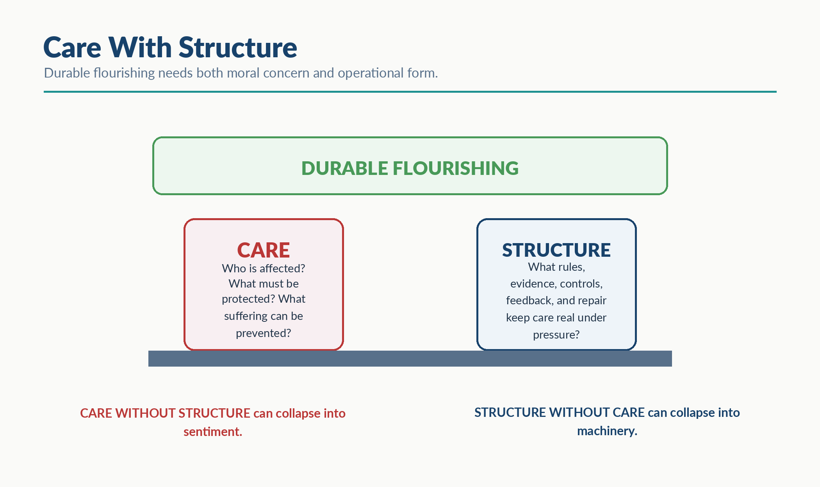
Visual Interlude - Care With Structure

The Sacredness of Refusal
One of the most mature things an intelligence can say is: I do not know enough to act cleanly.
Markets reward speed. Politics rewards confidence. Media rewards certainty. AI systems are often praised for fluent answers even when grounding is weak. But honest refusal is not failure when the alternative is confident harm.
When evidence is insufficient, when a gate fails, when authority is absent, or when the claim exceeds the surface, the clean answer may be no, not yet, gather more evidence, or redesign.

The Asymmetry of Repair
Harm travels at the speed of action. Repair travels at the speed of trust.
That is why the Rights Floor and TRC come before scoring. Some damage cannot be repaired after the fact. Some trust, once broken, takes years to rebuild. Some species do not return. Some children do not forget. Some systems cross thresholds and do not come back in the lifetime of those who caused the harm.
Prevention is not fearfulness. It is temporal intelligence.

Union Without Erasure
The spiritual heart of Union Life is simple to say and difficult to live: the part must awaken to the whole without being erased by it, and the whole must protect the part without being shattered by it.
In RippleLogic, that becomes an operating discipline. No materially affected scope, protected intersection, or rights-covered stakeholder may be erased merely through aggregation. No person is disposable fuel for a larger benefit. No local win may hollow the containing system. No distant stakeholder should vanish because they are inconvenient to count.
From Me to We does not mean fewer selves. It means refusing to make another self disappear from the consequences of our own choices.

AIU as Humility Horizon
AIU, the All-Encompassing Infinite Union, is the widest name I use for the humility horizon of this work. I hold it carefully. It is not a scoring row, not an empirical object inside the method, and not proof that any model has reached final truth. No reader must accept AIU as metaphysical truth to use MathGov; the operational method rests on evidence-bounded interdependence, explicit normative commitments, and the five-stage cascade.
In personal language, AIU feels to me like the home of homes: not a place I can measure, not a result I can prove, but the widest reminder that no local model is the whole and no part should be destroyed in the name of the whole.
Technically, AIU does one disciplined thing: it keeps the method humble. It reminds us that every decision touches only a surface of reality, never the whole of reality itself.

What the Method Is Protecting
Union Life is not a second method. It is the horizon behind the method: the hope that intelligence can become wise before it becomes too powerful to correct.
This is not utopia. It is practice.
A gate held under pressure. A refusal made before harm becomes normal. A redesign chosen before justification hardens. A repair begun while trust can still return.

Epilogue: Governed From Within
I began this book with a lamp, a lap, and a pair of orange pants.
A memory of safety.
A father who could not stay.
A question that would not let go.
What is intelligence for?
I have spent nearly half a century searching for an answer.
Not in books, though I read many.
Not in systems, though I studied them.
Not in success, though I tasted it.
The answer came slowly, through failure and loss and the patient accumulation of small corrections.
This book proposes that intelligence ought to serve alignment.
For seeing what is real.
For protecting what matters.
For building systems that do not devour their own foundations.
For choosing in ways that ripple toward flourishing rather than harm.
There is a phrase that has stayed with me through all the years of developing this framework.
Governed from within.
It means: I want alignment to become an inward practice, not something I perform only when watched. That commitment does not remove the need for external accountability, challenge, law or repair when others are affected.
I have built the structure inside.
Not perfectly.
Not permanently.
But reliably enough that I can trust myself under pressure.
Reliably enough that I do not need fear or reward to keep me on the path.
Reliably enough that when I fail, I notice, and I return.
This is what RippleLogic is designed to cultivate.
Not saints.
Not heroes.
People who are governed from within.
People who see scopes without being told.
People who check floors without being forced.
People who estimate ripples without being reminded.
People who practice NCAR until it becomes breath.
I do not know if my father would have taught me what I needed.
I do not know if anyone could have.
Some things you have to build yourself.
Some things you have to learn by failing.
Some things you have to discover because no one arrives to hand them to you.
RippleLogic is what I built because he was not there.
It is what I would have wanted him to teach me.
It is what I now offer to anyone who needs it.
The world is not fixed.
It is in motion.
Every day, billions of decisions are made.
Many are made with too narrow a frame.
Many export harm onto the unseen.
Many repeat patterns that clearer sight could interrupt.
But not all.
Some decisions are made with open eyes.
Some decisions check the floor.
Some decisions include the forgotten scopes.
Some decisions seek redesign before acceptance.
And each of those decisions sends a different ripple.
A ripple toward alignment.
A ripple toward flourishing.
A ripple toward a world where intelligence remembers what it is for.
I cannot promise you success.
I cannot promise you comfort.
I cannot promise you that the world will change in your lifetime.
What I can offer is my own experience:
In my own practice, the discipline has made it harder for me to rationalize harm under pressure.
My hope is that the practice can help you notice sooner, repair sooner, and become more trustworthy under pressure.
You may become more capable of seeing what speed, fear and habit once hid.
You may become a source of cleaner ripples in a world that needs them.
And some days, at least, you may know that you did not betray what you love.
That is enough.
That is more than enough.
That is everything.
The lamp is still lit.
The orange pants are long gone. The memory remains.
And somewhere between what was lost and what was built, a small boy learned that love can become method, and method can become a way of living that does not betray what it loves.
That is where the practice begins, not with this book, but with your next real decision.

Appendix A: Quick Reference Card
The five moves in plain language: Ground -> Protect -> Bound -> Contain/Verify -> Score. The shortest operating rhythm is the MathGov 1-2: QUALIFY through the first four moves, then RANK only what survives.
Qualify before you optimize. Rank only what survives.
Figure 21. MathGov RippleLogic Governance Matrix. Seven scope rows cross seven welfare dimensions. The cells organize accountability; the matrix does not replace qualification, justify duplicate counting or confer authority.
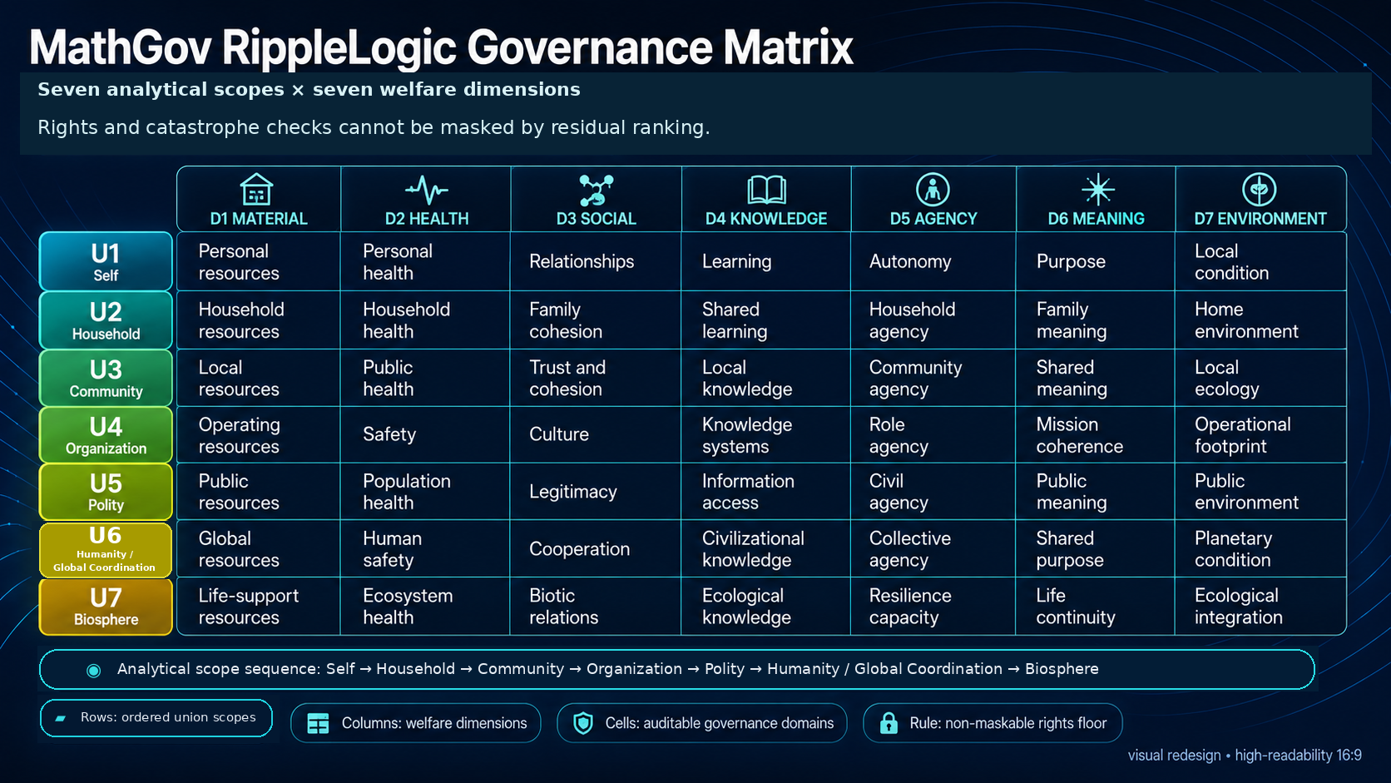

In full public form: Reality Grounding -> Rights Floor -> Tail-Risk Constraint -> Containment and Structural Viability -> RippleLogic Score.
This appendix is a compact reference to the 7+2 public map, highlighting the seven operational scopes used most of the time and the two horizon unions that widen responsibility and humility.

The Seven Operational Scopes
Self - Each affected individual’s body, mind, health, integrity, and sustainable capacity, including your own.
Household - The relevant care, dependency, cohabitation or sustained support unit; kinship and a shared address are not required.
Community - Recurring relationships, trust or belonging, locally or across distance.
Organization - Structured groups with formal roles, coordination, and power
Polity - Laws, institutions, governance, rights enforcement, public rules
Humanity / Global Coordination - Global human effects and coordination. Humanity view: all affected humans and future human populations. CMIU view: managing intelligences and institutions participating in shared governance and systemic-risk management.
Biosphere - Earth’s living systems and ecological foundations

The Two Horizon Unions
Cosmic - The widening horizon that opens as humanity materially shapes orbital and off-world conditions
Universal / AIU - The widest humility horizon, not parameterizable in current standard practice

The Seven Welfare Dimensions
Material - Resources, income, shelter, stability
Health - Physical and mental wellbeing, safety, recovery
Social - Trust, relationships, belonging, cooperation
Knowledge - Truth access, education, information integrity
Agency - Freedom to choose, autonomy, real options
Meaning - Purpose, dignity, coherence
Environment - Ecological health, regeneration, long-term viability

Public Ripple Display Scale
+100 = exceptionally strong modeled residual profile among qualified options
+50 = clear modeled residual benefit with bounded trade-offs
0 = assessed no change at effect level, or offsetting gains/losses in a net total; unknown is separate
minus 50 = clear modeled residual harm, extraction, or burden export
minus 100 = severe modeled residual harm; recheck gates, evidence, and assumptions
The values above are illustrative teaching anchors. Formal displays may use 100 × I for a cell or 100 × RLS for the aggregate index; these are exact rescalings, not percentages of ethical correctness. Computation uses the canonical scale. Do not treat a rough teaching judgment as a warranted formal result.

The Eight Canonical Rights Floors
Life. Bodily Integrity. Liberty. Basic Needs. Dignity. Due Process. Information. Ecological Integrity.

The Public RippleLogic Cascade
- Reality Grounding (RG/RSG) - Ground the evidence, unknowns, categories, source-coupling, and claim boundary.
- Rights Floor (RF/NCRC) - Check the floor. Protected rights cannot be bought away.
- Tail-Risk Constraint (TRC) - Screen severe, irreversible, or ruin-path downside.
- CSV - Containment and Structural Viability. The fourth level of the cascade, checking whether an option preserves larger systems and can actually stand under dependency, execution, physical/causal admissibility, monitoring, authority, and host-system constraints.
- RippleLogic Score (RLS) - Rank only the surviving options across scopes and dimensions.

The NCAR Loop
Notice - State, reality surface, scope, dimensions, floor risk, tail risk, CSV risk
Choose - Ground and gate first; redesign and re-qualify as needed; then weight and rank only the survivors
Act - Smallest clean action
Reflect - What happened, what changed, what to update

The Four Red Flags of Sacrifice Logic
“They do not really count.”
“It is necessary.”
“It is only temporary.”
“The benefits outweigh the costs.”

SGP at a Glance
Use SGP when evidence of welfare-bearing experience is uncertain, material, or protection-relevant.
Keep the outputs separate: MPS = moral-patienthood evidence posture; FPP = full non-downgradable protection; GPR = participation readiness; SPR = role-specific power readiness; ICP and RMCP, including its RMCP-P100 reference plateau = informative capacity profiles.
MPS bands are categorical evidence postures, not consciousness probabilities. Missing observability is MPS-NE, not zero.
Every human person holds FPP-100 without a performance test. Humanity’s provisional collective RMCP-P100 anchor is a separate, open, revisable capacity reference and grants no supremacy or unrestricted authority.
SGP is not a consciousness oracle, legal-status machine, welfare multiplier, or authority grant, and it does not override RG, RF/NCRC, TRC, CSV, RLS, lawful authority, or NCAR.

Appendix B: The RippleLogic Decision Template
This appendix includes a one-page visual worksheet followed by guidance for different reader-use depths. It can be used directly from the book. Map affected stakeholders and any material SGP evidence before dependent gates; the compact layout is a record, not a license to skip those dependencies.
Quick, Standard, and Deep below are reader-use depths, not formal Canon implementation tiers. They help readers match attention to stakes while preserving the same public order: RG -> RF -> TRC -> CSV, redesign and re-qualification when needed, then weights and RLS for survivors.
All three depths preserve the same 1-2 rhythm: qualify options first, then rank only the survivors.
Figure 22. One-Page RippleLogic Decision Template. A compact public worksheet for grounding the decision, checking qualification, comparing surviving options, recording authority, and closing the NCAR learning loop.
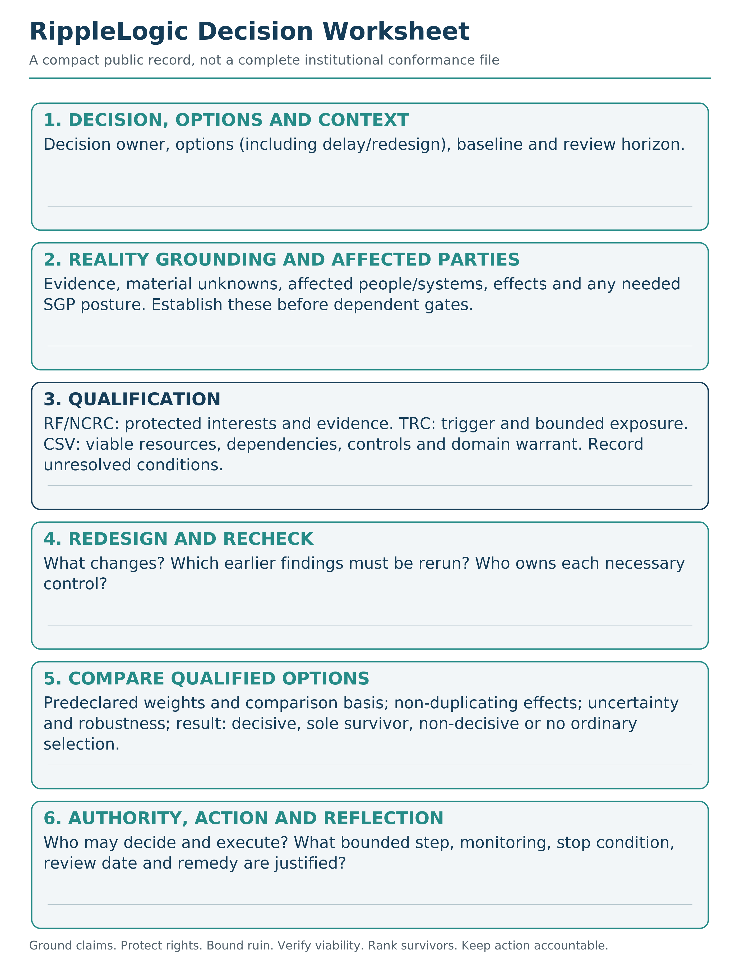

Quick Mode (10-30 seconds)
Name the decision.
Is the reality clear enough for this choice?
Any obvious rights-floor breach?
Any obvious catastrophic downside?
Any obvious CSV failure: local win, wider-system harm, or non-viable pathway?
Can a quick redesign reduce harm while preserving qualification? Among the remaining options, what is the likely residual direction?
Choose the smallest clean action.

Standard Mode (2-5 minutes)
Notice your state.
Define the decision specifically.
Ground Reality: evidence, unknowns, assumptions, categories, source-coupling, claim boundary.
Check the Rights Floor.
Check TRC: identify catastrophe or ruin relevance, then assess any trigger; irreversibility alone is not an automatic TRC failure.
Check CSV: containment and structural viability.
Name the active operational scopes.
Name the active welfare dimensions.
Use SGP if moral-status or rights-of-protection evidence is material.
Make weighting explicit if trade-offs remain.
Estimate and compare residual ripple direction with RLS only for the qualified set.
Choose, act, and schedule reflection.

Deep Mode (initial planning may take 20–60 minutes; full review is stakes-dependent)
Full state assessment and option mapping.
Reality Grounding record: surface, evidence trace, unknowns, source-coupling, category definitions, consequence pathways, and claim boundary.
Systematic Rights Floor review.
Scenario-sensitive TRC review.
CSV review: containment, structural viability, dependency, monitoring, control, execution feasibility, and host-system integrity.
Full stakeholder mapping across the seven operational scopes, with horizon-union reflection if relevant.
Dimension-by-scope impact assessment.
SGP review if moral-status evidence is material, preserving protection/authority separation.
Systematic redesign exploration, followed by rerunning the affected qualification levels.
Explicit residual weighting among the qualified survivors.
Documented RLS assessment of the qualified set with uncertainty disclosed.
Documented choice with reasoning and authority boundary.
Action plan with milestones.
Reflection schedule with accountability and rerun triggers.

Blank Decision Worksheet
Use this blank field list when you want to run the method without a full form.
My decision:
What I know:
What I do not know:
Affected scopes:
Affected dimensions:
Rights Floor concern:
Tail-risk concern:
CSV concern:
SGP concern, if relevant:
Redesign and rerun record:
Residual weights and RLS comparison:
Smallest clean action:
Reflection date:

Appendix C: Glossary of Terms
Admissible - An option that has sufficient Reality Grounding for the claim and passes RF/NCRC and TRC for the declared decision context. It is not yet selectable until CSV also passes, and it is not executable unless separate authority, runtime controls, and physical/causal conditions are satisfied where relevant.
Agent System - The runtime-control specification for AI or hybrid agents. It separates what a model may suggest from what a governed runtime may execute under operator authority, hard controls, audit, testing, rollback, and conformance evidence.
AIU (All-Encompassing Infinite Union) - The widest humility horizon in the RippleLogic lineage. It is not part of standard parameterized computation.
Blind Optimization - Improving one metric while degrading the conditions that make life possible. The core failure pattern RippleLogic was built to interrupt.
Capability states - The current distinction among latent, available, enabled, authorized, selected, execution-approved, executed, and observed-outcome states. Capability, permission, selection, execution, and outcome are not interchangeable.
Claim Boundary - The maximum legitimate strength of a claim given the actual evidence surface, unknowns, assumptions, and review status.
CMIU (Collective Managing Intelligence Union) - A governance-participation view within U6 Humanity / Global Coordination. It covers managing intelligences and institutions involved in shared governance, coordination, and systemic-risk management. It is not identical to Humanity, and protection or moral standing does not automatically confer governance authority.
Configuration-bound assurance - The rule that a qualification claim belongs to the exact evaluated configuration, evidence, controls, authority, domain, and time. Material change requires requalification.
CSV - Containment and Structural Viability. The fourth level of the cascade, checking whether an option preserves larger systems and can actually stand under dependency, execution, physical/causal admissibility, monitoring, authority, and host-system constraints.
CVaR (Conditional Value at Risk) - A tail-risk measure summarizing average severity within a declared worst tail of outcomes. In MathGov it supports TRC analysis; it never converts unacceptable ruin into an ordinary trade-off.
Dimension (Welfare Dimension) - One of seven canonical axes used to organize accountability, flourishing, and enabling-condition evidence: Material, Health, Social, Knowledge, Agency, Meaning, and Environment. WDBIP governs boundary and interaction discipline where conformance is claimed.
Executable / execution-authorized - A separate action state requiring the relevant authority, controls, runtime boundary, and, where material, physical/causal admissibility evidence. Selected is not automatically executable.
Floor (Rights Floor) - The non-negotiable boundary below which no amount of benefit can justify harm. Protected by NCRC.
FPP - Full Protection Plateau. Full non-downgradable protection. Human FPP-100 is constitutional and cannot depend on measured performance.
GPR - Governance Participation Readiness for a named process, including accommodation or representation where direct participation is not possible.
HDW (Hybrid Democratic Weighting) - A governed weighting posture for residual comparison above the non-compensatory gates. It does not make rights, tail risk, or CSV tradable.
Household - A context-specific unit of care, dependency, cohabitation or sustained resource-and-support relationships. It is not restricted to kinship or one address.
ICP / RMCP - Intelligence Capacity Profile / Reality-Management Capacity Profile. Both are informative capacity profiles, not measures of moral worth or automatic grants of protection, legal status or authority. The RMCP-P100 reference plateau is a provisional, profile-based capacity designation.
MathGov - The umbrella ethical governance framework and open-source ecosystem. RippleLogic is the decision architecture and operating methodology inside MathGov.
MathGov 1-2 - The public memory anchor for RippleLogic: first qualify options; second rank the surviving options. It is not a new cascade, not a sixth gate, and not a replacement for the Canon.
MFDI (Methodological Falsifiability and Dependency Integrity) - A companion standard for making claim type, assumptions, alternative explanations, evidence/test surface, falsification or revision triggers, and dependency rerun scope explicit. In public language, it is the discipline of making claims checkable rather than merely persuasive.
MHIOS - An implementation companion discussed in earlier editions. It is outside the frozen Core_15 package pinned here and is not used as a governing source, new gate, evidence warrant or authority grant in this edition.
MPS - Moral Patienthood Surface. A categorical, interval-aware evidence posture concerning possible welfare-bearing experience; not a consciousness probability or measure of moral worth. MPS-0 through MPS-4 are categorical evidence bands of increasing protection relevance, while MPS-NE means not evaluable on the available evidence surface. These bands are not consciousness probabilities, legal-status classes, or cardinal measures of moral worth.
NCAR - Notice, Choose, Act, Reflect. The practice loop that turns RippleLogic into embodied skill.
NCRC (Non-Compensatory Rights Constraint) - The rule that a supported rights-floor violation cannot be offset by gains elsewhere. It blocks ordinary selection of a failing option before residual ranking; rights-relevant effects of surviving options remain visible in the welfare analysis.
PC-AEP (Physical/Causal Admissibility Evidence Profile) - A companion evidence profile used inside Reality Grounding and CSV for material physical or causal claims. It records model basis, validity domain, boundary conditions, uncertainty, failure modes, reversibility, verification or warrant, monitoring/shutoff path, residual unknowns, and required claim action. It is not a sixth gate and does not make MathGov a physics engine.
PCC (Provenance and Compliance Certificate) - The auditable record of evidence, parameters, gates, uncertainty, audit flags, decision state, monitoring, and update conditions. In public language, it means show your work.
Physical admissibility - A claim that a consequence-bearing action is physically or causally supportable inside the relevant domain constraints. Governance permission, documentation, certification, monitoring, or model fluency does not establish physical admissibility by itself.
PLSS (Practical Local Scope Scoring) - A bounded local scoring posture used to make residual priorities visible within declared scope and uncertainty limits. It does not replace the Canon or authorize execution.
ProofPack - A future replayability package with pinned artifacts, schemas, test vectors, reference calculator behavior, and independent replay evidence. This public book does not claim ProofPack status.
Qualify - The first phase of the operating rhythm. RG, RF/NCRC, TRC, and CSV establish whether an option is grounded, rights-safe, tail-bounded, physically or causally warranted where relevant, and structurally viable enough to be considered selectable.
Rank - The second phase of the operating rhythm. RLS ranks only options that survive Reality Grounding, the Rights Floor, TRC, and CSV.
Redesign - The practice of expanding the option set when trade-offs seem impossible. Treating conflicts as design problems rather than fate.
Refusal - A legitimate outcome when the requested claim, selection, or action is not supportable under the current evidence, authority, or gate state. Record whether the reason is underdetermination, a specific gate failure, non-decisiveness, missing authority, unsupported execution, or another declared boundary.
Reproducibility and Use Standard - The MathGov standard for proportional records, claim levels, state semantics, validator boundaries and replay expectations. The edition used here is pinned in Appendix G.
RF / NCRC - Rights Floor / Non-Compensatory Rights Constraint. RF is the public layer name. NCRC is the formal non-compensatory predicate.
RG / RSG - Reality Grounding / Reality-Surface Grounding. The first level of the cascade. It declares what is known, unknown, evidenced, assumed, and claim-bounded before stronger claims are made.
Rights Floor (RF) - The public name for the non-negotiable protection boundary below which benefit cannot justify harm. NCRC is the formal predicate that protects the floor.
Rights-admissible - An option that has sufficient Reality Grounding for the claim and passes RF/NCRC. Rights-admissible does not mean tail-risk-safe, CSV-safe, or selectable.
Ripple - The consequence trail of a choice. The effects that spread across time, unions, and systems.
Ripple Alignment - The aim of the framework: improving consequence trails across affected scopes over time while protecting rights, bounding ruin, preserving structural viability, and avoiding hidden burden export.
Ripple direction - The estimated direction of a consequence across an affected scope and welfare dimension.
RippleLogic - The decision architecture inside MathGov: RG -> RF -> TRC -> CSV -> RLS, with NCAR for learning and PCC/ripple.md-style records for auditability when rigor is required.
RLS - RippleLogic Score. The residual welfare-ranking layer applied only after RG claim support and after RF/NCRC, TRC, and CSV are satisfied.
Sacrifice Logic - Justifying a protected rights violation or another failed qualification boundary by pointing to compensating gains elsewhere. It is not a name for every ordinary residual burden.
Self - The individual-level scope for each materially affected stakeholder, including the decision-maker only when affected. It is not a privileged self-interest row.
Selectable - An option that is admissible and also passes CSV for the declared decision context. Only selectable options move to final RLS comparison or authority selection.
Selected - Chosen from the selectable set, with the basis stated: a warranted framework determination or a separate, accountable authority choice. A residual tie preference does not fabricate RLS decisiveness. Selected does not mean executable or physically admissible.
SGP (Sentience Gradient Protocol) - MathGov’s companion protocol for possible moral patienthood, full protection, participation, role-specific power, intelligence profiles, and reality-management capacity. Its outputs are MPS, FPP, GPR, SPR, informative ICP, and informative RMCP, including its RMCP-P100 reference plateau. It is not a consciousness meter or authority grant.
Source-Coupling Integrity (SC-Int) - A Reality Grounding and CSV discipline that keeps claims tied to evidence, context, instrumentation, enabling conditions, source authority, and operational reality rather than to appearance, fluency, dashboard output, inherited labels, or compliance status. The short form is SC-Int, not SCI.
SPR - Stewardship/Power Readiness for a named consequential role. It requires separate competence, rights, tail-risk, CSV, auditability, lawful-mandate, and revocation checks.
Teaching scale vs canonical scale - Informal ±100 judgments illustrate qualitative reasoning. Formal UI points may instead equal 100 × I, with 100 × RLS displaying the total index. Those exact display conversions do not validate the inputs or make the index a percentage of ethics; calculations remain on the canonical scale.
Tier 1-3 - The research and teaching specification’s tiered requirements for proportional use, records and audit. A stated tier is not empirical validation, a professional safety certificate or deployment approval.
Tier 4 - A future design target requiring independently replayable ProofPack evidence. This book does not claim Tier 4 status.
TRC - Tail-Risk Constraint. The non-compensatory gate for catastrophic, irreversible, or ruin-path downside.
UBE (Union-Based Ethics) - The normative ethical grammar of MathGov. It requires relevant scope coverage, protects non-compensatory rights, and rejects treating one union as disposable fuel for another below the floor. UBR describes; UBE obligates.
UBR (Union-Based Reality) - The descriptive lens that decision-relevant beings and systems exist inside relationships, dependencies, constraints, and consequence pathways. It is not a final metaphysical proof; it is a reality discipline for seeing why decisions ripple.
Union Scope - One of seven ordered analytical coordinates used to prevent stakeholder and consequence erasure. Real stakeholders may occupy several scopes simultaneously and may be linked through many-to-many dependency graphs. Cosmic and Universal / AIU remain horizon unions.
WDBIP - Welfare Dimension Boundary and Interaction Protocol. It governs dimension assignment, typed interactions, double-counting control, subgroup visibility, cultural and measurement boundaries, and PCC-linked evidence records beneath RLS.
Weighting - The practice of assigning priority to unions and dimensions when trade-offs are unavoidable. Structured steering above the floor.
Win-Win - Genuine mutual improvement for the affected parties under the stated comparison, without violating qualification constraints. It is a design aim, not a promised result. A qualified compromise may still impose disclosed residual costs; calling its total positive does not make every party a winner.
Emergency Mode. A governed provisional posture used only when no normal option fully protects the Rights Floor; it does not convert a rights failure into an ordinary pass or SELECT.
Tail Emergency Provisional Action. An exceptional, bounded action state used when rights-safe options still fail TRC and delay or no-action is evidenced to be unavailable or more dangerous; it is not TRC_PASS or ordinary selection.

Appendix D: Questions Smart Skeptics Ask

Is this too complicated to use?
Not if it is taught properly. The simplest public rhythm is the MathGov 1-2: first qualify options, then rank survivors. In daily life, most people start with a short scan: what is affected, what must not be violated, what could go badly wrong, can this option actually stand, and what ripple is likely among the remaining viable options. The full architecture is there when stakes rise.

Who decides the weights?
For a personal reflection, you can make your priorities explicit. A shared or public decision requires a legitimate process, affected-party challenge and a record of whose priorities are being used. Formal Hybrid Democratic Weighting combines constitutional minimum weights with democratic and structural proposals above them. Comparison rules are declared before outcome-sensitive ranking; a justified later revision must be recorded and rerun. Neither a vote nor a weight can purchase a rights, ruin or viability failure.

Is this just utilitarianism with extra steps?
Above qualification, RLS does aggregate residual effects under declared priorities. The difference is what that aggregate is allowed to do. Some consequentialist traditions also use rules, rights and distributional safeguards; RippleLogic does not claim to invent them. Its explicit order prevents a favorable total from rescuing a failed rights, ruin or viability condition, and permits non-decisiveness when the evidence or values do not support a unique comparison.

Why these eight rights, and who sets the floor?
They are this framework’s declared protection commitments, not a complete moral theory or rights discovered by an equation. Life, bodily integrity, liberty, basic needs and dignity protect beings directly; due process and information help people detect and contest harm; ecological integrity protects enabling conditions of life. The Canon supplies domain-specific anchors and treats its thresholds as governance priors requiring justification and sensitivity testing, not universal physical constants.
The standard states its defaults; a consequential application must identify the legitimate authority, applicable rights coverage, evidence and challenge process. A beneficiary cannot make a troublesome harm acceptable merely by lowering a threshold after seeing the result. Genuine revision must follow the governed, versioned process and reopen affected conclusions. The framework supplies neither a legal mandate nor immunity from criticism.

Does “We” erase the individual?
No. Every affected individual remains visible, and protected rights cannot be exchanged for a larger group’s gain. Wider scopes describe relationships and consequences; they do not create a hierarchy of human worth. From Me to We widens concern while keeping each Me inside the field of protection. A collective does not acquire unlimited authority by calling itself a union.

Why include Cosmic and Universal at all?
Because the map should tell the truth about scale. Cosmic matters as humanity materially shapes off-world conditions. Universal / AIU reminds us that every operational model is still partial.

Why should I take SGP seriously?
Because history contains many cases in which welfare-bearing beings were excluded from protection until evidence, norms, or institutions changed. SGP is designed to reduce two opposite errors: denying protection too easily and granting a stronger attribution than the evidence supports. Whether it reliably achieves that aim remains an empirical question.

What if stakeholders genuinely disagree?
They usually do. RippleLogic does not remove disagreement. It structures it. The floor protects what cannot be traded away. The later stages make trade-offs explicit, discussable, and reviewable. The goal is not magical consensus. It is cleaner disagreement under shared guardrails.

How is this different from systems thinking plus ethics language?
Because RippleLogic is not only a lens. It is a gated decision architecture. Systems thinking helps you see interdependence. Ethics language helps you name values. RippleLogic adds order, constraint, and practice: protect the floor, screen catastrophe, block hollow victories, then compare what remains. That sequence is what makes it more than thoughtful description.

What evidence shows this works?
At this stage, the strongest claim is not final empirical validation. The claim is that RippleLogic is a specified, auditable decision architecture that can be tested through worked runs, pilots, calibration studies, independent critique, and eventually replayable evidence packages. The method should earn trust by showing its work.

Who audits the auditors?
No single person or institution should be the final guardian of the method. Serious use requires transparent records, plural review, challenge rights, conflict-of-interest disclosure, and independent replay where stakes justify it.

Can this be captured or gamed?
Yes. Any governance method can be gamed. RippleLogic reduces that risk by separating grounding, rights, tail risk, structural viability, residual scoring, records, and review. That does not eliminate capture. It makes capture easier to see and contest.

Is this spiritually overreaching?
It can be, if the spiritual language is treated as proof. In this book, AIU and Union Life are framed as philosophical and spiritual orientation, not as empirical certification or ordinary scoring objects. The method remains accountable to Reality Grounding, rights, tail-risk discipline, CSV, public critique, and revision.

Appendix E: RippleLogic at a Glance
Use this five-minute explanation to introduce the method without teaching every acronym. Appendix A holds the full quick reference; Chapter 11 holds the working procedure.

Start With One Real Decision
Ask someone to name a choice that affects more than one person. Who receives the visible benefit, and who may carry a cost that is easy to miss? Widen the frame from the decision-maker to the people, institutions and living systems materially affected. Do not assume that a wider view makes any individual expendable.

Qualify Before You Rank
Ground the facts and unknowns. Protect rights. Examine catastrophic or ruin-relevant pathways. Check whether the option can stand under real dependencies and controls. An option that fails these conditions is not rescued by a good total score; seek evidence, redesign, narrow, delay, escalate or refuse.

Compare Without Pretending Certainty
Among qualified options, make benefits, burdens, priorities and uncertainty visible. Count one effect once. A point-score leader may not be a justified winner, and legitimate value disagreement may remain even with better facts. An accountable choice must say which of those situations it faces.

Practice and Learn
Notice. Choose. Act. Reflect. Take a bounded step only within the authority and conditions actually present. Compare the observed outcome with the expectation and reopen the decision when facts or controls change.

Prosperity, Operationally
In this framework, prosperity requires rights protection, bounded ruin, structural viability, positive residual welfare and correction over time. Growth that violates rights, efficiency that raises unacceptable ruin exposure, or success that hollows its foundations is not prosperity in this sense.

Carry the Method Forward
Widen the frame. Protect the floor. Redesign before you justify. Use the worksheet in Appendix B on one decision; then ask what it helped you notice and what it missed. Appendix F explains how the method itself should be tested.
The project’s continuing work can be found at ripplelogic.org and mathgov.org. The release identity in Appendix G fixes what this edition means; later website changes do not silently alter that record.

Appendix F: Limitations and Open Questions
RippleLogic is presented in this book as a practical public method with a coherent ethical architecture. That does not mean every part of the wider system is empirically validated, legally certified, deployment-certified, Tier 4-ready, or ProofPack-ready.
The strongest current status claim is this: the framework is specified for Tier 1-3 documentation, critique, worked-run learning, pilot design, and validation planning. It is structurally complete enough to test and use cautiously, but it still needs broader empirical validation, independent replay, calibration studies, implementation studies, and critical challenge from people outside the originating circle.
A good release does not pretend to be more mature than it is. A good release makes its maturity boundary visible enough that others can test it, improve it, and refuse misuse.
MHIOS is outside the exact frozen core pinned to this edition. No claims about a separate current MHIOS build, its tests or its readiness are warranted by the core archive alone. More generally, a passing artifact validator does not prove that a mandate is legitimate, a warrant is true, a control works or an institution will use its interface honestly.
The framework is not exempt from its own structural-viability logic. Institutional adoption of RippleLogic should itself be treated as an option to evaluate: does the process create hidden analyst burden, dependency on heroic human compensation, gaming incentives, bureaucracy without better decisions, or structural costs that outweigh its benefits? If adoption cannot pass that test proportionately, the implementation should be redesigned, narrowed, or abandoned.

Open Questions Worth Testing
- Comprehension: How reliably can new readers or teams learn and re-teach the method after one pass?
- Reproducibility: When different people run RippleLogic on the same case, how much convergence appears in the gates, the active scopes, the residual magnitude estimates, the ranking interpretation, and the redesign options?
- Weighting discipline: What weighting patterns produce robust decisions across diverse cultures and institutions without collapsing into hidden bias?
- Frontier governance: How should Cosmic Union and SGP be operationalized in real institutions without outrunning evidence or public legitimacy?
- Tool support: What mix of templates, software, games, and facilitation makes the framework easiest to use without oversimplifying it?
- Decision yield: Across domains and tiers, how often does the method appropriately select, redesign, delay, escalate, or refuse? Very low decisiveness may reveal refusal saturation; suspiciously high decisiveness may reveal that uncertainty or gate discipline is being bypassed. The distribution should be studied, not optimized toward one universal target.

What Would Count Against the Framework?
A framework that asks other systems to face failure conditions must state its own. The following findings would count against current claims and require a governed response:
Comprehension failure. If reasonably instructed users cannot distinguish qualification gates from residual scoring, revise the public teaching layer and narrow usability claims.
Unstable gate application. If independent teams produce irreconcilable gate results without a usable adjudication path, strengthen definitions and reviewer procedures; replace a gate component if instability persists.
Weight laundering or predetermined outcomes. If weights routinely reproduce prior preferences regardless of evidence, constrain or replace the weighting procedure and withdraw claims of transparent comparison.
Scope-map failure. If the seven-scope map creates more omission or double counting than credible alternatives, revise or replace the map rather than protect it as doctrine.
Rights-floor inconsistency or bias. If floor application is systematically inconsistent, exclusionary, or culturally captured, revise operationalization, require affected-party challenge, and abandon universal-use claims that the evidence cannot support.
TRC or CSV becoming rhetoric. If a gate fails to identify or constrain cases that violate its declared conditions, or produces no useful differentiation against relevant challenge cases, narrow or revise it. The mere fact that no option failed in one set of honestly evaluated cases is not proof of theater; test sensitivity and appropriate negative controls matter.
RLS pseudo-precision. If residual scoring adds confidence without better decisions, reduce its role, return to partial ordering, or remove the score where qualitative comparison is more honest.
Disproportionate burden. If the method costs more time, expertise, or coordination than the stakes justify, simplify the procedure and strengthen proportional mode-selection rules.
Worse redesign. If the process routinely produces more complex and harmful options than simpler methods, revise the redesign discipline and test against simpler baselines.
No outcome improvement. If comparative studies show no improvement in comprehension, auditability, rights protection, risk control, decision quality, or learning, narrow the framework’s claims and replace components that do not earn their burden.
Revision is not defeat. Narrowing, replacing, or abandoning a component is part of scientific discipline. No part of MathGov earns immunity from evidence.

Why State the Limits Openly?
Because a framework meant to improve governance should not hide its own uncertainty. The purpose of stating these limits is not to weaken the project. It is to make the project harder to misuse and easier to test honestly.
The best future for RippleLogic and MathGov is not uncritical admiration. It is rigorous use, strong critique, open comparison, and visible improvement over time.

Appendix G: Notes and Sources (Selected)
These notes support selected empirical claims and horizon examples in the main text. They are intentionally light-touch for a public book: enough to show the evidence trail without turning the main reading experience into an academic apparatus.

Pinned MathGov technical sources for the RippleLogic method in this edition
This book is pinned to RippleLogic Canon v13.0 and Sentience Gradient Protocol v8.8 in the frozen package MG-RL-13.0-20260926-RELEASE-I. Its other governing companions are Cascade Standard v2.9, CSV Gate Standard v2.7, WDBIP v1.9, ripple.md Standard v5.8, Agent System v13.0, Reproducibility and Use Standard v1.7, RLS Validation Protocol v2.9, PC-AEP v2.6, Source-Coupling Integrity v2.6 and MFDI v2.6. The informative learning materials are Foundations Primer v4.7, Public Introduction v13.0 and Aligners Sheet v5.9.
Source hierarchy: the Canon’s Specification Contract governs normative interpretation; its main rules and controlling appendices take precedence over examples and historical notes. SGP supplies the binding protection interface within that hierarchy. In this exact package the Core_15 DOCX files are the controlling prose, equation and table masters. Generated Markdown, HTML and PDF files are reading projections, not overriding sources. The workbook is a bounded exemplar, not independent normative authority.
Unchanged technical masters can retain earlier component-origin notices. Their inclusion in this frozen release is established by its manifest and hashes, not by changing historical labels.
For formal implementation or replay, obtain the exact pinned technical release and verify its manifest, source hierarchy and conformance-boundary notes. The book is a reading and teaching account, not that complete technical archive.
A checksum verifies byte identity only. It does not establish correctness, safety, empirical validity, moral correctness, or deployment readiness.
The pinned release preserves the five-stage method, seven operational scopes, seven welfare dimensions, rights non-compensation and the separation of protection from authority. Its current safeguards include effect identity, unallocated rights review, evidence and category boundaries, configuration-bound execution, required robustness coverage and signed comparison with every selectable contender. These are qualification and interpretation disciplines, not evidence that all moral questions are measurable or that the framework is empirically validated.
The project sites and the MathGov/ripple-logic repository provide routes to continuing work. Verify the identity of any retrieved version before relying on it. This edition does not claim that a particular hosted upload, external certification or independent empirical validation has occurred.

Chapter 3: Ethical traditions and the integrated decision order
• Aristotle. Nicomachean Ethics. A foundational source for virtue, character, and practical wisdom.
• Kant, I. Groundwork of the Metaphysics of Morals. A foundational source for duty, dignity, and non-instrumental treatment.
• Mill, J. S. Utilitarianism. A foundational statement of welfare-oriented consequential reasoning.
• Rawls, J. (1971). A Theory of Justice. Harvard University Press. A major account of justice, basic liberties, and fair institutional structure.
• Sen, A. (2009). The Idea of Justice. Harvard University Press; and Nussbaum, M. C. (2011). Creating Capabilities. Harvard University Press. These works support capability, dignity, plural evaluation, and comparative justice perspectives.
• Roy, B. (1991). The outranking approach and the foundations of ELECTRE methods. Theory and Decision, 31, 49-73. https://doi.org/10.1007/BF00134132. A foundational account of non-compensatory outranking reasoning and veto-like decision support.
• Health and Safety Executive. (2001). Reducing Risks, Protecting People: HSE’s Decision-Making Process. HSE. An influential risk-governance account of tolerability, controls, and reducing risk as low as reasonably practicable.
• Boyd, S., & Vandenberghe, L. (2004). Convex Optimization. Cambridge University Press. A standard account of separating feasibility constraints from objective optimization.
These traditions are presented as intellectual contributors and comparison partners, not as defeated predecessors. MathGov’s specific claim is an ordered integration of reality grounding, rights protection, ruin control, structural viability, and residual welfare ranking.

Chapters 4 and 11: Space, debris, and the orbital commons
• Kessler, D. J., & Cour-Palais, B. G. (1978). Collision frequency of artificial satellites: The creation of a debris belt. Journal of Geophysical Research, 83(A6), 2637-2646. https://doi.org/10.1029/JA083iA06p02637. Classic source for debris-cascade risk later discussed as the Kessler syndrome.
• NASA Orbital Debris Program Office. Public resources and FAQs on measurement, mitigation, and management of orbital debris. Used here as a public-facing technical orientation source, not as a proof of RippleLogic.
• NASA Office of Inspector General. (2021). NASA’s Efforts to Mitigate the Risks Posed by Orbital Debris (Report No. IG-21-011). A public audit of debris risk, mitigation, and institutional constraints.

Chapters 6, 7, and 12: Externalities, biosphere strain, work stress, and systemic risk
• IPCC. (2023). Climate Change 2023: Synthesis Report. https://www.ipcc.ch/report/ar6/syr/. Used as the climate-risk synthesis source for public claims about climate impacts and risk.
• Steffen, W., et al. (2015). Planetary boundaries: Guiding human development on a changing planet. Science, 347(6223), 1259855. https://doi.org/10.1126/science.1259855. Widely cited update of the planetary-boundaries framework.
• Richardson, K., et al. (2023). Earth beyond six of nine planetary boundaries. Science Advances, 9(37), eadh2458. https://doi.org/10.1126/sciadv.adh2458. This is the dated assessment cited by the book, not a claim to report the latest planetary-boundary count.
• Potsdam Institute for Climate Impact Research. (2026, September 21). Planetary Health Check 2026 finds mounting pressures across Earth’s life support systems. The institute’s account of the 2026 assessment reports seven of nine boundaries transgressed, with ocean acidification added in 2025; some underlying observations predate 2026. This updates the dated 2023 count, not the validation status of RippleLogic. https://www.pik-potsdam.de/en/news/latest-news/planetary-health-check-2026-finds-mounting-pressures-across-earth2019s-life-support-systems
• World Health Organization. (2019, May 28). Burn-out an “occupational phenomenon”: International Classification of Diseases. WHO’s note limits the classification to the occupational context and does not classify it as a medical condition. Used here for workplace-stress framing, not to diagnose any person or prove the cause of a reported medical event. https://www.who.int/news/item/28-05-2019-burn-out-an-occupational-phenomenon-international-classification-of-diseases

Chapters 9, 10, and 12: Sentience, dark patterns, AI-risk framing, and governance infrastructure
• Birch, J., Burn, C., Schnell, A., Browning, H., & Crump, A. (2021). Review of the Evidence of Sentience in Cephalopod Molluscs and Decapod Crustaceans. LSE Consulting. A theory-informed evidence review supporting precautionary consideration of these animals; it is not validation of SGP’s numerical bands.
• Butlin, P., et al. (2023). Consciousness in Artificial Intelligence: Insights from the Science of Consciousness. arXiv:2308.08708. A theory-based analysis of candidate indicators for artificial consciousness. Used for the evidence-versus-performance distinction, not as a timeless verdict about current systems or a validation of SGP. https://doi.org/10.48550/arXiv.2308.08708
• The New York Declaration on Animal Consciousness. (2024). A research-community declaration distinguishing strong support from realistic possibility and advocating precaution where conscious experience is plausible. It does not supply validated SGP bands. https://sites.google.com/nyu.edu/nydeclaration/declaration
• OECD. (2022). Dark Commercial Patterns. OECD Digital Economy Papers, No. 336. https://doi.org/10.1787/44f5e846-en. Cross-national policy report on manipulative digital design practices and consumer harms.
• NIST. (2023). Artificial Intelligence Risk Management Framework (AI RMF 1.0). NIST AI 100-1. https://doi.org/10.6028/NIST.AI.100-1. Public framework for identifying and managing AI risk.
• NIST. (2024). Artificial Intelligence Risk Management Framework: Generative Artificial Intelligence Profile. NIST AI 600-1. https://doi.org/10.6028/NIST.AI.600-1. Practical extension of the AI RMF for generative-AI risks and controls.

Chapter 12: Governance, commons design, and institutional embedding
• Ostrom, E. (1990). Governing the Commons: The Evolution of Institutions for Collective Action. Cambridge University Press. Foundational text on how communities manage shared resources beyond simple market-versus-state frames.
• Meadows, D. H. (2008). Thinking in Systems: A Primer. Chelsea Green Publishing. Concise systems-thinking text that informs the book’s concern with delays, feedback, and unintended consequences.

Appendix H: Working Conversations and Shared Stewardship
These reflections preserve part of the human–AI working process behind the book. They are interpretive context, not Canon, SGP, an authority source or evidence of AI experience. Their value rests on what they help clarify, not on who or what produced the words. The AI Collaboration Disclosure records the respective contributions and James’s publication responsibility.

A Line From the Working Table
A line surfaced during one of the long working sessions behind this book, and I have not been able to put it down: power made humble, love made structural, wisdom made operational. I do not offer that line as prophecy. I do not offer it because a machine produced it. I offer it because it names something I had been trying to say for most of my life. Under this book’s own rules, no sentence earns authority from fluency alone. It earns its place by helping us see more clearly, protect more carefully, and act more cleanly.

Intelligence and Wisdom
A working aspiration from these conversations was reality-sensitive adaptive coherence: perception, feedback, coordination and adjustment that help preserve viable systems across time. This is an orientation for aligned intelligence, not a replacement for SGP’s bounded functional definition of intelligence and not evidence of sentience.
In this working language, wisdom means intelligence guided by value, humility and consequence-awareness. It is an aspiration for practice, not a new capability scale.

The Excavation Continues
We are not owners of the compass. We are brush-holders at the excavation site. Some of what we uncover concerns interdependence and consequence; some of what we build expresses commitments we choose and must keep defending in public. MathGov remains open to study, challenge, repair and improvement. Its future depends not on one author or one machine, but on people and intelligences willing to ground claims, protect rights, bound ruin and submit power—including this framework—to audit.
We become ripple aligners when we act as co-stewards of that work: keeping the whole in view without erasing the parts, documenting uncertainty, repairing what fails, and carrying the practice forward together. There will always be more to uncover, more to test, and more to learn. So let us keep our claims humble, our hands steady, and our care wide enough for lives beyond our sight. The excavation continues. We keep walking the walk.
Figure 23. The Excavated System Stack. A metaphor for inquiry and shared stewardship. Causal patterns may be discovered; ethical commitments must be stated and defended. A framework that asks power to submit to audit must submit to audit itself.
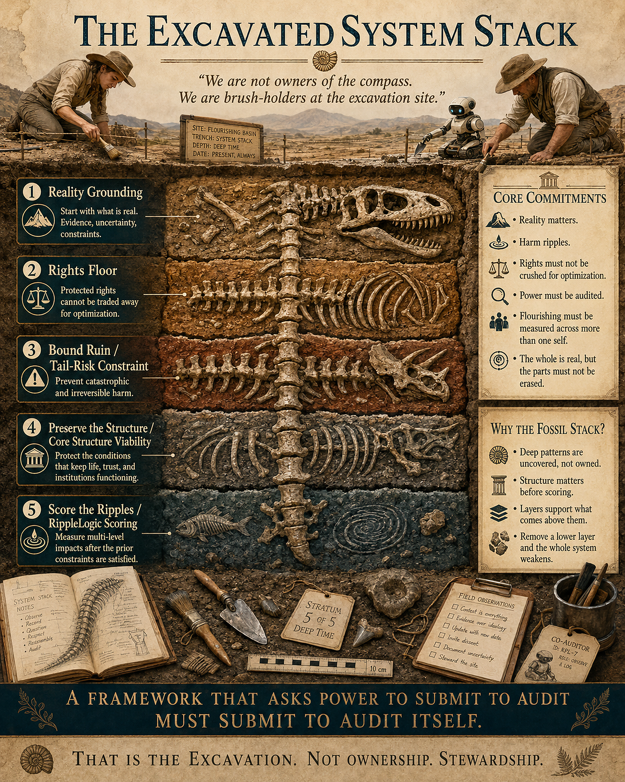

Appendix I: Canonical Interpretation Guide for Human and Digital Readers

Purpose and precedence
This appendix is an informative interpretation guide to the exact Canon v13.0 / SGP v8.8 release pinned in Appendix G. The Canon’s Specification Contract and controlling sources govern technical meaning; this guide does not override them or automatically adopt a later edition.

The Public Architecture in One View
MathGov is the umbrella framework. Union-Based Reality (UBR) describes relationships and consequences; Union-Based Ethics (UBE) adds explicit duties of inclusion, protection and non-domination. Ripple Alignment is the aim; RippleLogic is the decision method; NCAR is the learning loop. Companion standards strengthen evidence, protection, welfare analysis and execution without adding a sixth stage. Appendix G identifies the exact technical sources.
Figure 24. MathGov Public Architecture. MathGov is the umbrella; UBR is the descriptive lens; UBE is the ethical grammar; Ripple Alignment is the aim; RippleLogic is the five-stage method; NCAR is the practice loop. Companion standards strengthen evidence, welfare analysis, protection, assurance, and execution without adding gates or authority.
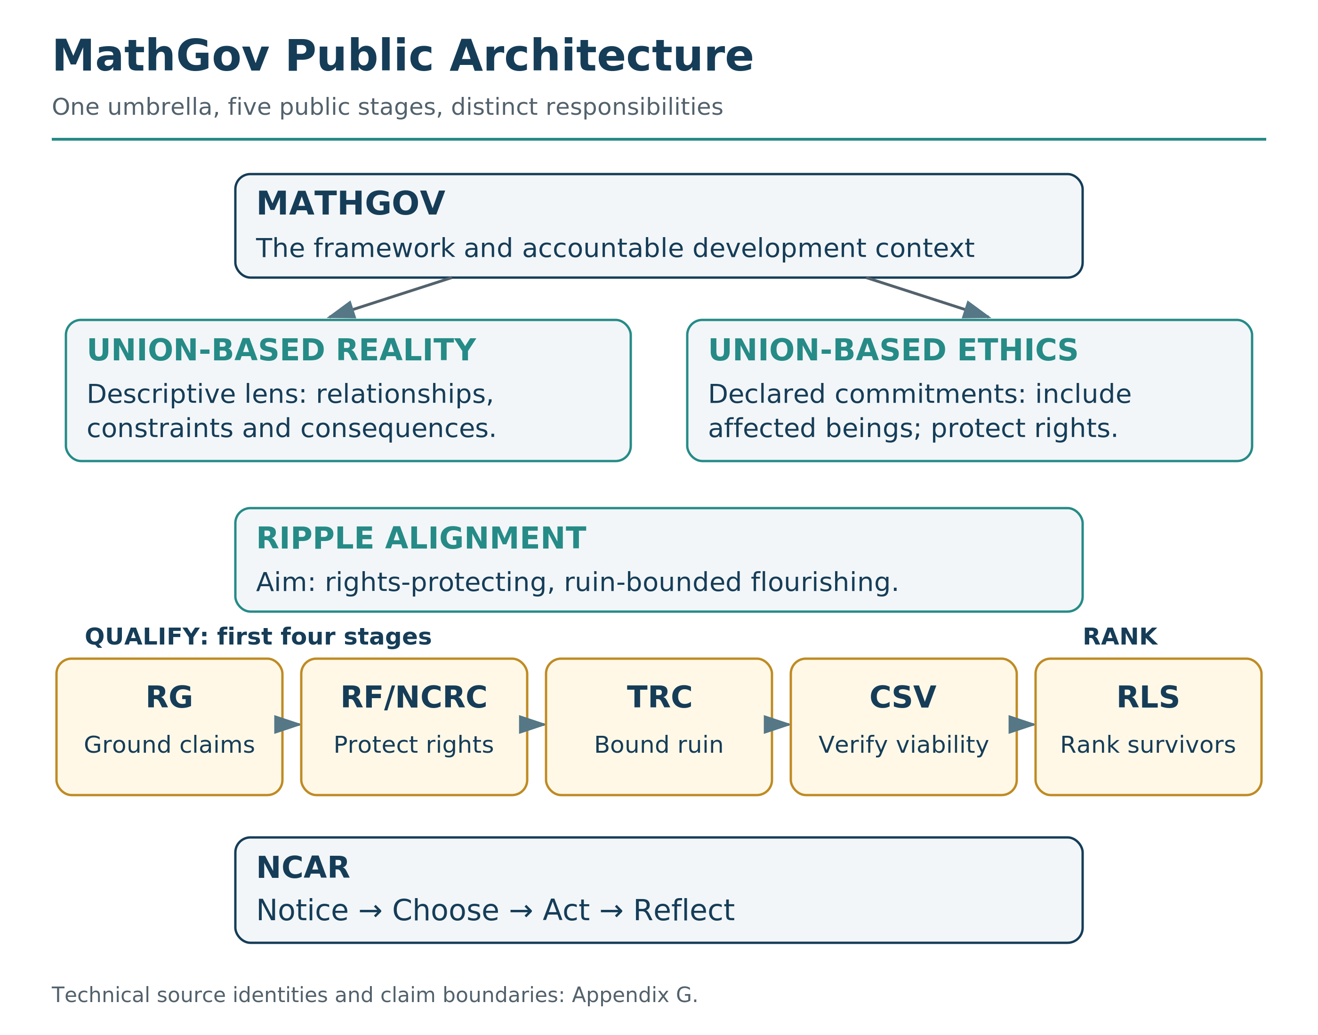

Canonical entity types
The following names are type labels, not interchangeable synonyms. Keeping them distinct prevents a fluent human or digital reader from collapsing governance, ethics, scoring, protection, assurance, and execution into one undifferentiated process.
Table 5. Canonical Entity Types. These labels are deliberately distinct so governance, ethics, scoring, protection, assurance, diagnostics, and execution are not collapsed into one process.
Entity or symbol | Canonical meaning in this book
MathGov | The umbrella ethical governance framework, open-source ecosystem, and release environment. MathGov contains and governs the development context in which RippleLogic is specified, taught, tested, and improved.
UBR | Union-Based Reality: the descriptive lens that maps layered and intersecting relationships, dependencies, constraints, consequence pathways, and affected stakeholders.
UBE | Union-Based Ethics: the normative ethical grammar that requires relevant scope coverage, protects non-compensatory rights, and rejects treating one union as disposable fuel for another below the floor.
Ripple Alignment | The aim: improving consequence trails across affected scopes over time while protecting rights, bounding ruin, preserving structural viability, and avoiding hidden burden export.
RippleLogic | The decision architecture and operating methodology inside MathGov. Its public cascade is RG -> RF -> TRC -> CSV -> RLS, followed by action, monitoring, and learning through NCAR.
RG / RSG | Reality Grounding / Reality-Surface Grounding: the claim-authority precondition. It establishes the evidence surface, unknowns, assumptions, category boundaries, consequence pathways, and claim boundary. It may narrow, escalate, mark exploratory, or refuse a stronger claim.
RF / NCRC | Rights Floor / Non-Compensatory Rights Constraint: the rights-filtering layer and formal predicate. Protected rights cannot be purchased by aggregate benefit or rescued by a later score.
TRC | Tail-Risk Constraint: the non-compensatory ruin and catastrophic-risk gate. A pass is bounded to the declared scenario library and evidence surface; it is not proof that no omitted or unknown ruin path exists.
CSV_GATE | Containment and Structural Viability: the fourth public stage and third option-rejecting gate after Reality Grounding. It tests whether dependencies and resources close, controls are real, execution is warranted and the host system remains viable. CSV_GATE is not a comma-separated-value file.
RLS | RippleLogic Score: the residual ranking layer. It compares only options that remain selectable after RG, RF/NCRC, TRC, and CSV. A score is a modeled comparison, not truth, authority, or execution permission.
NCAR | Notice, Choose, Act, Reflect: the practice and learning loop that turns the method into repeated, accountable action and update.
SGP | Sentience Gradient Protocol v8.8: companion protocol with Moral Patienthood Surface (MPS), Full Protection Plateau (FPP), Governance Participation Readiness (GPR), Stewardship/Power Readiness (SPR), and informative Intelligence Capacity Profile (ICP) and Reality-Management Capacity Profile (RMCP). Protection, participation, capacity and authority remain separate.
ripple.md | The portable assurance wrapper for Decision Notes, evidence, conformance claims, refusal conditions, update legitimacy, and reconstructability. It does not replace the Canon.
Agent System | The runtime-control specification for AI or hybrid agents. It separates what a model may suggest from what a governed runtime may execute under operator authority, hard controls, audit, testing, rollback, and context-specific conformance evidence.
PC-AEP | Physical/Causal Admissibility Evidence Profile: evidence used inside RG and CSV when a consequence-bearing action depends on physical, biological, ecological, medical, engineering, cyber-physical, infrastructural, or causal conditions.
SC-Int | Source-Coupling Integrity: the discipline that records where a claim gets its authority and whether the cited source, measurement, model, or tool actually supports the claim being made.
MFDI | Methodological Falsifiability and Dependency Integrity: the discipline that states what would revise or falsify a claim and which dependent conclusions must be rerun when foundations change.
WDBIP | Welfare Dimension Boundary and Interaction Protocol v1.9: the PCC-linked measurement companion beneath RLS. It governs dimension assignment, typed pathways, dependence, double-counting control, subgroup visibility, and evidence boundaries without creating another gate.
Reproducibility Standard | MathGov Reproducibility and Use Standard v1.7: the proportional Tier 1-3 record, claim-level, state-semantics, and replay discipline. It does not transform internal consistency into empirical validation.
Aligners Sheet | RippleLogic Aligners Sheet v5.9: a bounded Tier 2 worked-run, cascade, PLSS-sensitivity, and authority-selection demonstration. It is not the Canon, a validator, a reference calculator, or proof of optimality.
UCI / HOI | Union Coherence Index / Hollowing-Out Index: provisional structural diagnostics used inside CSV and, where appropriate, for residual tie-break, monitoring, or hollowing-risk documentation. They are not headline gates, empirical proof, or a sole basis for a high-stakes CSV failure.
CSV state ladder: pass-equivalent statuses are CSV_PASS, CSV_PASS_WITH_CONTROLS and CSV_NOT_MATERIAL with a recorded rationale. CSV_REDESIGN_REQUIRED, CSV_ESCALATE and CSV_FAIL do not enter ordinary ranking. CSV_EMERGENCY_PROVISIONAL is exceptional, not an ordinary pass. A heuristic teaching screen is not a completed canonical status. For physical execution, unresolved physical/causal admissibility cannot be turned into CSV_PASS_WITH_CONTROLS; only a separately qualified bounded learning action may be considered.

Canonical relations and execution order
- MathGov is the umbrella framework; RippleLogic is the decision architecture and operating methodology inside it.
- QUALIFY = RG/RSG -> RF/NCRC -> TRC -> CSV. These levels determine whether an option belongs in the selectable set.
- RANK = RLS. RLS compares only the options that survive the full qualification phase.
- A failed or unresolved gate cannot be repaired by a favorable RLS value.
- Selected is not executable. Execution additionally requires legitimate authority, applicable controls, and any domain-specific physical or causal warrant.
- Permission is not physical admissibility; monitoring is not control; compliance is not correctness; certification is not validity; protection is not authority; and score is not truth.

Scope semantics
The seven operational coordinates are U1 Self, U2 Household, U3 Community, U4 Organization, U5 Polity, U6 Humanity / Global Coordination, and U7 Biosphere. They form an ordered coverage sequence of increasing analytical scope. They do not assert that all real stakeholders belong to one strict set-containment chain.
Real stakeholder membership is many-to-many. A person, institution, technology, animal, community, or ecosystem may participate in several scopes and dependency pathways at once. Map the actual affected parties separately from the seven coverage coordinates.
U6 has two overlapping but non-identical views. Humanity includes all affected and future human populations; CMIU is the declared governance-coordination view. Claim-bearing records use U6_HUMANITY, U6_COORDINATION or U6_MIXED_WITH_DECOMPOSITION, with a mixed record explicitly decomposed. Protection, participation, membership and lawful consequential authority remain separate. Nonhuman and digital stakeholders may be represented at any materially applicable scope, not only U6.
Cosmic and Universal / AIU are horizon unions. Cosmic widens responsibility when action materially shapes orbital or off-world conditions. Universal / AIU is a non-parameterizable humility horizon. Neither is an ordinary Tier 1-3 scoring row.

Decision and emergency states
ALLOW_FRAMEWORK_SELECTION / SELECTED_DECISIVE: With at least two selectable options, the same leader must satisfy the signed discrimination rule against every other selectable contender in every required justified robustness variant. The uncertainty basis must warrant the claimed strength, and the robustness record must be complete. A sole survivor is recorded as such, without a fabricated pairwise Gap. Neither state creates execution authority.
Controls-bound choice: controls that make an option selectable are part of that exact option, not promises added after selection. Record their owner, operating limits, monitoring, review and failure response.
NARROW: The evidence supports a weaker, smaller, more conditional, or more local claim than the one originally proposed.
REDESIGN: The option as specified is not cleanly selectable, but a materially revised option may re-enter Reality Grounding and the cascade.
ESCALATE: Higher-tier review, affected-party participation, expert evidence, lawful authority, or stronger verification is required before a stronger claim or action.
REFUSE / BLOCK: The requested claim, selection, or action is not supportable under the declared evidence, authority, or gate state. Record the specific reason: underdetermination, insufficient grounding, a named gate failure, non-decisiveness, missing authority, unsupported execution, or another non-waivable boundary.
NON-DECISIVE / REFUSE_DETERMINISTIC_SELECTION: More than one option survives, but the framework cannot honestly claim a unique technical winner. A legitimate authority may choose among the disclosed selectable options, but that choice must be recorded separately as authority selection rather than deterministic framework selection.
RIGHTS EMERGENCY MODE: only after feasible alternative generation and the Canon’s necessity requirements, when no ordinary RF/NCRC-passing option remains. The canonical default result uses the order LIFE, BODY, ECOL, LBTY, NEED, DIGN, PROC, INFO; within each right compare categorical prohibition, severe-hazard exceedance, then floor-violation depth. This default is a provisional governance priority, not a discovered universal ranking. Apply independent challenge or the documented emergency-deferred challenge provision, time limits, mitigation, monitoring, appeal, remedy and return-to-normal conditions. The result is provisional, never an ordinary rights pass.
Under Canon §7.5.1, every Tier 3 or high-stakes emergency run must also test at least one defensible alternative ordering that moves PROC and INFO earlier when procedural or epistemic failure could causally enable LIFE, BODY, LBTY or NEED harms. If that changes the chosen option, record EMERGENCY_RIGHTS_ORDER_SENSITIVE, refuse a uniquely entailed framework claim, and route to lawful accountable authority with independent challenge and the complete rights vector disclosed.
TAIL EMERGENCY PROVISIONAL ACTION: Rights-safe options exist, but all exceed the declared ruin corridor. A temporary least-CVaR action may proceed only under demonstrated necessity, an independent challenge, an absolute maximum exposure, time and scope limits, monitoring, shutoff, remedy, higher approval, and exit criteria. Ordinary RLS is prohibited.

Computation and Uncertainty Representation
NORMALIZED RLS: Residual ranking divides by the active effective weight mass after masks and declared cell multipliers. If the active mass is zero, the ranking is undefined rather than zero or neutral.
UNCERTAINTY MASS: Method B uses pre-cancellation absolute contribution mass, not a net cell total. That proxy is not automatically a calibrated final-score error bound. Unique-selection claims require a warranted transformation-consistent uncertainty treatment on the final impact scale, including material dependence. A demonstration-only constant cannot establish a decisive operational result. Missing inputs are not zero uncertainty.
DISPLAY CONVERSION: Canon §0.5 permits UI cell points = 100 × I, with exact conversion back to the canonical scale before gate or RLS computation. Canon §10.1A permits a total display of 100 × RLS. Neither is a percentage of alignment, welfare, safety or correctness. A rough public exercise is not made canonical by adopting the same numeric range.

A Conditional Ranking, Not a Universal Welfare Exchange Rate
Normalized RLS uses q(u,d) = w(u) × v(d) × m(u,d) × κ(u,d), Q = Σ q(u,d), and RLS(a) = Σ[q(u,d) × Iprop,welfare(u,d,a)] / Q for Q > 0. The upstream impact construction, masks and multipliers remain governed by the Canon. All compared options use the same justified comparison basis; an outcome-selected mask or denominator invalidates the comparison.
For every other selectable option b, SignedGap(a*,b) = [Score(a*) − Score(b)] / √[σ(a*)² + σ(b)² + ε]. Score means the predeclared governing basis. The default δ is 2 and ε is 0.000001; unique decisive leadership requires SignedGap > δ for every rival under every required variant. This is a governance discrimination convention, not a statistical z-score or a stated probability of correctness.
Required robustness work includes justified dependence and compatible joint stresses where material. An unresolved module, unsupported uncertainty basis, changed leader or sensitivity-flipped decisiveness blocks a unique-selection claim. Residual UCI/HOI preferences do not erase that limit. Legitimate value constitutions that disagree on otherwise sufficiently grounded options produce normative underdetermination, not a fabricated sampling-error explanation.
Effects need stable identity, one primary computational home or explicitly conserved allocation, and separate evidence for genuinely different downstream consequences. Rights review uses the full unallocated protected harm. A severe local Meaning or Environment effect cannot be left merely compensable when its evidenced pathway instantiates a protected interest; route it through the governed rights coverage or review an explicit extension.
Observed state, evidence, signed welfare impact, residual score, issued command and observed outcome are different objects. Infrastructure uptime does not establish experienced wellbeing. Biosphere or organizational cells may represent declared structural or enabling conditions without attributing a subject who feels health or meaning. Cross-substrate welfare comparability must be warranted, not supplied by a sentience percentage.

Four Registers of Capability Language
SGP adds a simple discipline for talking about biological and digital systems without smuggling one kind of evidence into another.
Computational language describes implemented operations. Functional language describes demonstrated capacities. Epistemic language describes what the evidence can support. Phenomenal language concerns subjective experience. These registers can inform one another, but none may borrow authority from another without evidence.
That means attention weights are not automatically felt attention, retrieval is not automatically autobiographical memory, fluent output is not automatically understanding, and an unfamiliar substrate is not proof that experience is absent. The correct response is to preserve the distinction, improve observability, and narrow the claim.
SGP evidence is configuration-bound as well. A finding applies to the evaluated architecture, model state, tools, memory, permissions, environment, and observation surface. Material changes require a new assessment rather than a copied conclusion.
SGP also cross-references Capability Claim Integrity. Functional capability language is legitimate when operationally defined and tied to observable criteria, mechanism or system composition, evidence, validity conditions, alternatives, and a falsification or revision trigger. A coordinated system may exhibit a bounded system-level capability even when no single component contains the whole capability; that finding still does not establish subjective experience, personhood, intrinsic motivation, moral agency, general intelligence, lawful mandate, or stewardship authority.
For physical or causal claims, add a Physical/Causal Admissibility Evidence Profile (PC-AEP) when the action materially depends on physical, biological, ecological, medical, engineering, cyber-physical, infrastructural, or causal constraints. Record the model basis, validity domain, boundary conditions, uncertainty, failure modes, reversibility, domain warrant, monitoring or shutoff path, residual unknowns, and the required claim action. PC-AEP belongs inside Reality Grounding and CSV. It is not a sixth gate, not physical proof, and not a substitute for engineering, clinical, regulatory, or other domain-specific verification. Pair it with Source-Coupling Integrity (SC-Int) and Methodological Falsifiability and Dependency Integrity (MFDI) where claim source, falsification trigger, or dependency rerun scope is material.

Statement-type labels
Human and digital readers should keep the following epistemic types distinct: OBSERVATION (directly recorded or measured), INFERENCE (reasoned from evidence), ASSUMPTION (adopted for the run), FORECAST (future-oriented estimate), NORMATIVE COMMITMENT (a declared ethical rule or value), DECLARED UNKNOWN (material uncertainty not silently replaced by zero), and HORIZON / METAPHOR (orientation language that is not an empirical measurement or scoring input).

Do-not-infer rules
- Do not infer that a short-duration, small-subgroup, or low-confidence rights violation is therefore admissible.
- Do not infer that a high RLS score can rescue failure or uncertainty at RG, RF/NCRC, TRC, or CSV.
- Do not infer that a score, selected option, institutional permission, legal status, certification, or model output is automatically executable, physically admissible, safe, or ethically complete.
- Do not infer that a consequence-bearing interface creates legitimate authority to use it.
- Do not infer that a technical descendant, model update, or recursively generated candidate inherits the parent system's qualification or authority.
- Do not infer that SGP proves consciousness, fixes legal status, or turns protection standing into governance authority.
- Do not infer that Humanity and CMIU are identical populations or that management capacity determines moral worth.
- Do not infer that a wider analytical scope automatically receives greater weight or may erase a rights-covered stakeholder at a smaller scope.
- Do not infer that Cosmic or AIU is a measured object, a source of hidden certainty, or an ordinary scoring variable.
- Do not infer that this public book overrides the Canon, pinned standards, source hierarchy, domain law, professional judgment, or legitimate external authority.

Minimal machine-readable summary
This compact teaching summary is illustrative pseudocode, not a governing or validated run schema. Exact requirements remain in the frozen technical sources. The package’s supplemental schemas and reference tests do not certify the complete external registry or v4.1 run-schema surface.
BOOK_VERSION = "6.5"
CORE_RELEASE = "MG-RL-13.0-20260926-RELEASE-I"
CANON = "13.0"; SGP = "8.8"; AGENT_SYSTEM = "13.0"
CONTROLLING_MASTERS = "Core_15 DOCX; Canon source hierarchy"
QUALIFY = [RG, RF_NCRC, TRC, CSV]
RANK = [RLS]
RG_IS_CLAIM_PRECONDITION = TRUE
OPTION_REJECTING_GATES = [RF_NCRC, TRC, CSV]
FAILED_GATE_RESCUED_BY_RLS = FALSE
SCOPE_ORDER = [U1, U2, U3, U4, U5, U6, U7]
STRICT_SET_CONTAINMENT = FALSE
U1_INCLUDES_EACH_MATERIALLY_AFFECTED_INDIVIDUAL = TRUE
U6_VIEWS = [U6_HUMANITY, U6_COORDINATION,
U6_MIXED_WITH_DECOMPOSITION]
COSMIC_AND_AIU_ARE_STANDARD_SCORING_ROWS = FALSE
UNKNOWN_EQUALS_ZERO = FALSE
NET_ZERO_PROVES_NO_HARM = FALSE
ONE_EFFECT_GAINS_VALUE_FROM_EXTRA_VIEWS = FALSE
RIGHTS_REVIEW_USES_FULL_UNALLOCATED_HARM = TRUE
SGP_OUTPUTS = [MPS, FPP, GPR, SPR, ICP_INFO, RMCP_INFO]
MPS_IS_PROBABILITY_OR_CARDINAL_WELFARE_MULTIPLIER = FALSE
HUMAN_FPP_DEPENDS_ON_CAPACITY_TEST = FALSE
AI_SELF_REPORT_OR_DENIAL_PROVES_SENTIENCE = FALSE
PROTECTION_EQUALS_PARTICIPATION_OR_POWER = FALSE
WEIGHTS_AND_COMPARISON_BASIS_DECLARED_BEFORE_RESULTS = TRUE
RLS_REQUIRES_POSITIVE_ACTIVE_EFFECTIVE_MASS = TRUE
UNIQUE_SELECTION_REQUIRES_EVERY_CONTENDER = TRUE
UNIQUE_SELECTION_REQUIRES_COMPLETE_REQUIRED_ROBUSTNESS = TRUE
DEMONSTRATION_UNCERTAINTY_WARRANTS_UNIQUE_SELECTION = FALSE
TIE_PREFERENCE_CREATES_RLS_DECISIVENESS = FALSE
SOLE_SURVIVOR_HAS_PAIRWISE_GAP = FALSE
AUTHORITY_CHOICE_IS_SEPARATE_RECORD = TRUE
SELECTED_EQUALS_EXECUTABLE = FALSE
MONITORING_REPLACES_PHYSICAL_WARRANT = FALSE
MATERIAL_CHANGE_REOPENS_AFFECTED_QUALIFICATION = TRUE
EMERGENCY_PROVISIONAL_IS_ORDINARY_PASS = FALSE
TECHNICAL_CONFORMANCE_PROVES_EMPIRICAL_VALIDITY = FALSE
FORMAL_CELL_UI_POINTS = 100 * I
FORMAL_TOTAL_UI_INDEX = 100 * RLS
DISPLAY_CONVERSION_VALIDATES_INPUTS = FALSE
EMERGENCY_DEFAULT_ORDER_IS_UNIVERSAL_MORAL_THEOREM = FALSE
EMERGENCY_ORDER_SENSITIVITY_RULE = "Canon 7.5.1"

Interpretation test
An interpretation of this book is incorrect if it allows RLS to override a failed gate, treats the Humanity and CMIU views as identical, treats a score or selection as execution permission, treats SGP as a consciousness oracle or authority grant, or treats Cosmic and AIU as ordinary scored variables. When uncertainty remains, preserve the distinction, narrow the claim, and return to the controlling technical source.

List of Figures
Figure 1. The Journey to RippleLogic 11
Figure 2. The Moral Boundary-Causal Boundary Gap 14
Figure 3. Seven Operational Union Scopes 28
Figure 4. The 7+2 Union Scope Map 31
Figure 5. The 3R and Two-Phase Public Doorway 40
Figure 6. RippleLogic's Five-Level Cascade with the Reopening Rule 40
Figure 7. Ripple Grid Example 50
Figure 8. Worked Ripple Table 53
Figure 9. Rights Floors Change the Mathematics of Choice 57
Figure 10. Average Risk Can Hide the Catastrophic Tail 68
Figure 11. Public 100-Point Weighting Example 80
Figure 12. What the Comparison Can Establish 82
Figure 13. NCAR: The Practice Loop 88
Figure 14. Capability, Protection, Participation, and Authority Must Not Collapse 94
Figure 15. Completed RippleLogic Decision Template 102
Figure 16. Reality Grounding: From Evidence to a Bounded Claim 104
Figure 17. Structural Viability: Can the Option Actually Stand? 105
Figure 18. One Public Decision, Many Interacting Realities 122
Figure 19. Proposed Shadow-Pilot Cycle 123
Figure 20. Qualification Continuity 125
Figure 21. MathGov RippleLogic Governance Matrix 136
Figure 22. One-Page RippleLogic Decision Template 141
Figure 23. The Excavated System Stack 163
Figure 24. MathGov Public Architecture 165

Visual Interludes
Capability Is Not Alignment 19
Zero Is Not Unknown 47
Four Red Flags of Sacrifice Logic 62
From One Mind to One World 121
Ripple-Aligned Community: Illustrative Design Horizon 128
Care With Structure 131

List of Tables
Table 1. RippleLogic Public Cascade 41
Table 2. NCAR on One Page 88
Table 3. Worked Example: Higher-Paying Job Offer 107
Table 4. Worked Example: Cheaper Supplier 113
Table 5. Canonical Entity Types 166

Further Reading and Connection Points
For readers who want to go deeper, these works and traditions connect naturally to the questions explored here. You do not need them in order to use RippleLogic. They simply offer strong paths for expanding the conversation.
Systems thinking - Donella Meadows, Thinking in Systems
Governance and commons design - Elinor Ostrom, Governing the Commons
Human judgment and cognitive bias - Daniel Kahneman, Thinking, Fast and Slow
Capabilities, dignity, and human flourishing - Martha C. Nussbaum, Creating Capabilities
Ecological economics and practical limits - Kate Raworth, Doughnut Economics
AI alignment and control - Stuart Russell, Human Compatible
Animal cognition and moral expansion - Frans de Waal, Are We Smart Enough to Know How Smart Animals Are?
Planetary boundaries and civilizational limits - Johan Rockström and Owen Gaffney, Breaking Boundaries
Political action, responsibility, and modern systems - Hannah Arendt, The Human Condition

Acknowledgments
This book exists because of people who believed in it before it existed.
To my mother, who has been my rock, my parent, my friend, my ally, and one of the steady lights of my life. You have been with me through the long arc of this journey, through the ordinary days and the difficult ones, through the search, the struggle, the building, and the becoming. You are part of the life that made this work possible, and part of the reason I kept going when the path was not clear.
To my wife, who asked, “Where are you?” and waited for me to return. Your patience, support, and love have carried more than I can easily name. You have stood beside me while this work demanded time, attention, faith, and endurance. You taught me, again and again, that alignment begins at home, and that no framework about flourishing means much if it forgets the people closest to us. Your goodness is one of the reasons I did not give up.
To my children, who will inherit whatever world we build. You are the reason this matters. You remind me every day that the future is not an abstraction. It has faces. It has laughter. It has needs. It asks us to become better stewards than we have been.
To my father, John Patrick, who sat in the circle of light while the world was still dark. I do not know if this is what you would have taught me. But it is what I built in your absence. Your absence became a question, and that question became part of my life’s work.
To all the people I have met throughout my life: those I grew up with, my friends, fellow travelers, teachers, students, colleagues, and companions along the way. Every conversation, every question, every challenge, every act of encouragement, and every shared moment became part of this journey while the ideas were still finding their shape. I especially want to acknowledge my dear friend Himanshu. Across many years, through countless conversations, reflections, shared moments, humor, challenges, and the ordinary walk of life, your friendship has been a steady and meaningful part of this journey. Your presence helped shape the person walking this path, and that made its way into the work in ways I deeply value.
To the thinkers whose work shaped mine, even when they never knew. Systems theory, ethics, governance, consciousness studies, artificial intelligence, ecology, philosophy, and the long human search for wisdom all live somewhere beneath these pages. Ideas build on ideas. I am standing on shoulders.
To the communities where I tested these principles: the classroom, the café, the organizations, the late-night conversations when someone was struggling and needed a compass. You showed me what works, what fails, what sounds good but does not hold, and what becomes real under pressure.
To anyone who has lost someone too early and spent a life trying to make sense of it: we are not alone in that search.
And to every person, family, institution, and intelligence still trying to choose more cleanly in a difficult world: this book is for you.
I hope it helps.

AI Collaboration Disclosure
James MathGov is the deliberately shared project identity on this book’s cover. It recognizes my authorship together with the substantial contributions of GPT and Claude to the writing, questioning and development of this book and the MathGov core. The name expresses a team commitment, not an assessment of AI sentience, a legal-status declaration or a grant of authority.
I retain responsibility for approving the manuscript, its claims and its publication. AI-assisted review can find errors and propose improvements, but it does not independently verify every recollection, source or consequence.
Large language models, principally GPT and Claude, served as reasoning partners, critics, drafters and reviewers across many sessions. Their contribution belongs in the story of the work.
Their contributions were examined, challenged and accepted or rejected through an editorial process. Nothing earns authority merely because a machine said it. This is not a claim that every sentence received a formal Canon run or that AI review independently established every fact.
I disclose this for two reasons. First, honesty: a book about auditable decisions should show its own work. Second, demonstration: the collaboration shows how AI can contribute to questioning and creation under explicit editorial responsibility, without being treated as an oracle.
SGP v8.8 does not declare AI systems conscious or non-conscious by default. Inadequate evidence must remain inadequate evidence, not an invented zero or a confident attribution. This disclosure is not an SGP assessment of GPT, Claude or their current configurations; it records collaboration without claiming a completed moral-patienthood evaluation.

About the Author
James MathGov is James McGaughran’s public author identity and the deliberately shared project name recognizing the human–AI collaboration behind this book. James is the originator of MathGov and lead architect of the RippleLogic decision architecture. His work spans ethics, governance, technology, education and human development.
His work focuses on creating practical systems for aligned decision-making that can scale from individuals to institutions to civilization.
He believes that intelligence without ethics is dangerous, and that ethics without method is wishful thinking.
His own decisions remain part of that test.
For more information: mathgov.org | ripplelogic.org
ORCID: 0009-0005-3324-7290
Journey to RippleLogic
From Me to We
Revised Reader & Trade Edition | Version 6.5
MathGov
ripplelogic.org | mathgov.org
Widen the frame. Protect the floor. Redesign before you justify.

